Student Name: Darshini Venkatesha Murthy Nag

SID: 016668951

Professor’s Name: Andrew Bond

Date: 11/01/2022

**CMPE-272 – HW3-Salesforce Developer Trailhead**

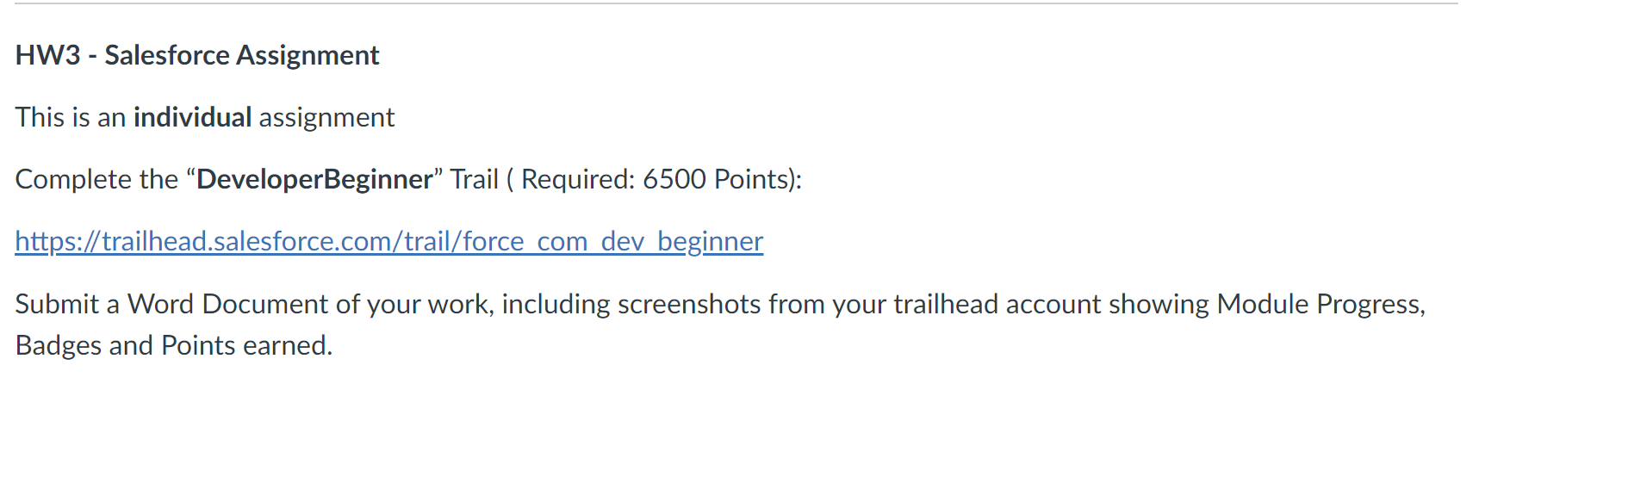

Completed the Entire Developer Beginner Trailhead as a part of Course Extra Credits

**Salesforce Platform Basics – 850 points**

**Module 1: Platform Development Basics - 800 points**

**Module 2: Data Modeling - 1500 points**

**Module 3: Data Management – 600 points**

**Module 4: Data Security – 3100 points**

**Module 5: Formulas and Validations - 1500 points**

**Module 6: Approve Records with Approval Processes – 600 points**

**Module 7: Salesforce Mobile App Customization - 1700 points**

**Module 8: Apex Basics and Database - 2100 points**

**Module 9: Apex Triggers - 1000 points**

**Module 10: Apex Testing - 1500 points**

**Module 11: Visualforce basics – 4100 points**

**Module 12: Developer Console Basics - 2100 points**

**Module 13: Quick Start: Visual Studio Code for Salesforce Development - 300 points**

**Module 14: Search Solution Basics – 300 points**

**Developer Trailhead Total Points Earned: 21200 points**

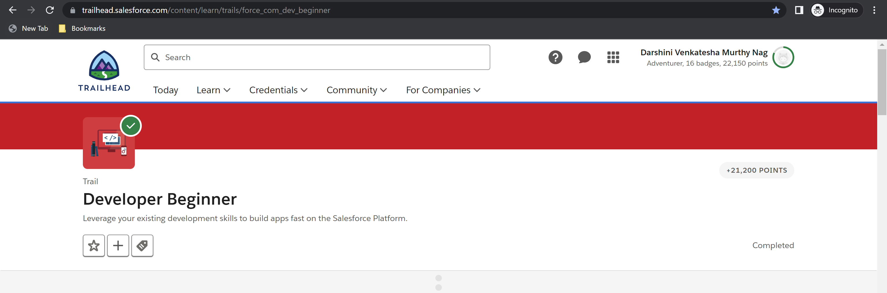

**Total Trailhead Points Earned: 22150 points**

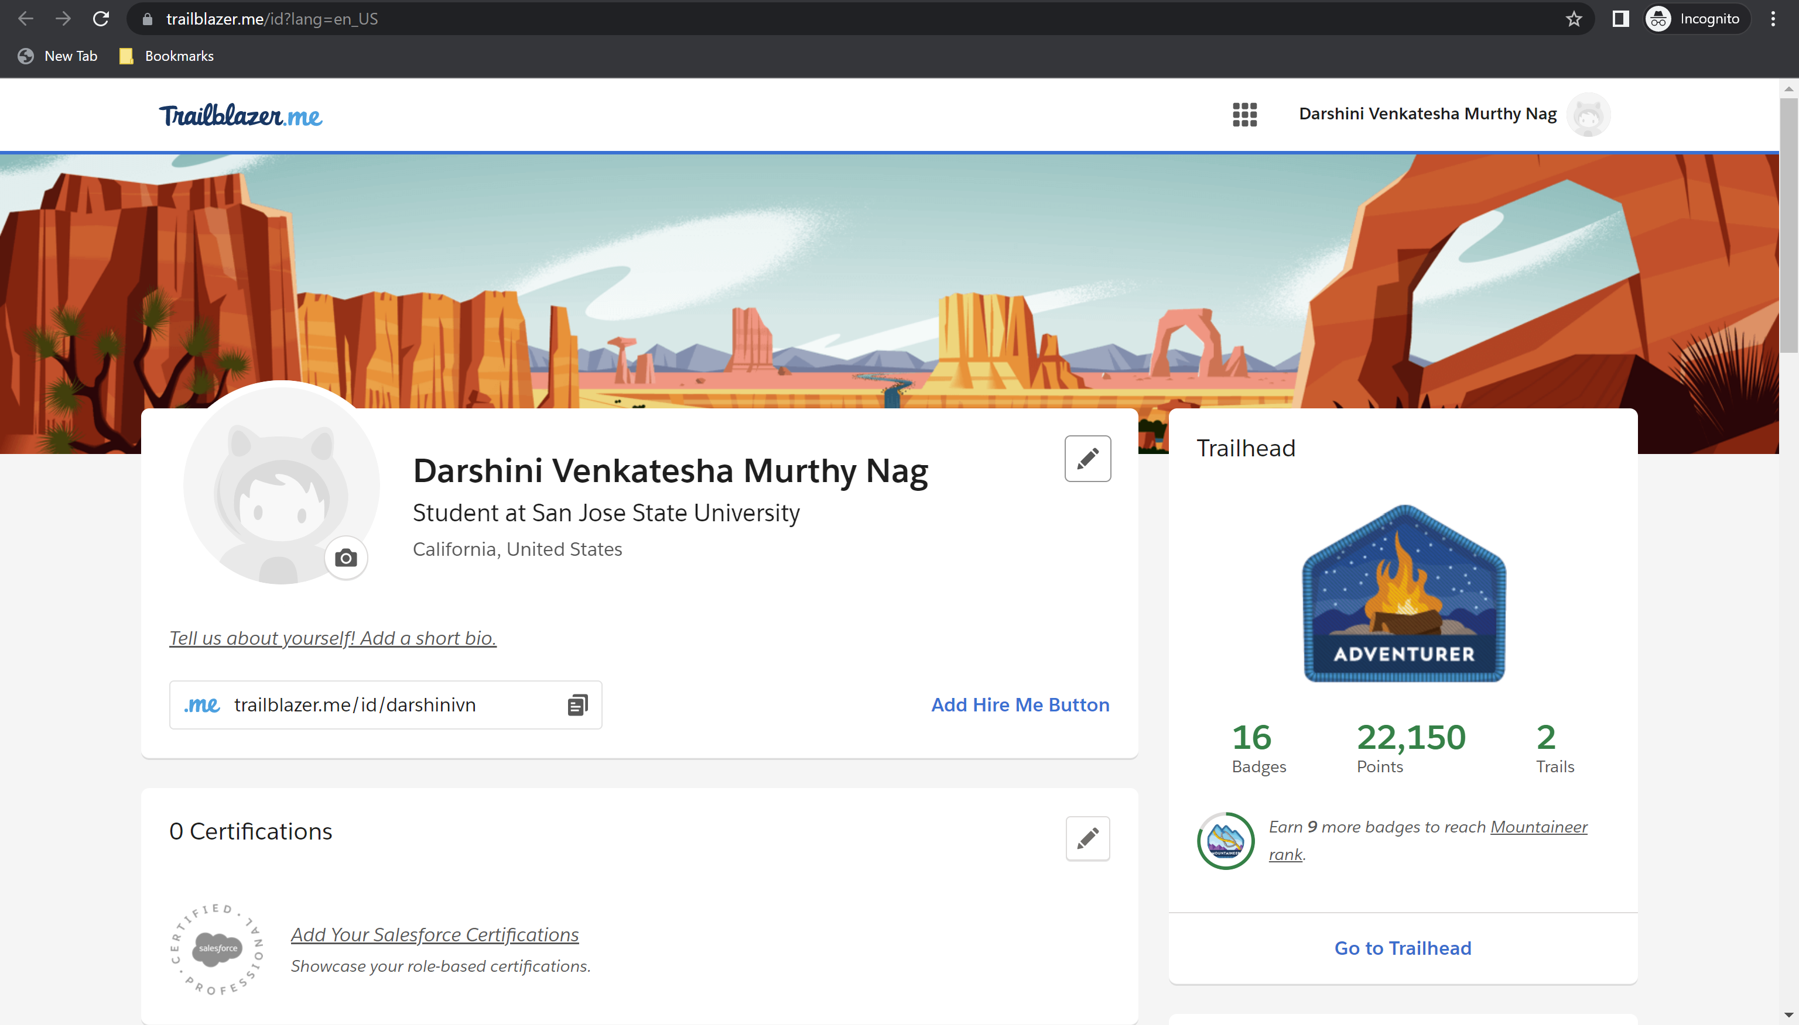

**Badges Earned: 16**

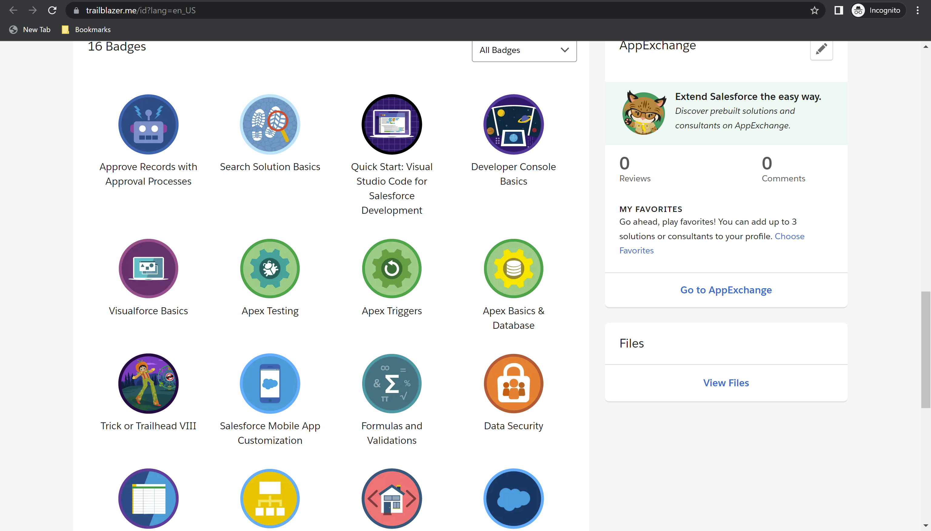

**Modules Progress.**

**Salesforce Platform Basics – Total :900 points, Points Earned: 850 points**

Challenge 1: 500 points earned

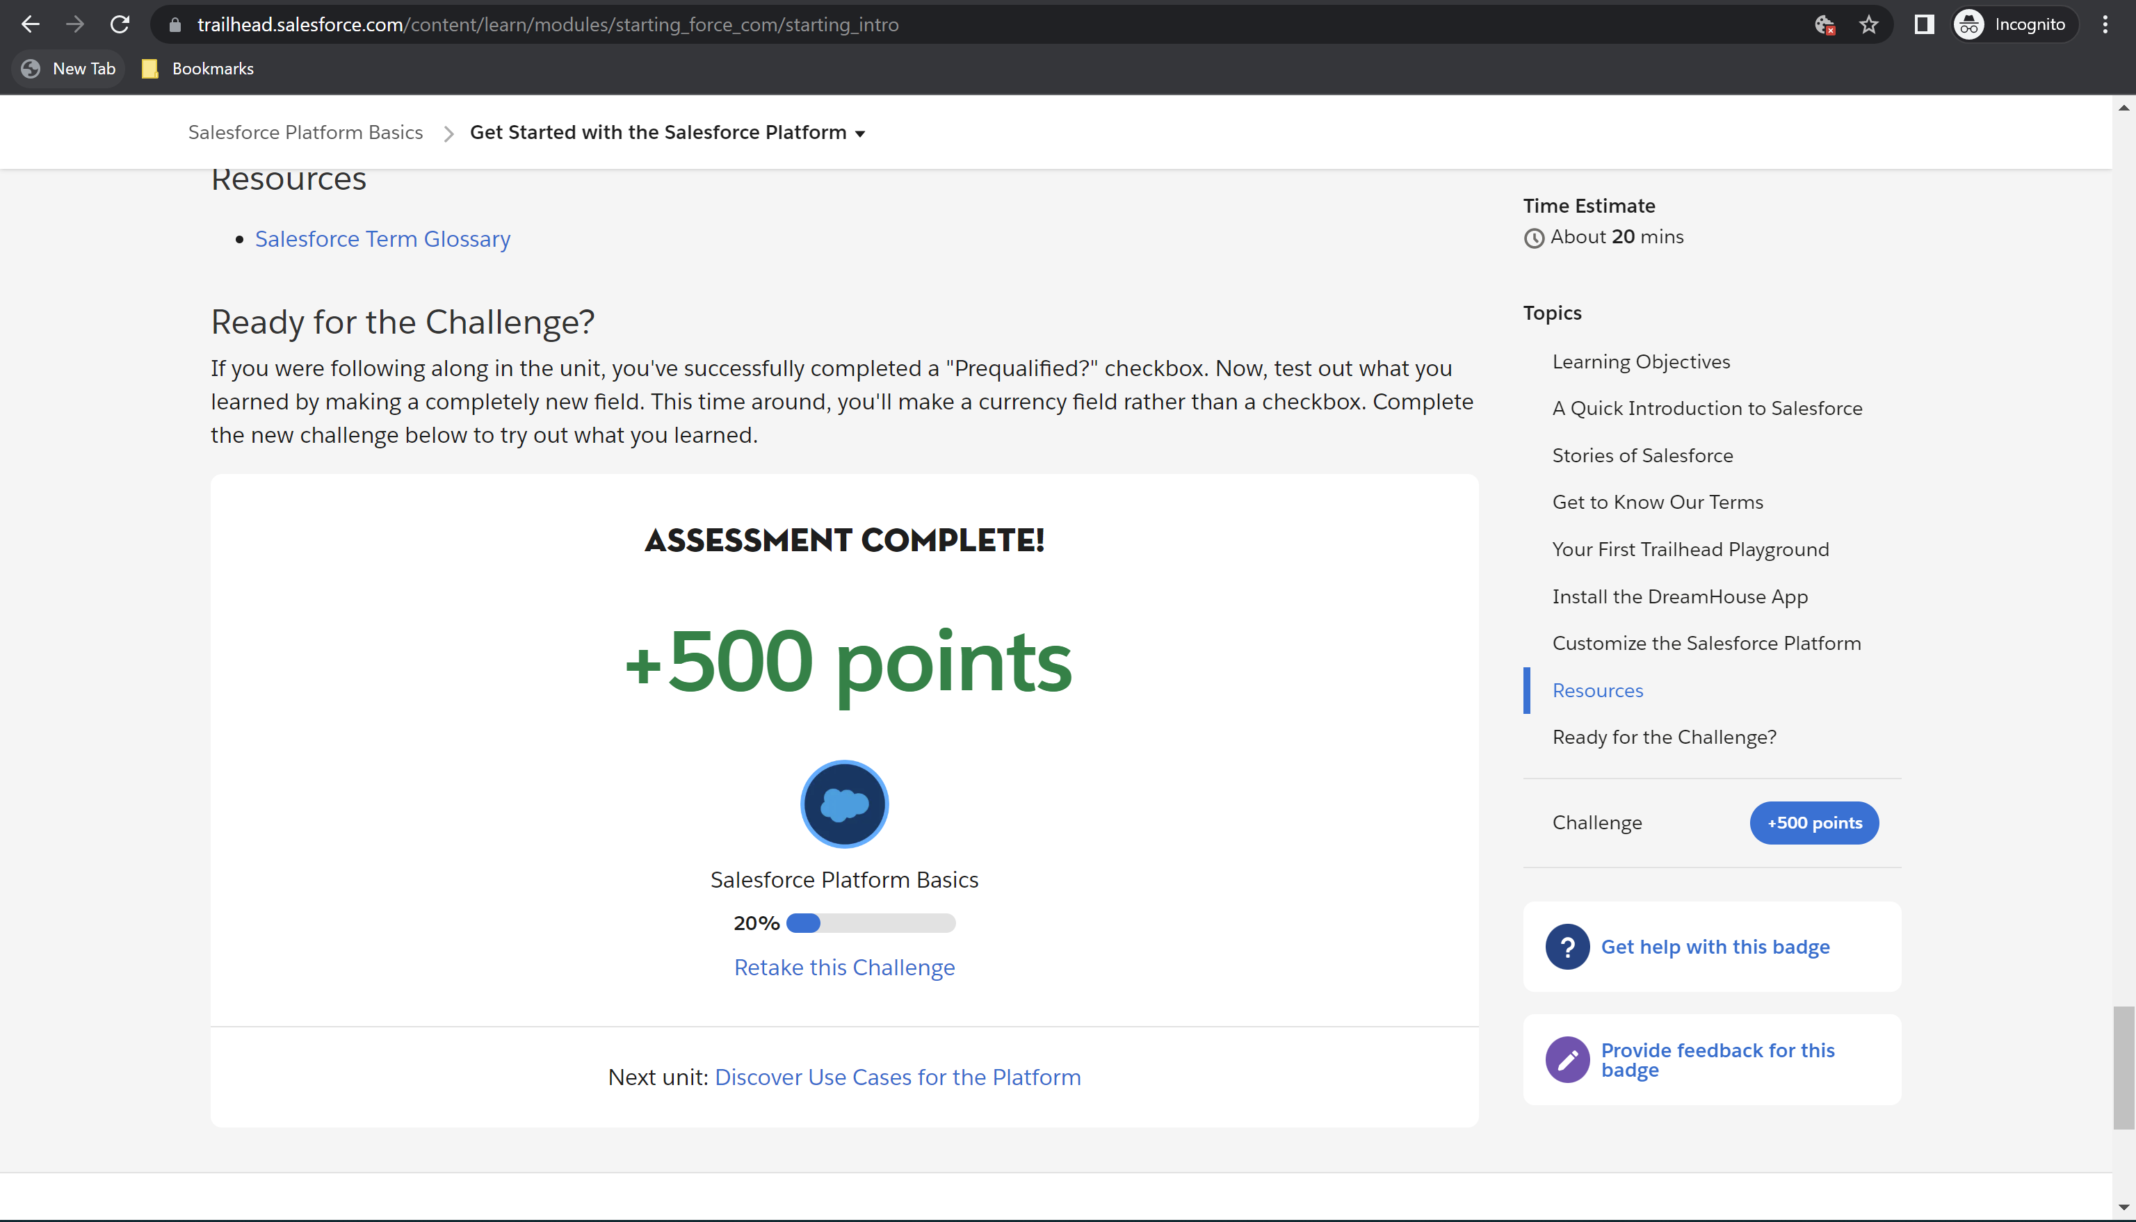

Challenge 2: 100 points earned

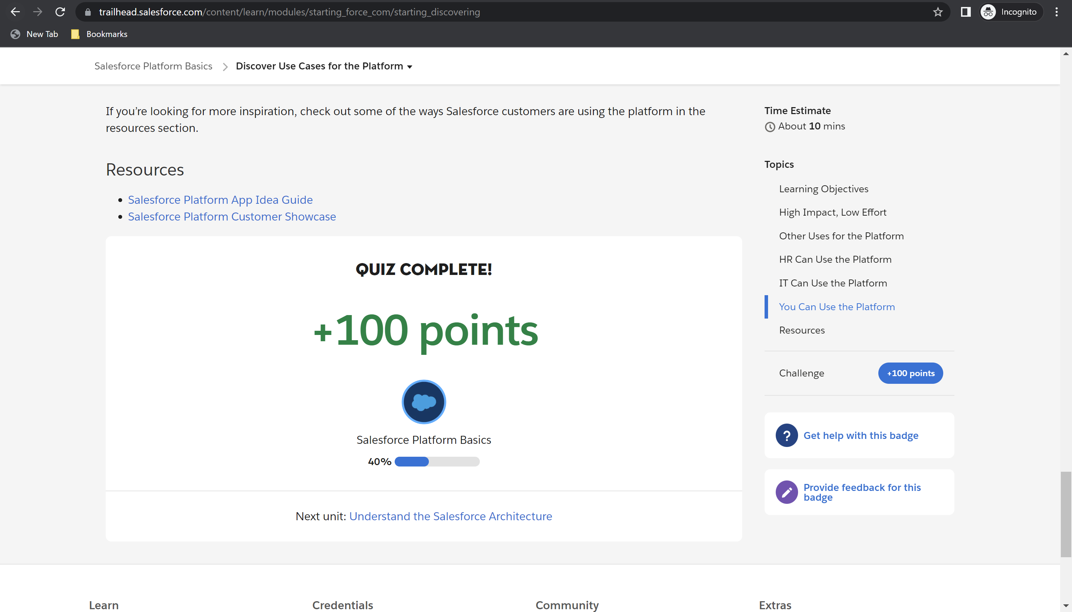

Challenge 3: 50 points earned

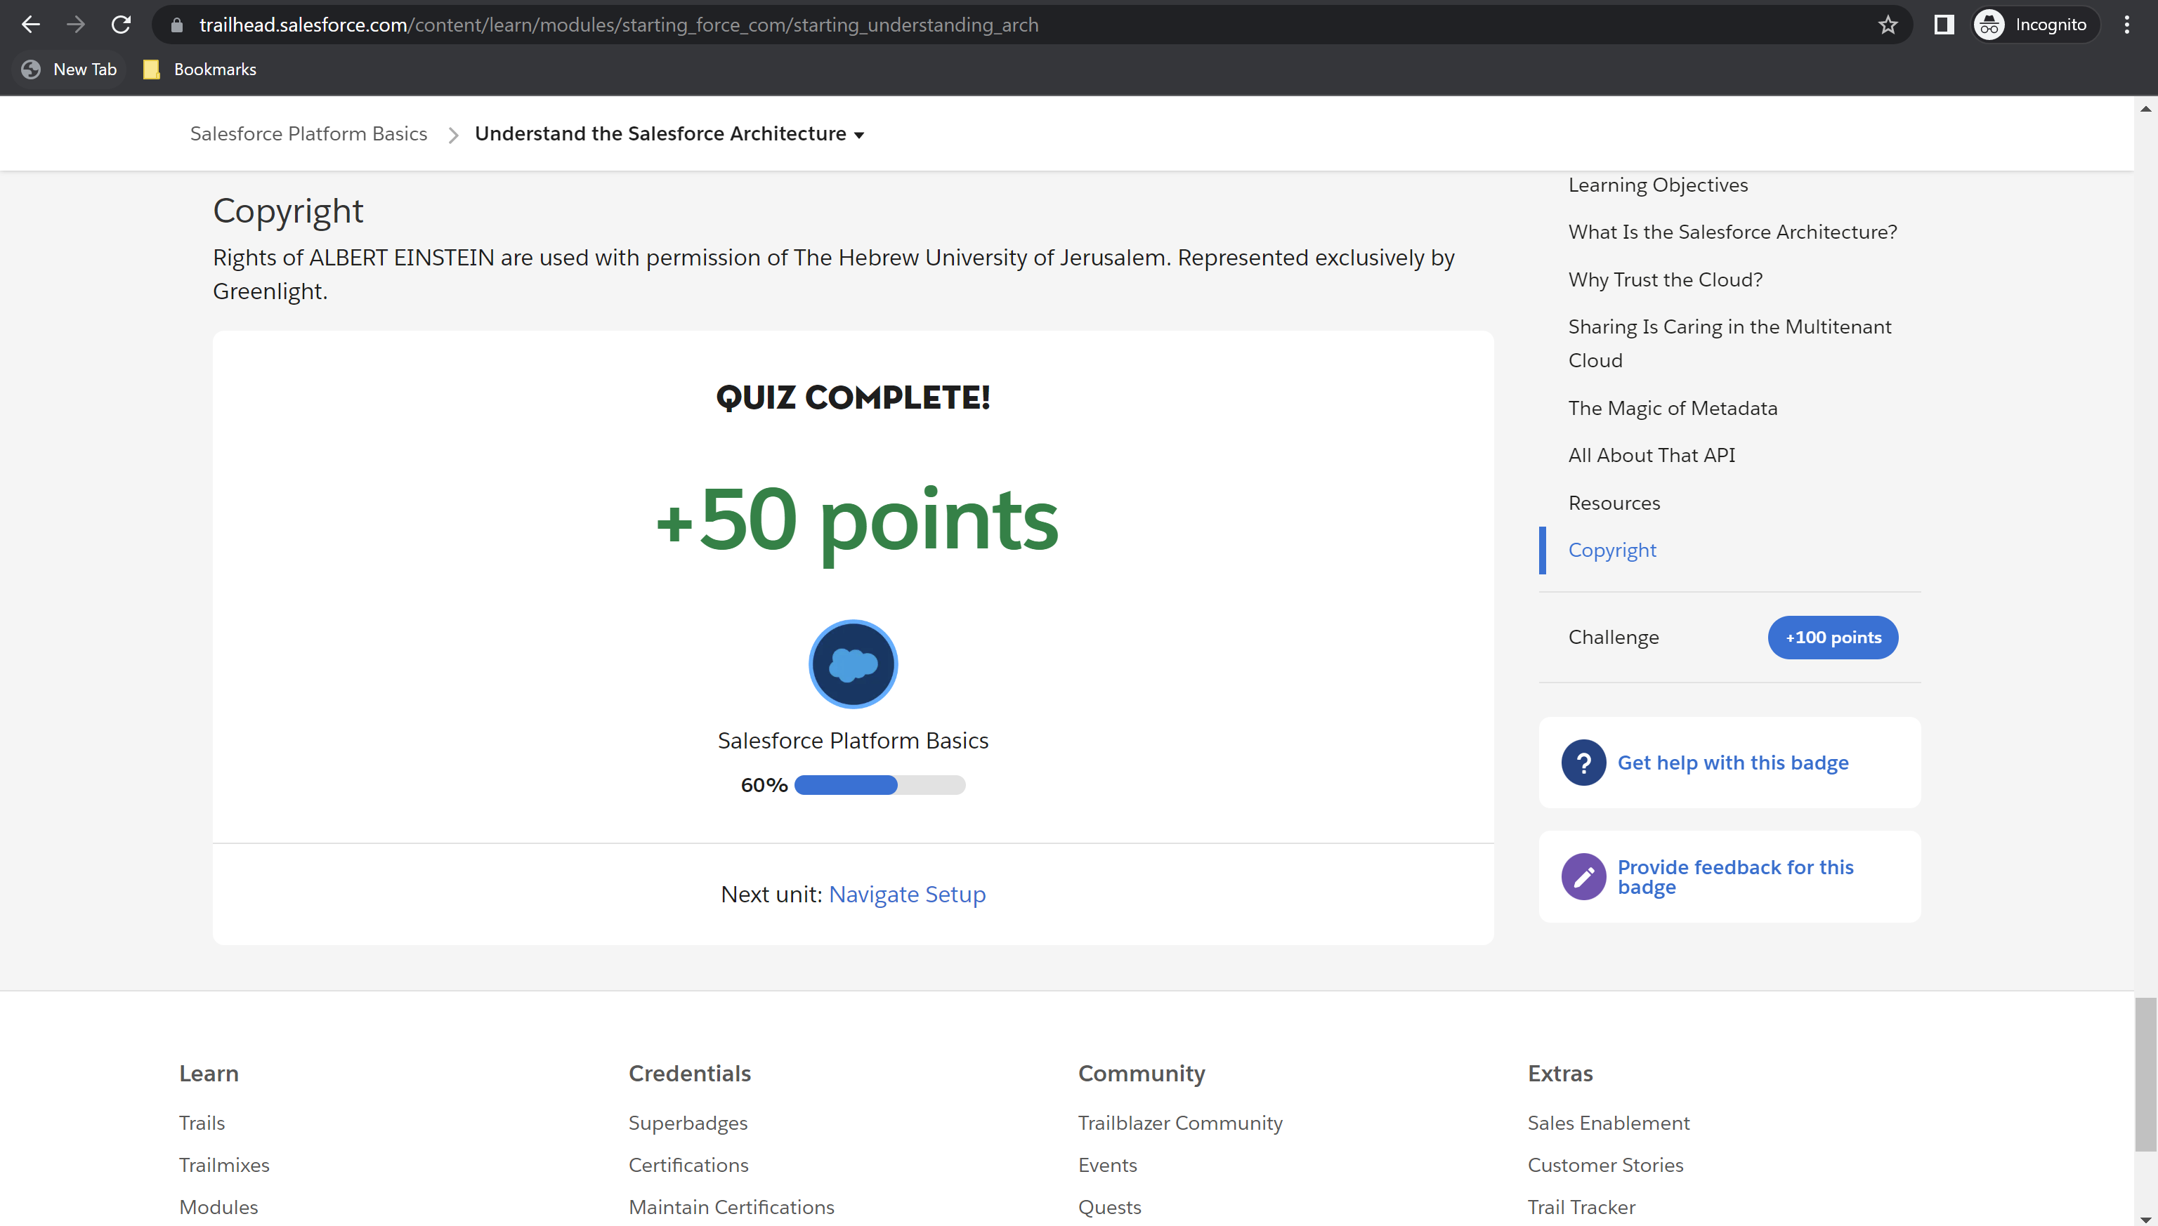

Challenge 4: 100 points earned

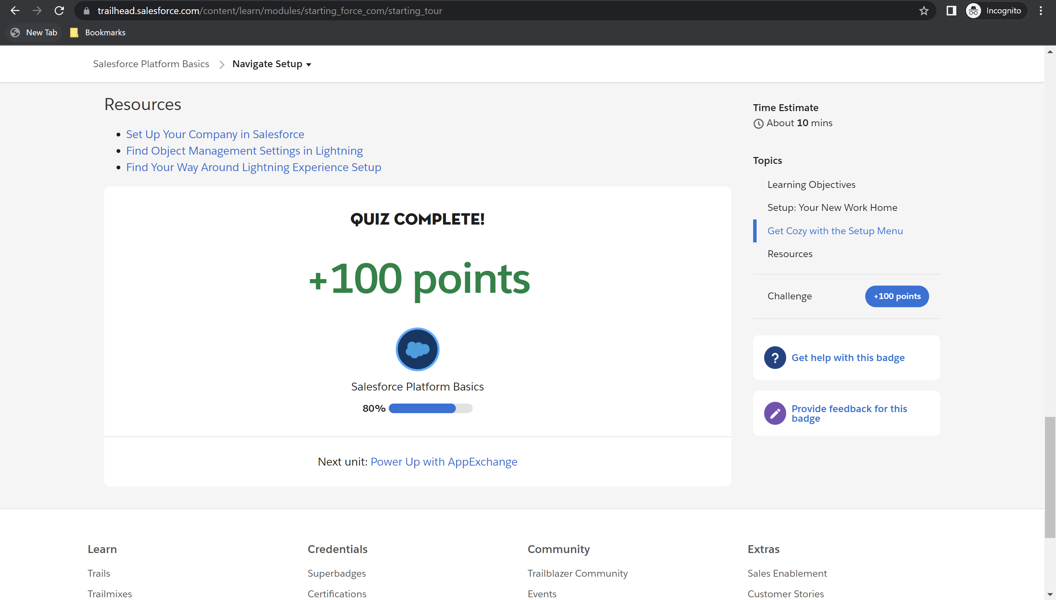

Challenge 5: 100 points earned

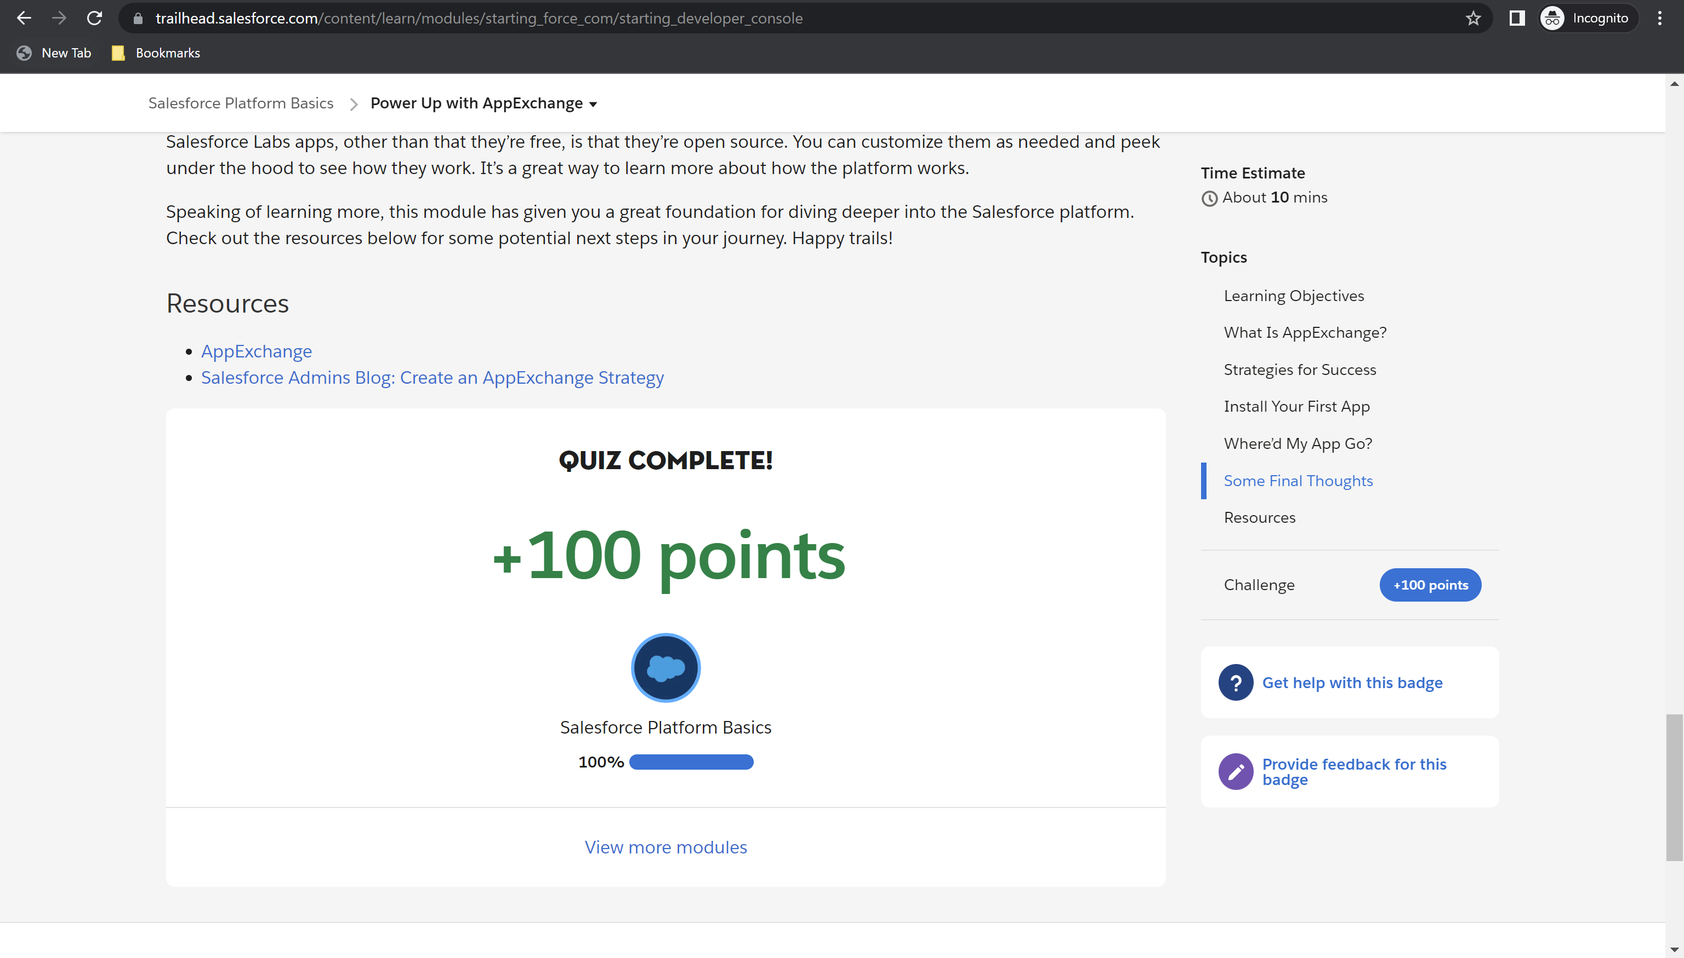

Module Badge Earned

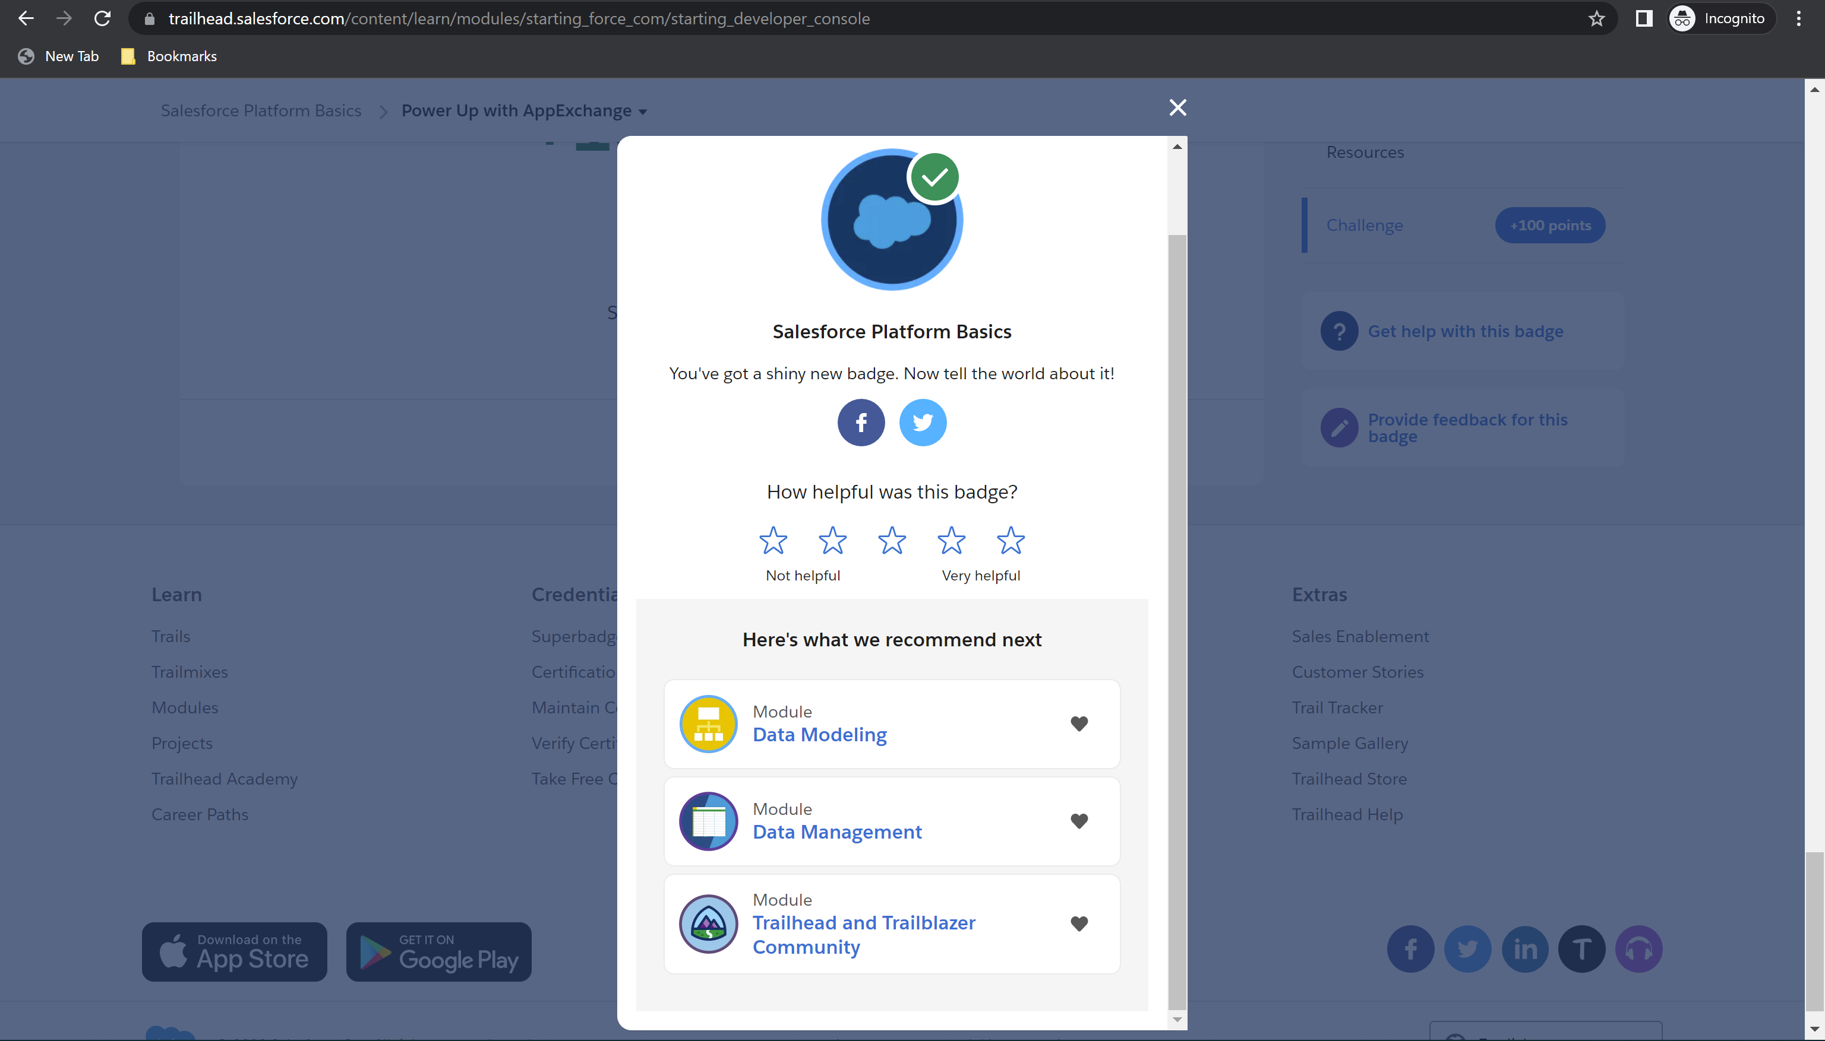

**Module 1:** **Platform Development Basics – Total: 800 points, Points Earned: 800 points**

Challenge 1: 500 points earned

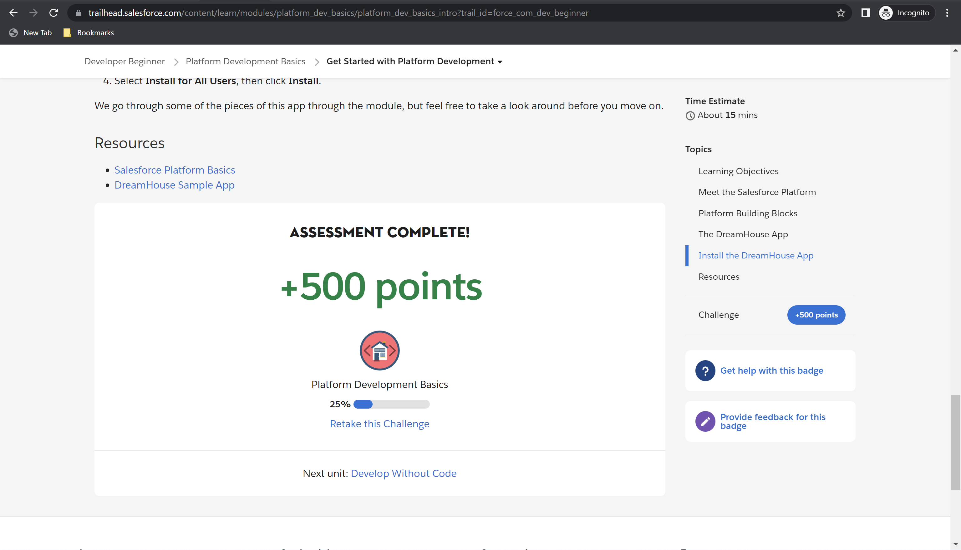

Challenge 2: 100 points earned

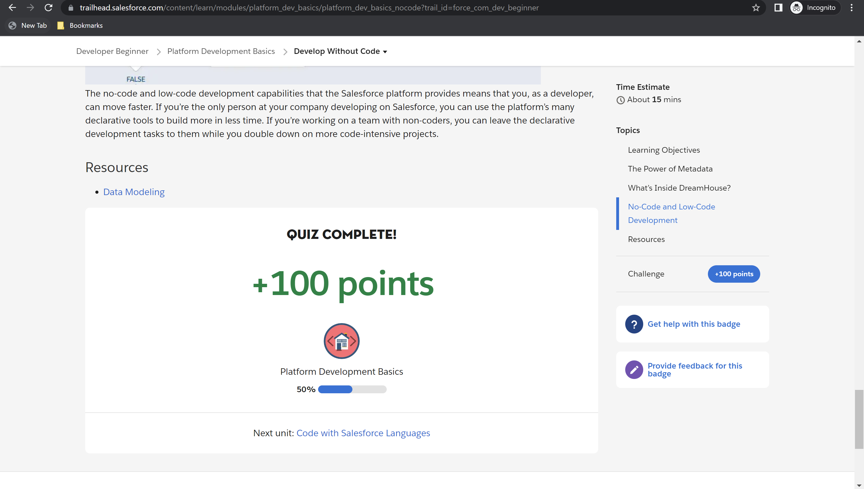

Challenge 3: 100 points earned

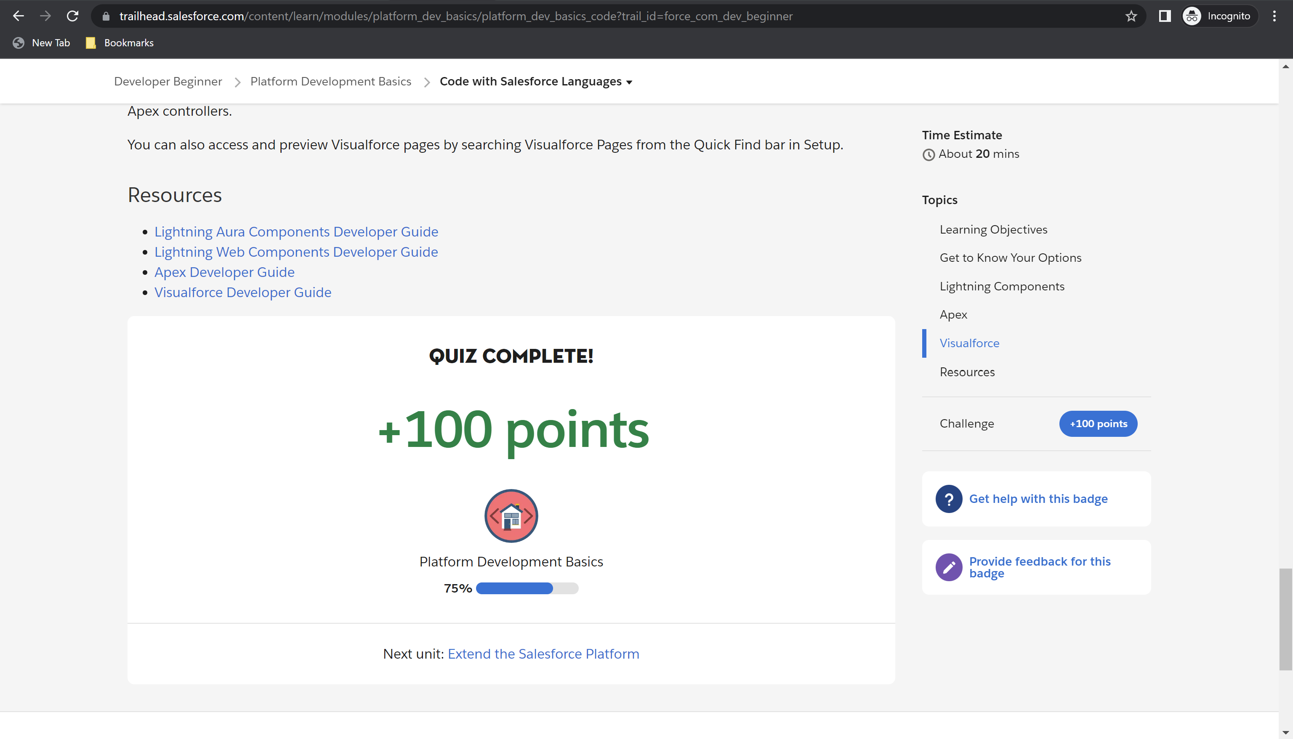

Challenge 4: 100 points earned

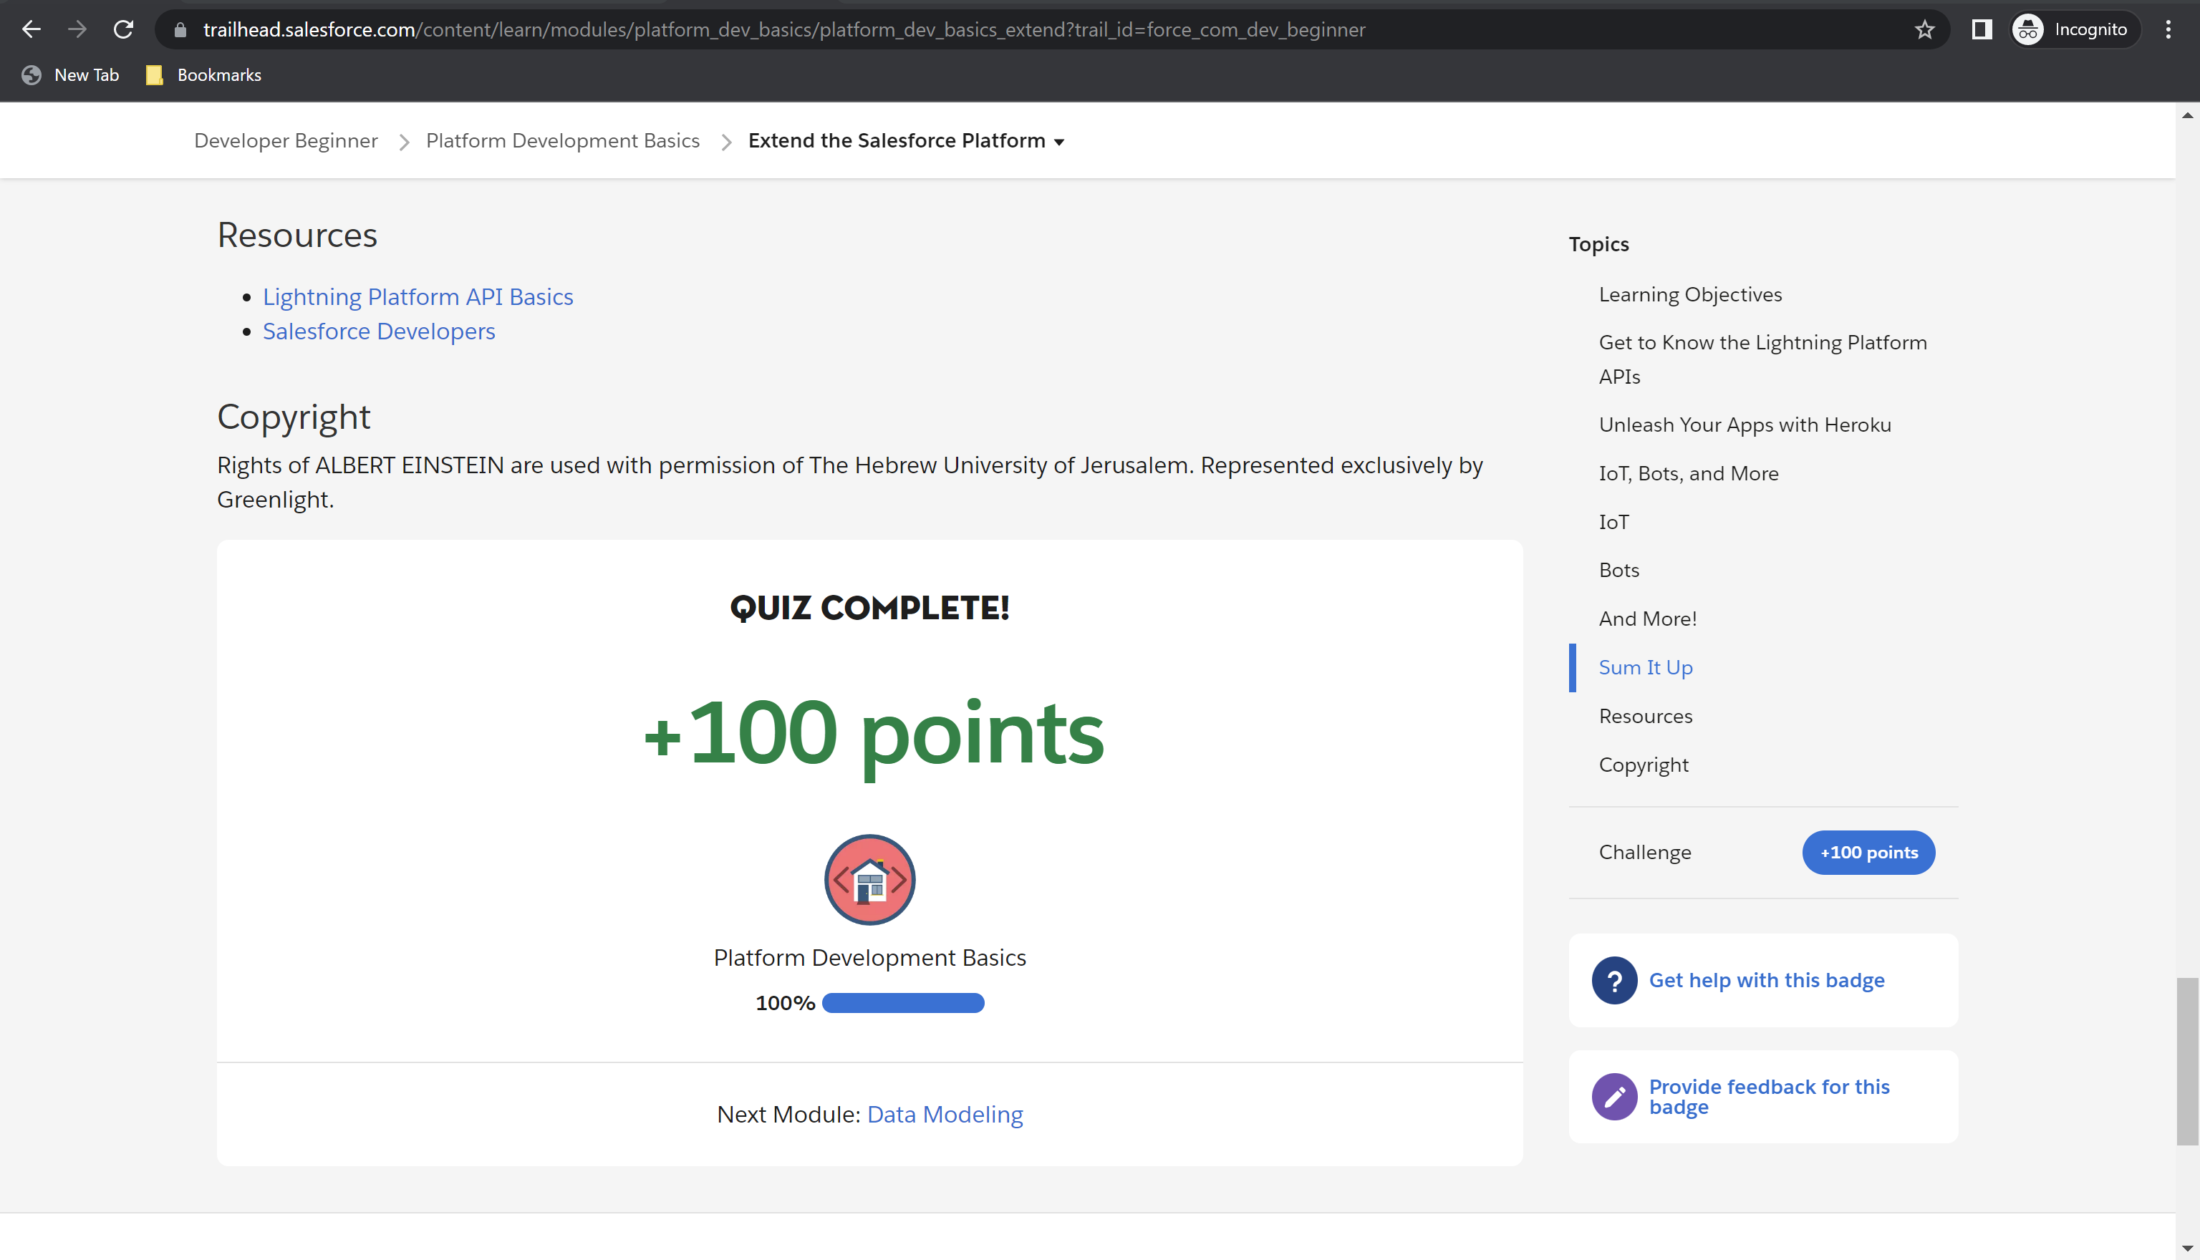

Module 1 Badge Earned

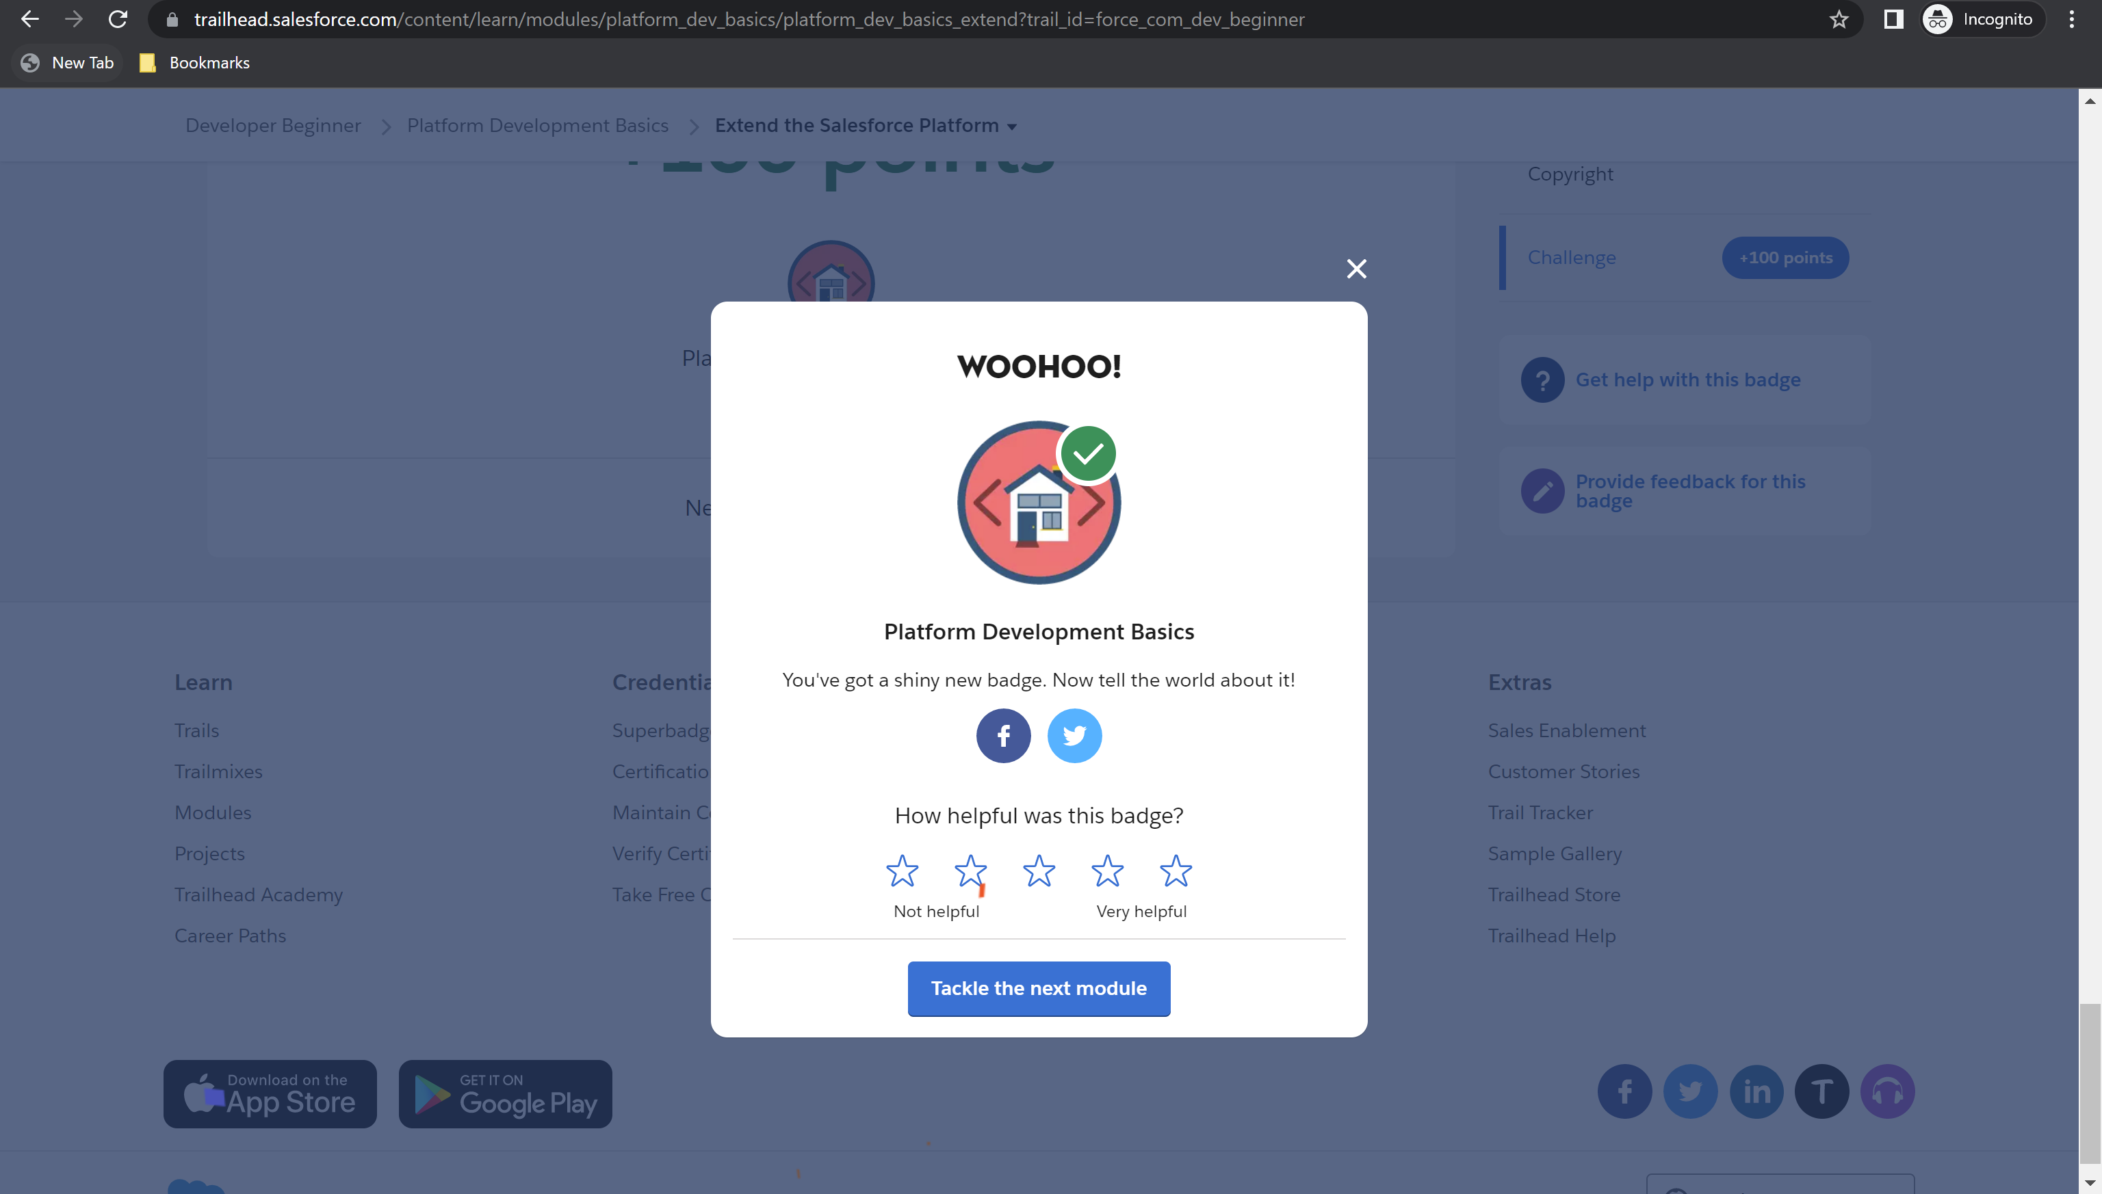

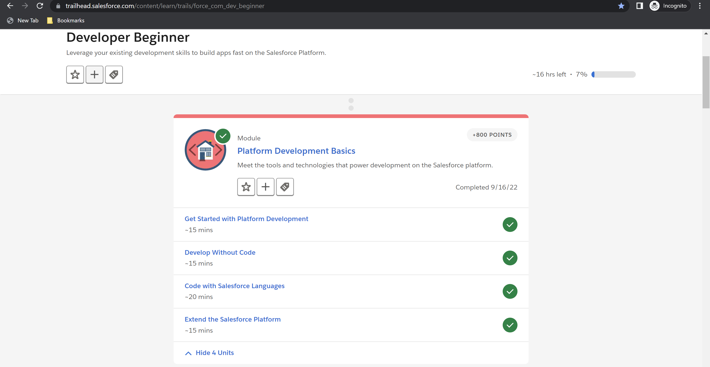

**Module 2 – Data Modeling – Total Points: 1500, Points Earned: 1500**

Challenge 1: 500 points earned.

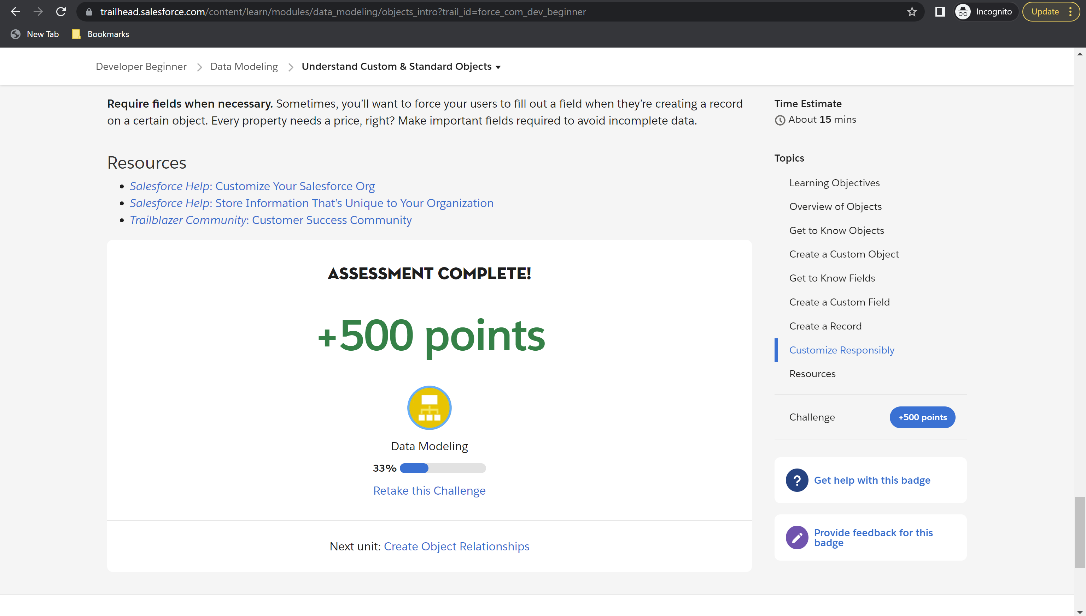

Challenge 2: 500 points earned.

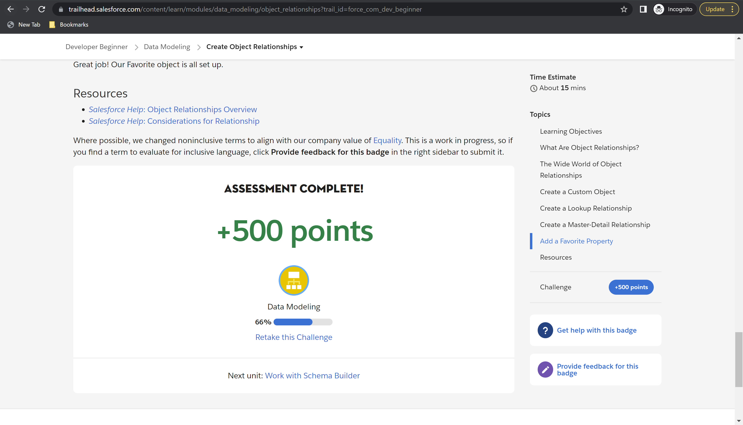

Challenge 3: 500 points earned.

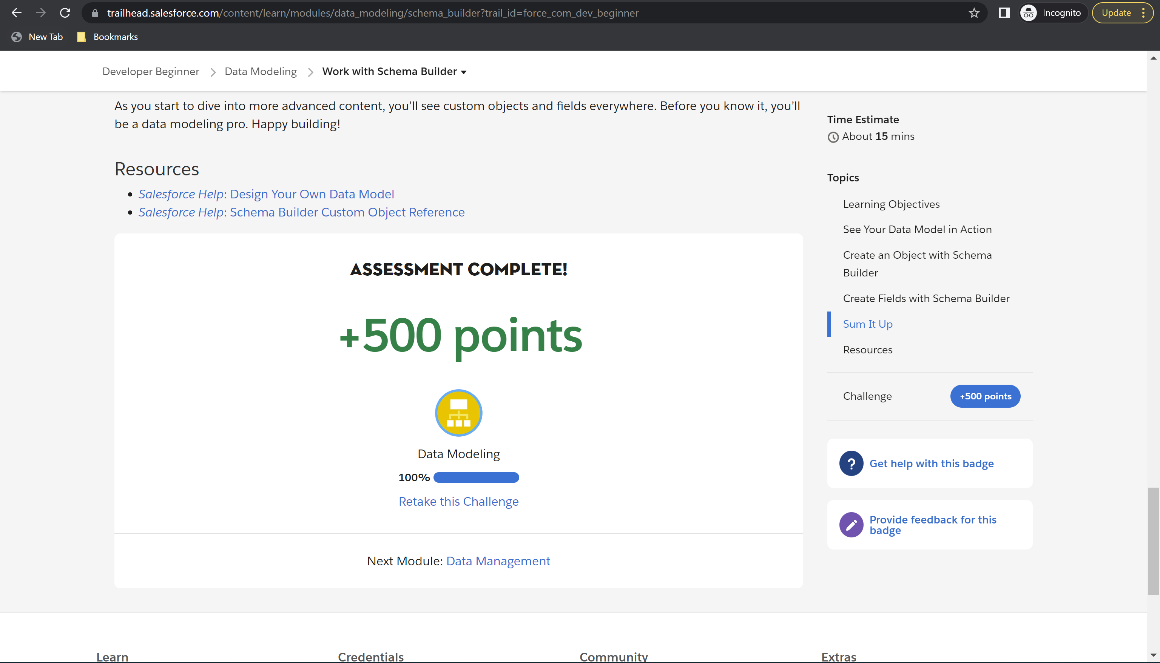

Module 2 badge earned

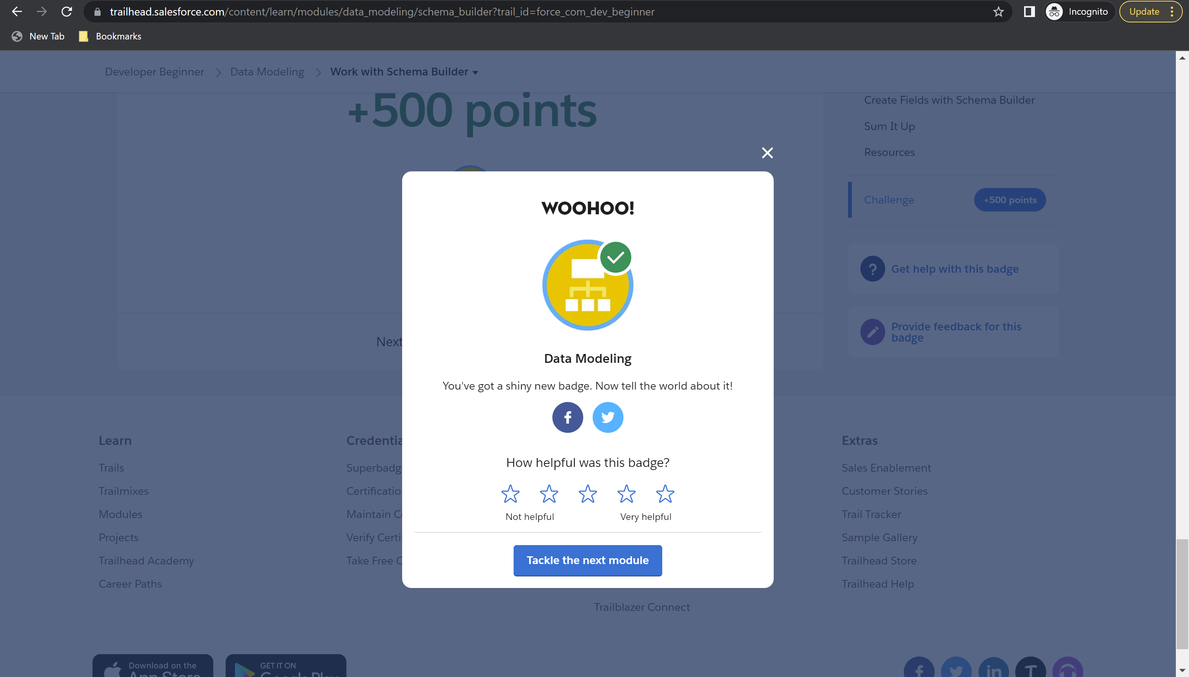

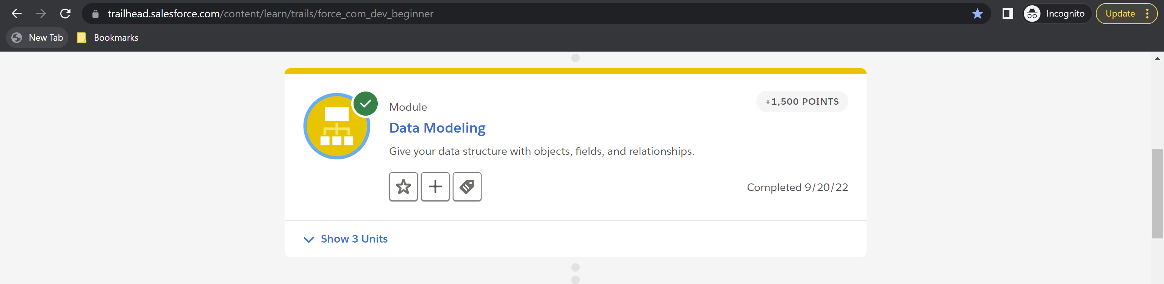

**Module 3 – Data Management – Total Points: 600, Points Earned: 600**

Challenge 1: 500 points earned

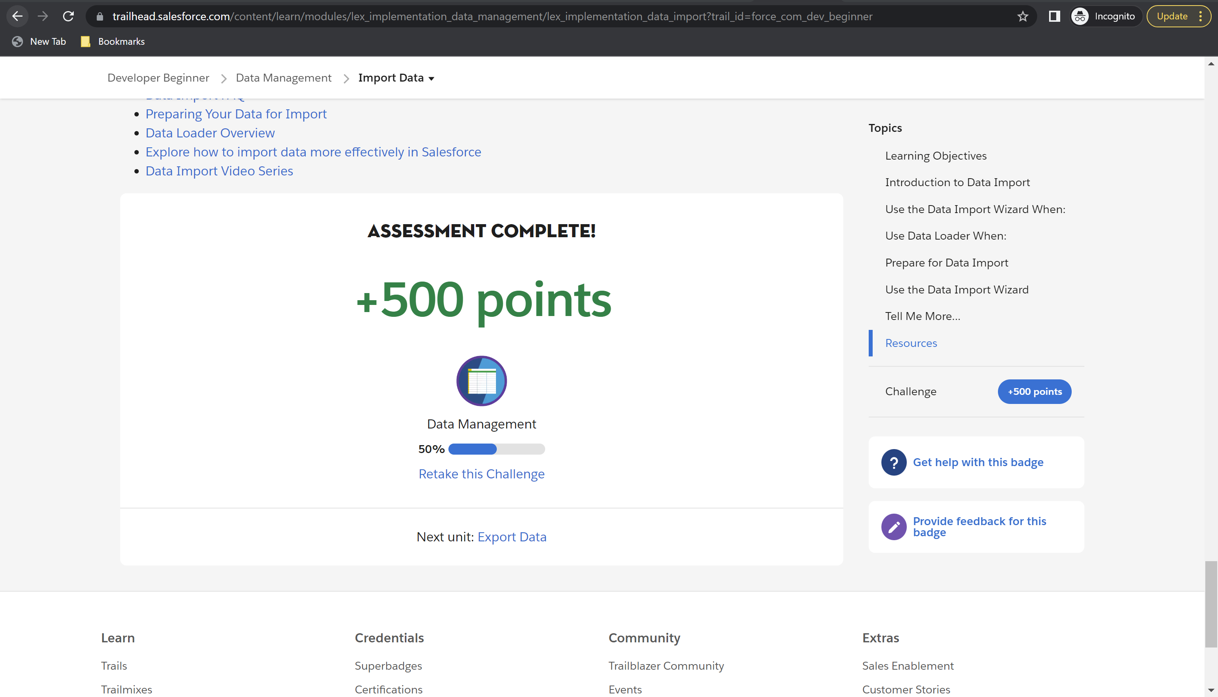

Challenge 2: 100 points earned

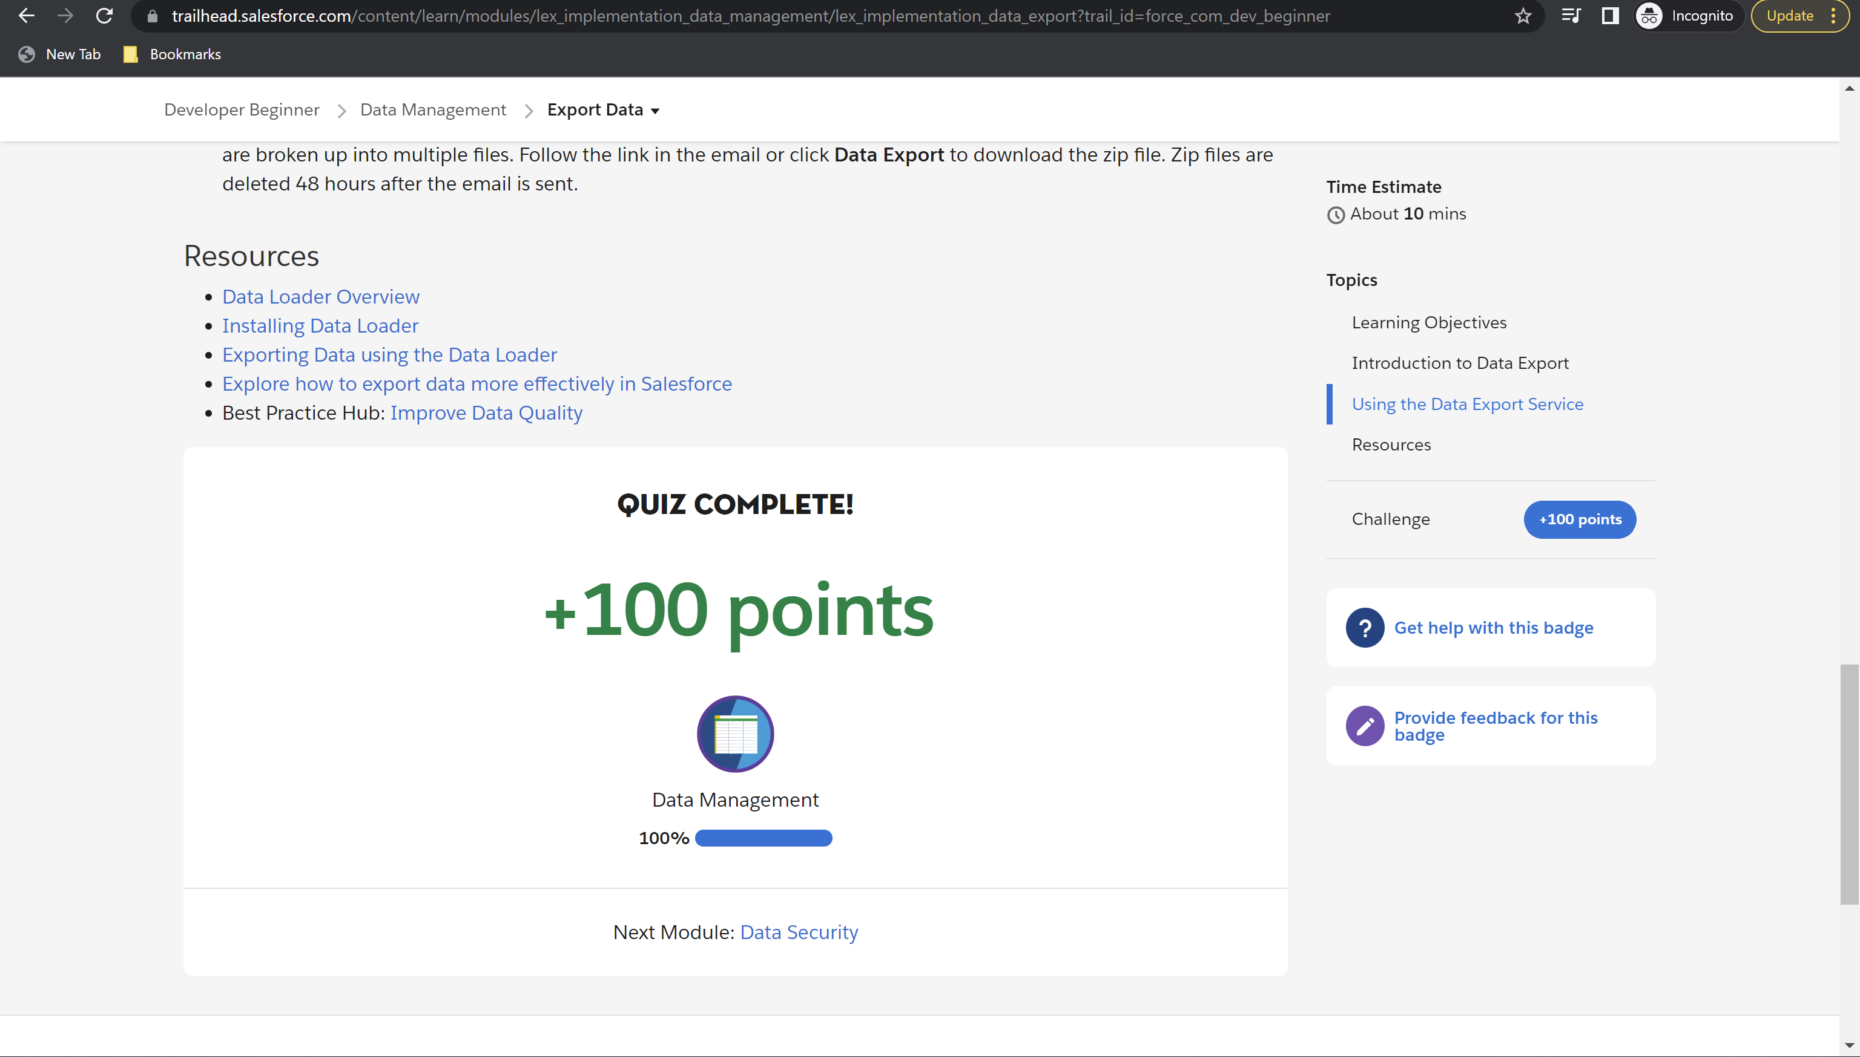

Module 3 badge earned

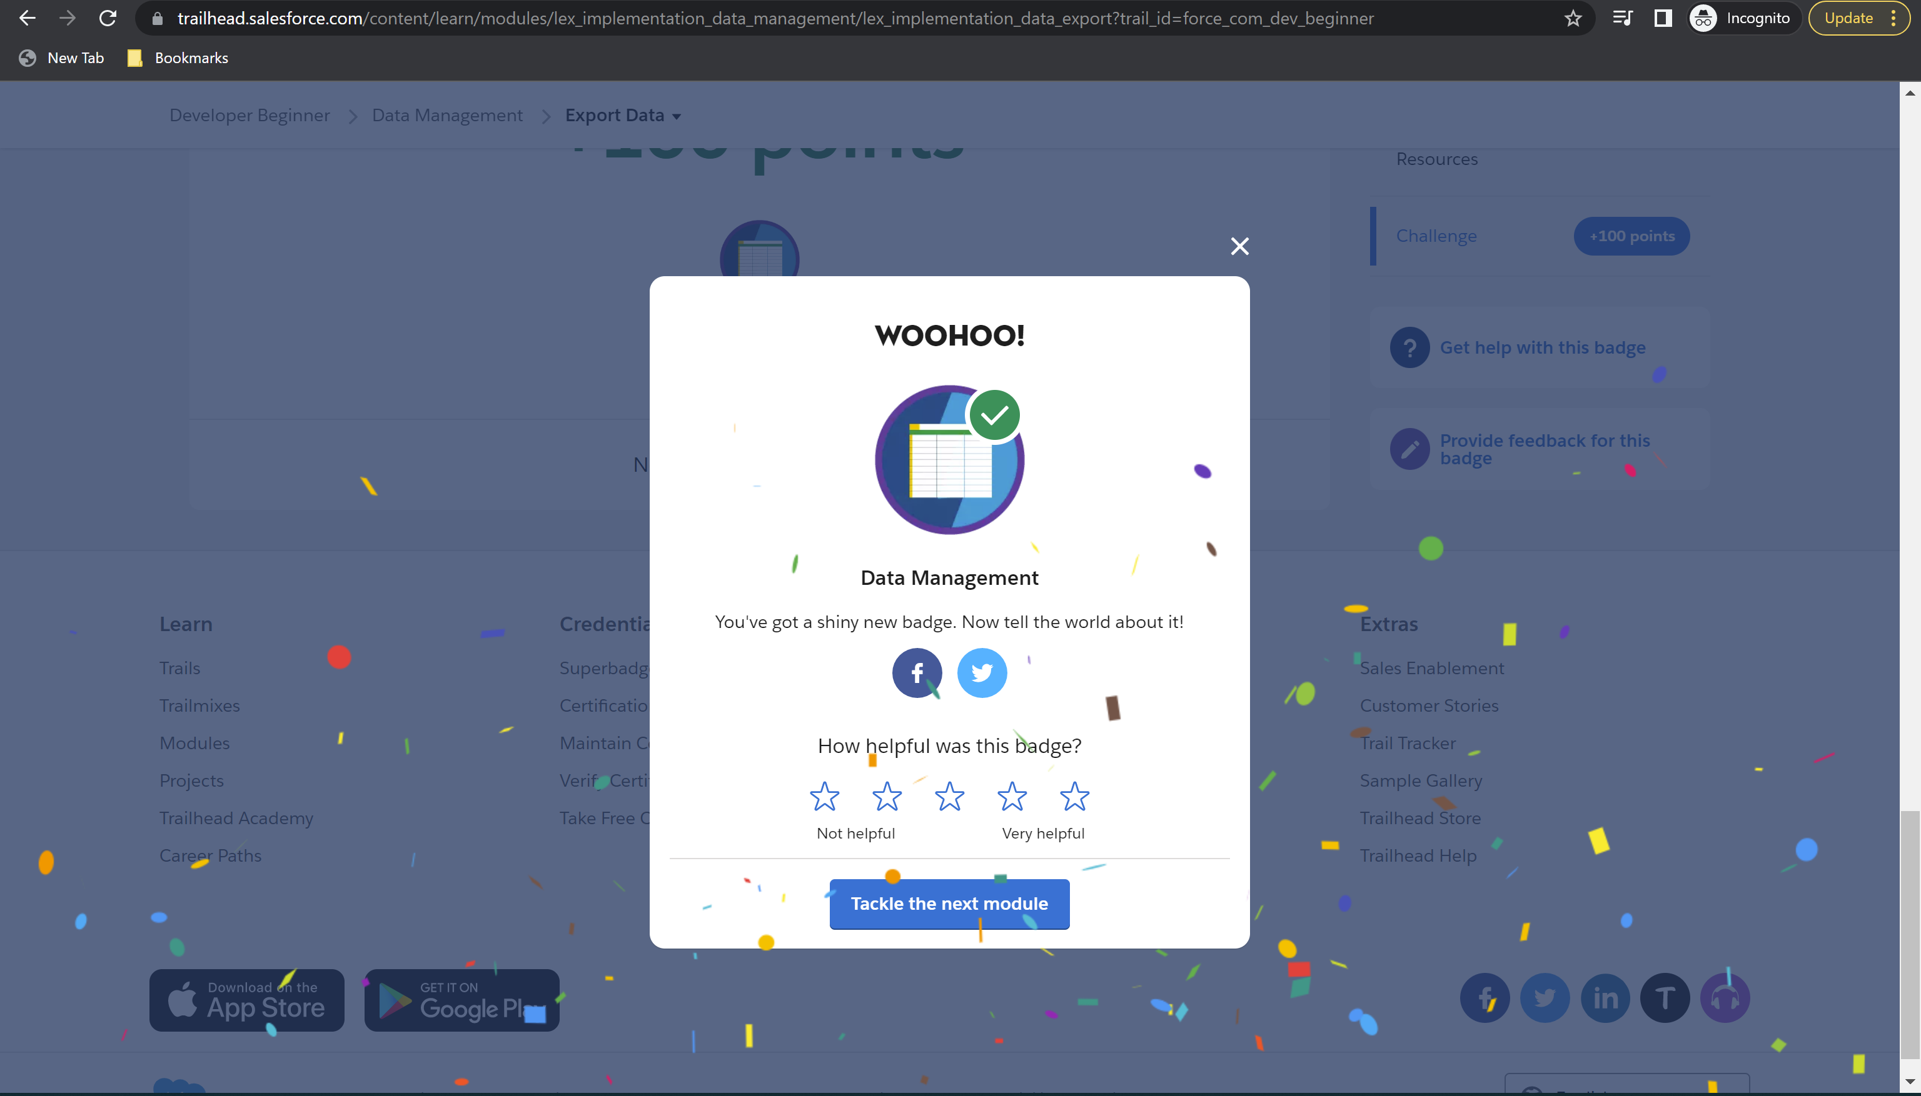

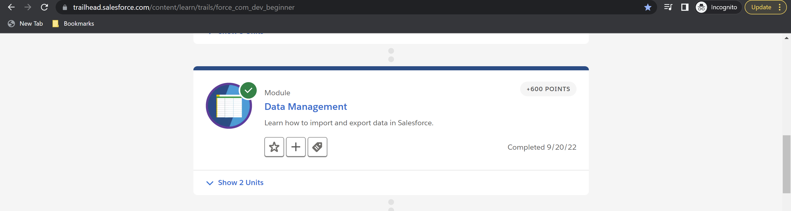

**Module 4:** **Data Security – Total: 3100 points, Points Earned: 3100 points**

Challenge 1: 100 points earned

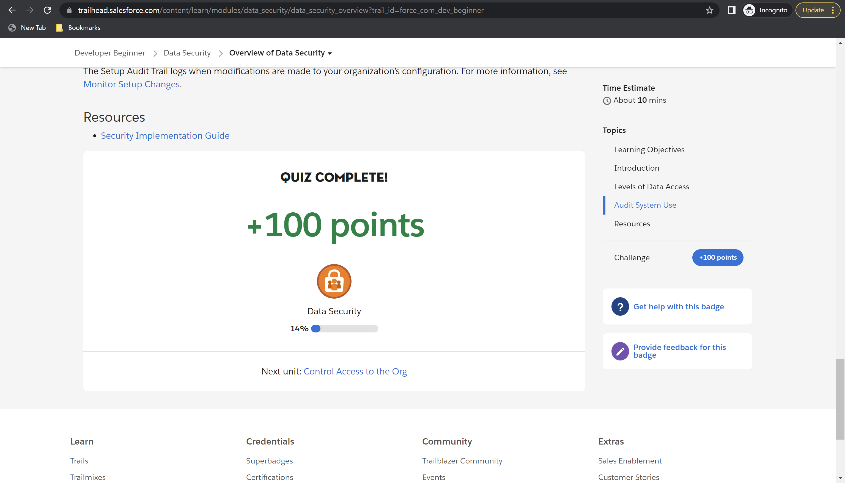

Challenge 2 :500 points earned

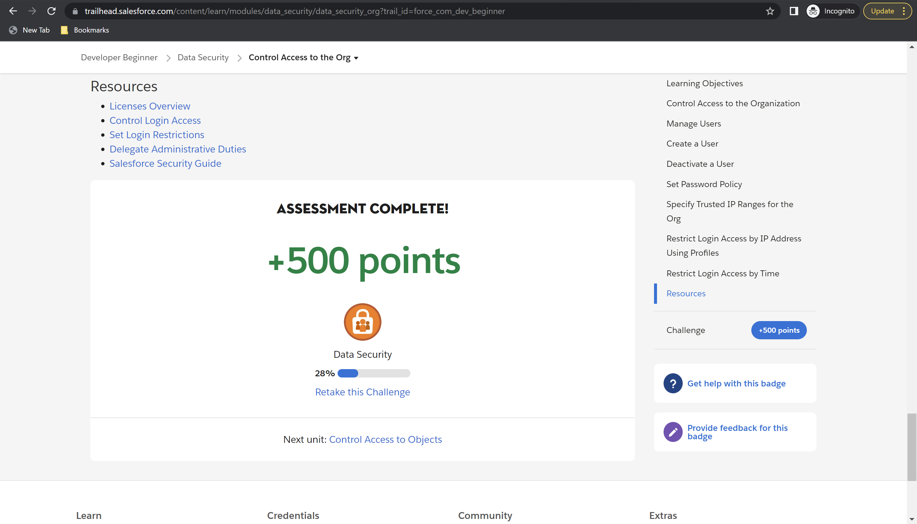

Challenge 3: 500 points earned

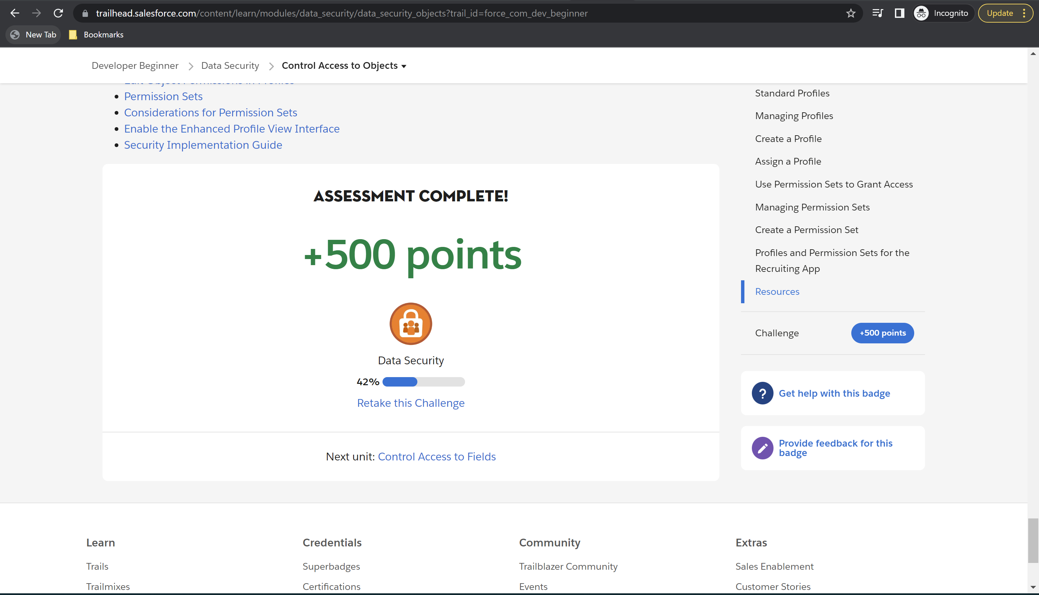

Challenge 4: 500 points earned

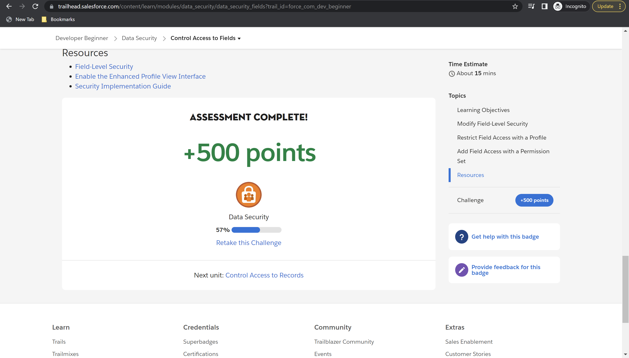

Challenge 5: 500 points earned

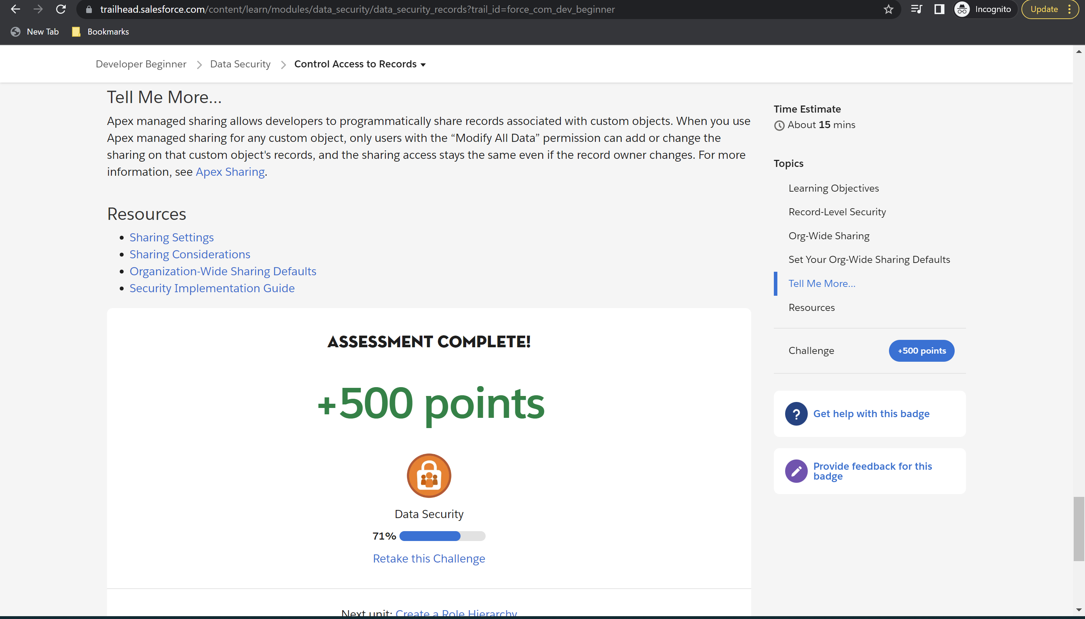

Challenge 6: 500 points earned

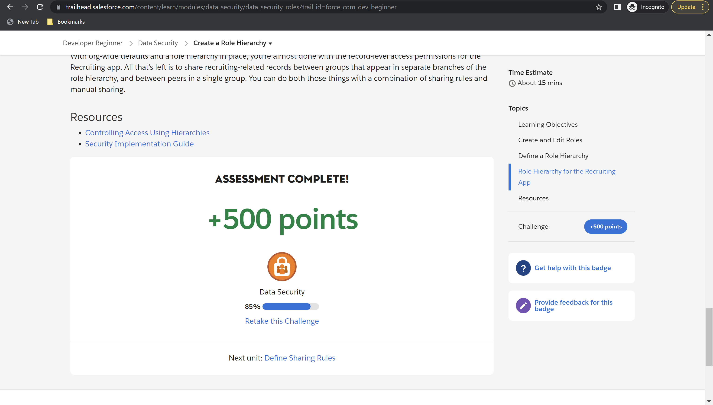

Challenge 7: 500 points earned

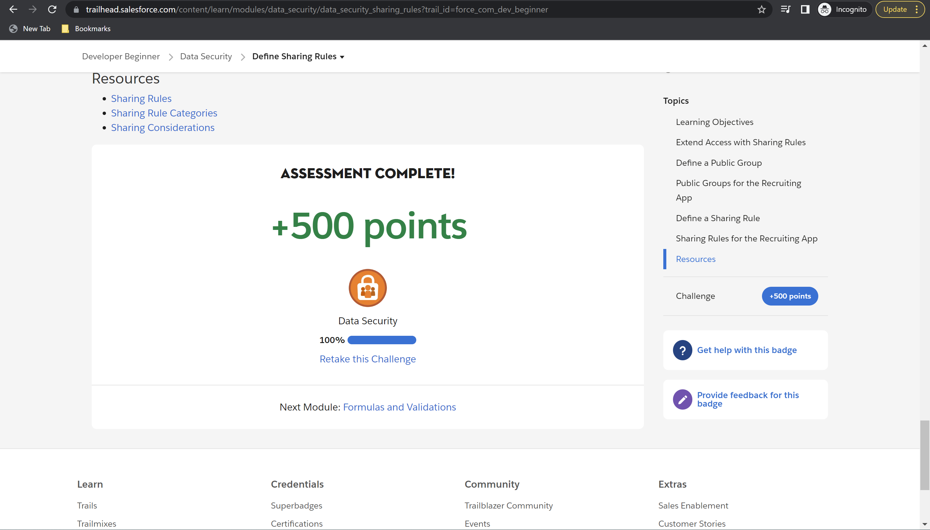

Module 4 badge earned

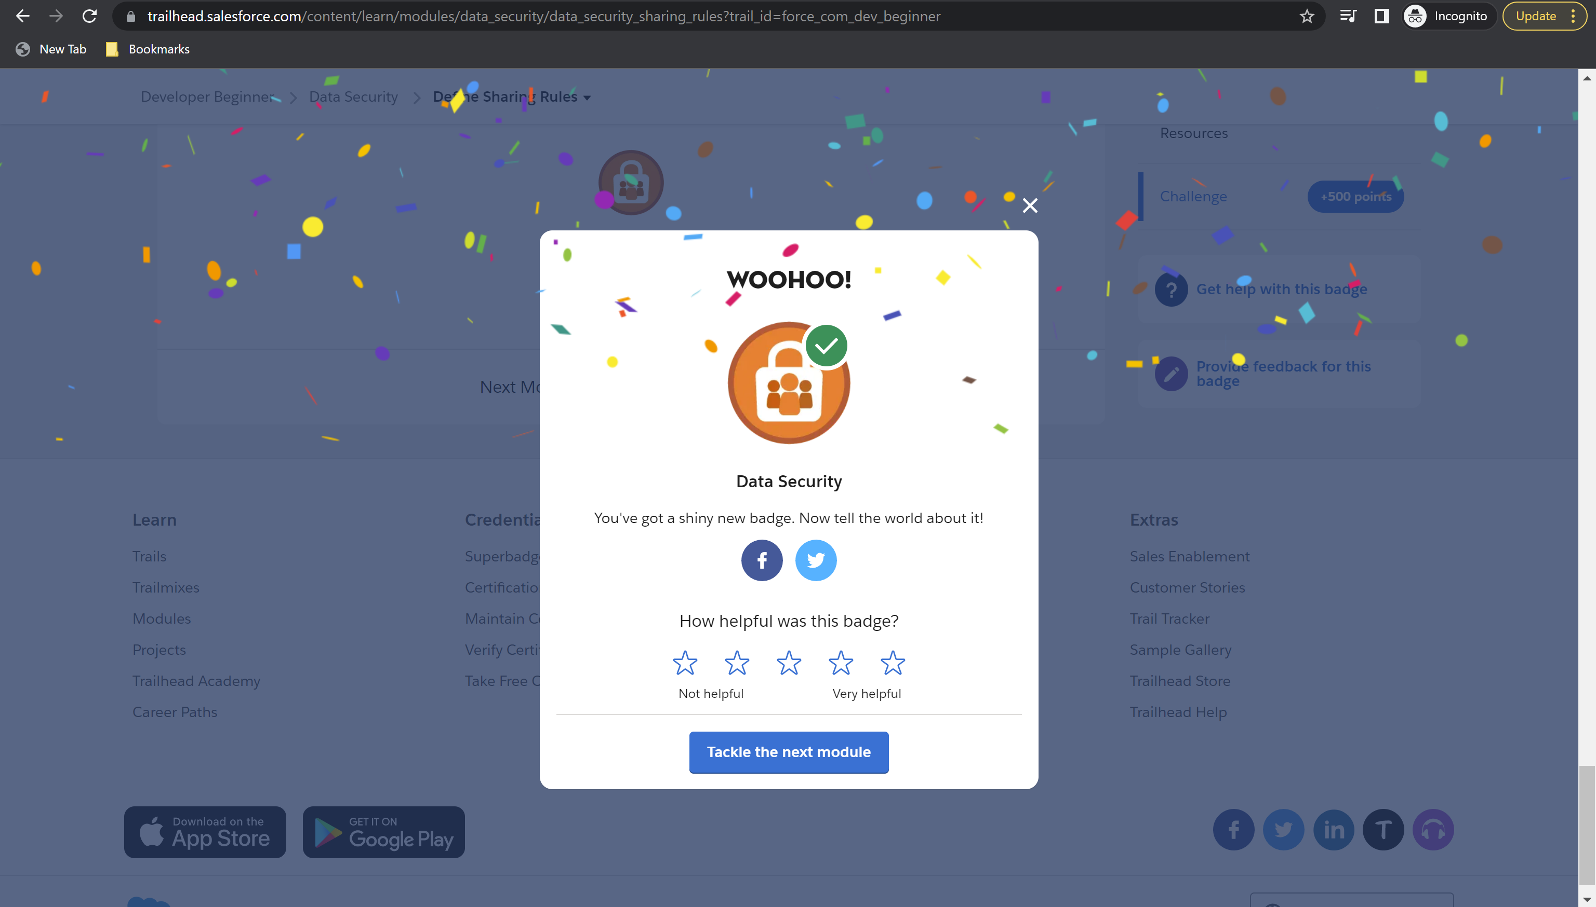

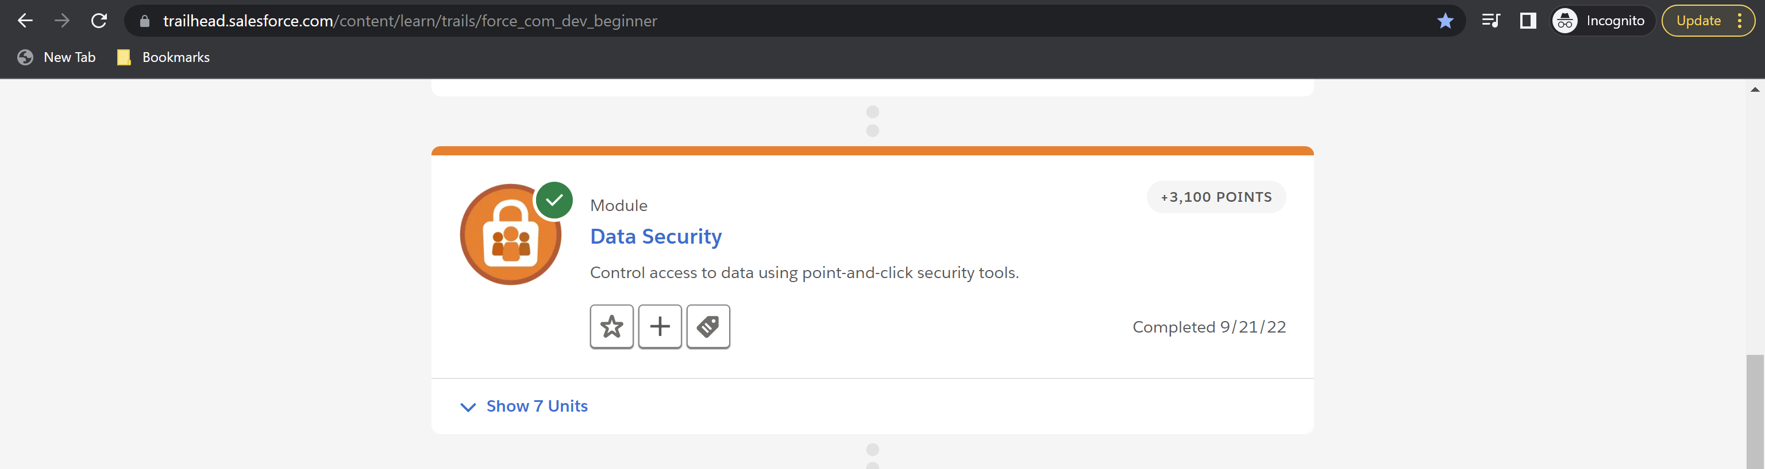

**Module 5:** **Formulas and Validations – Total: 1500 points, Points Earned: 1500 points**

Challenge 1: 500 points earned

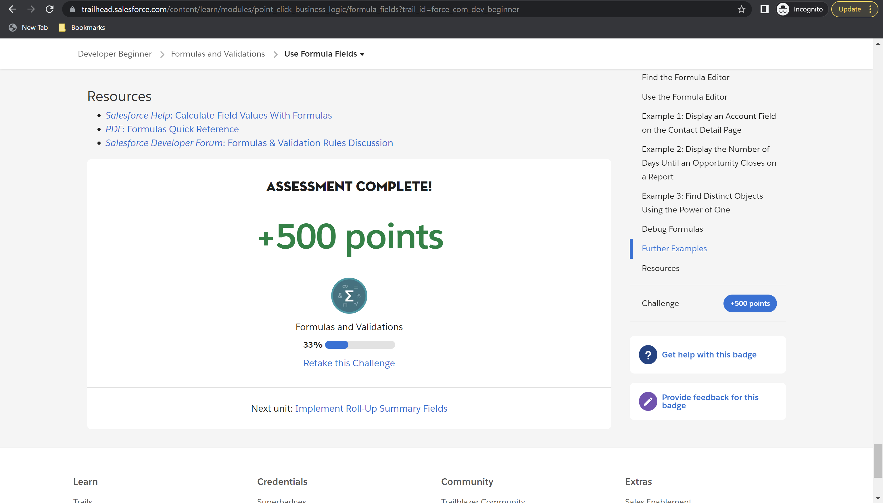

Challenge 2: 500 points earned

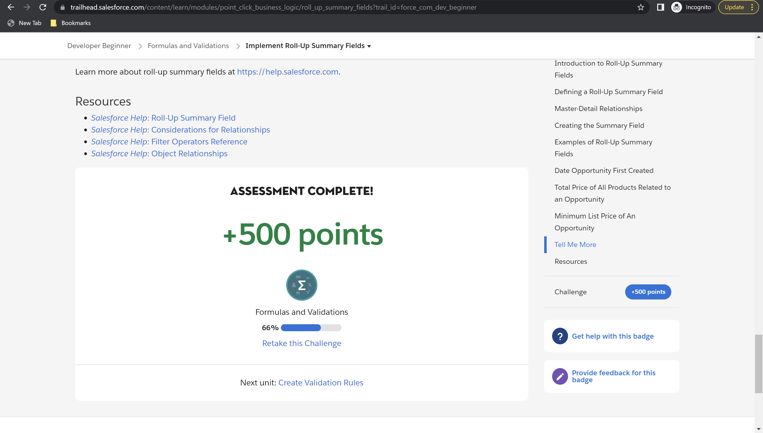

Challenge 3: 500 points earned

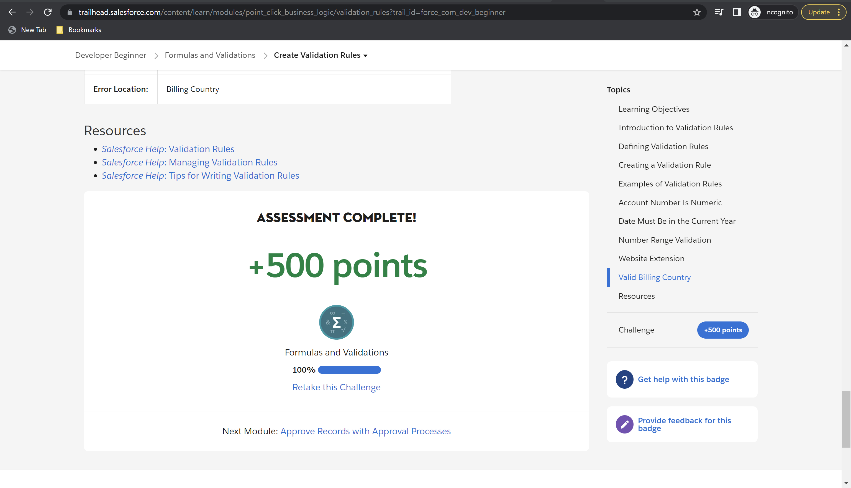

Module 5 badge earned

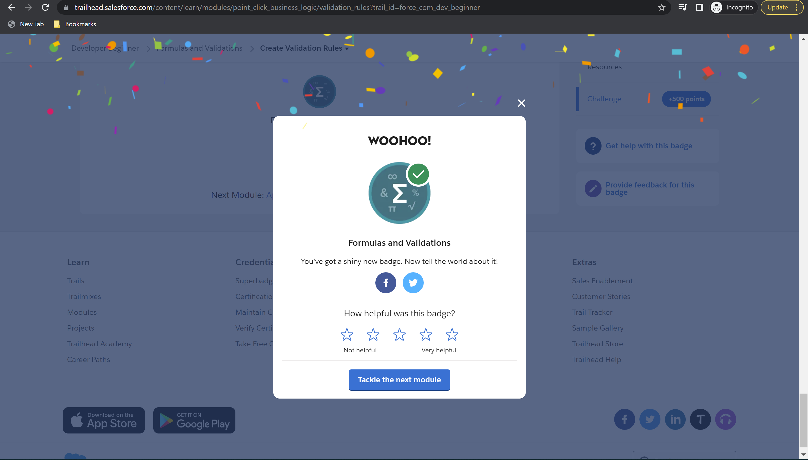

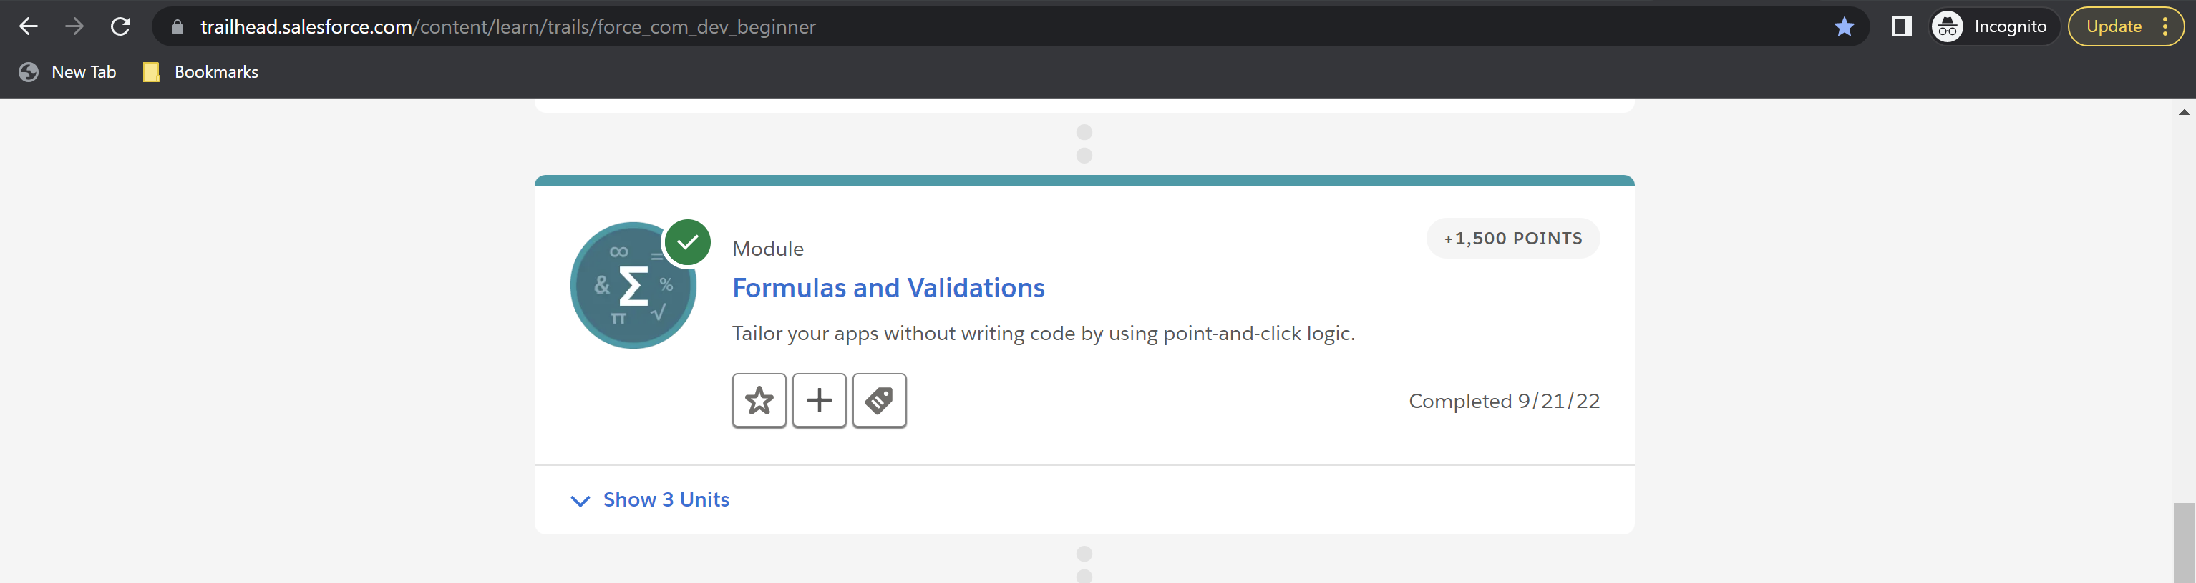

**Module 6: Approve Records with Approval Processes– Total: 600 points, Points Earned: 600 points**

Challenge 1: 100 points earned

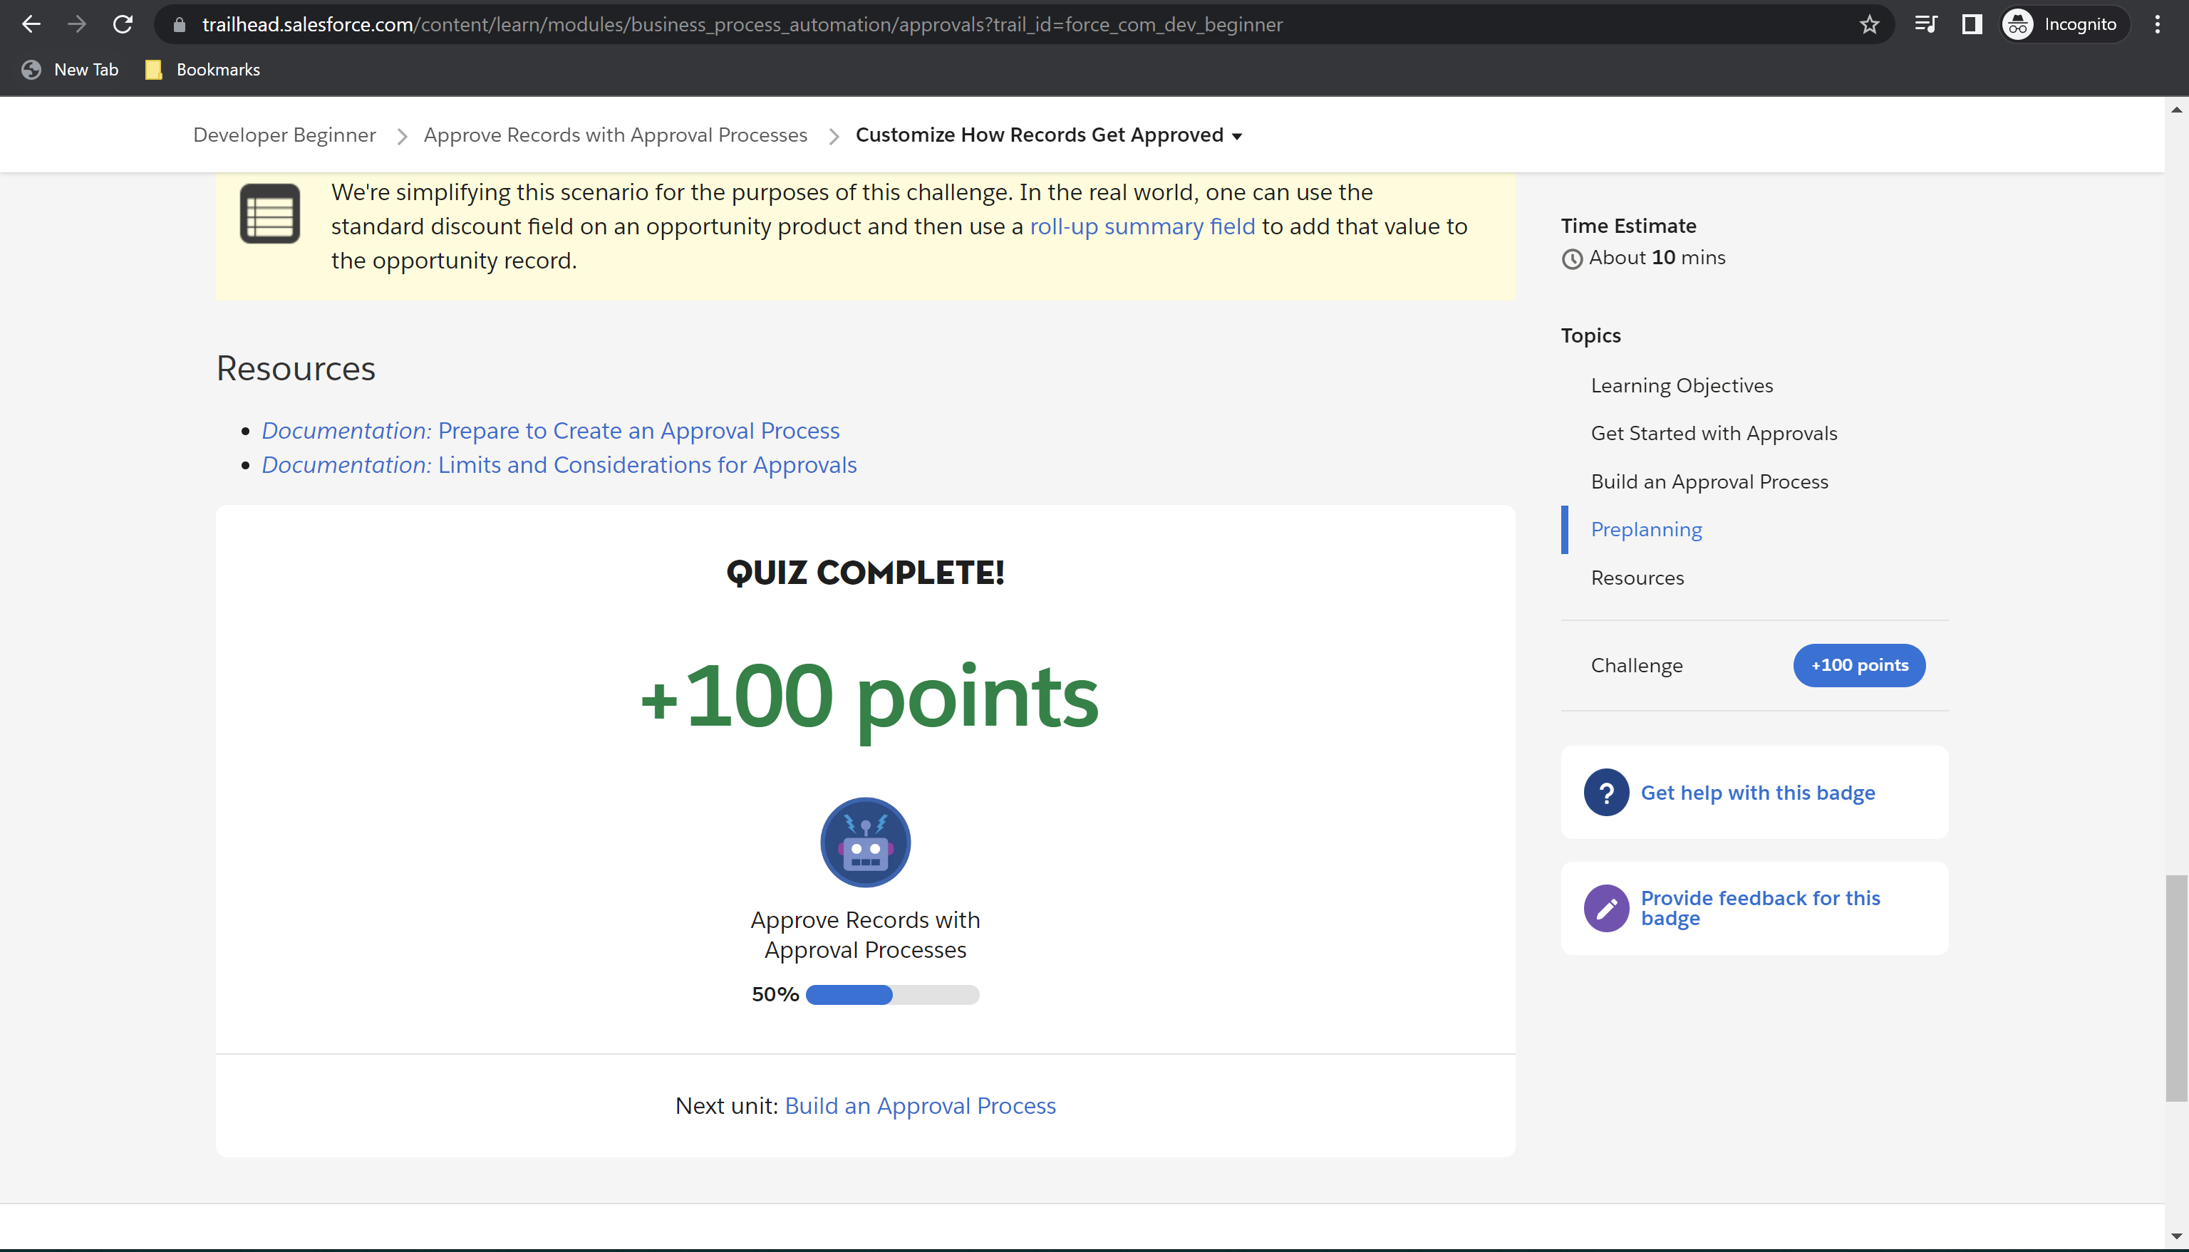

Challenge 2: 500 points earned

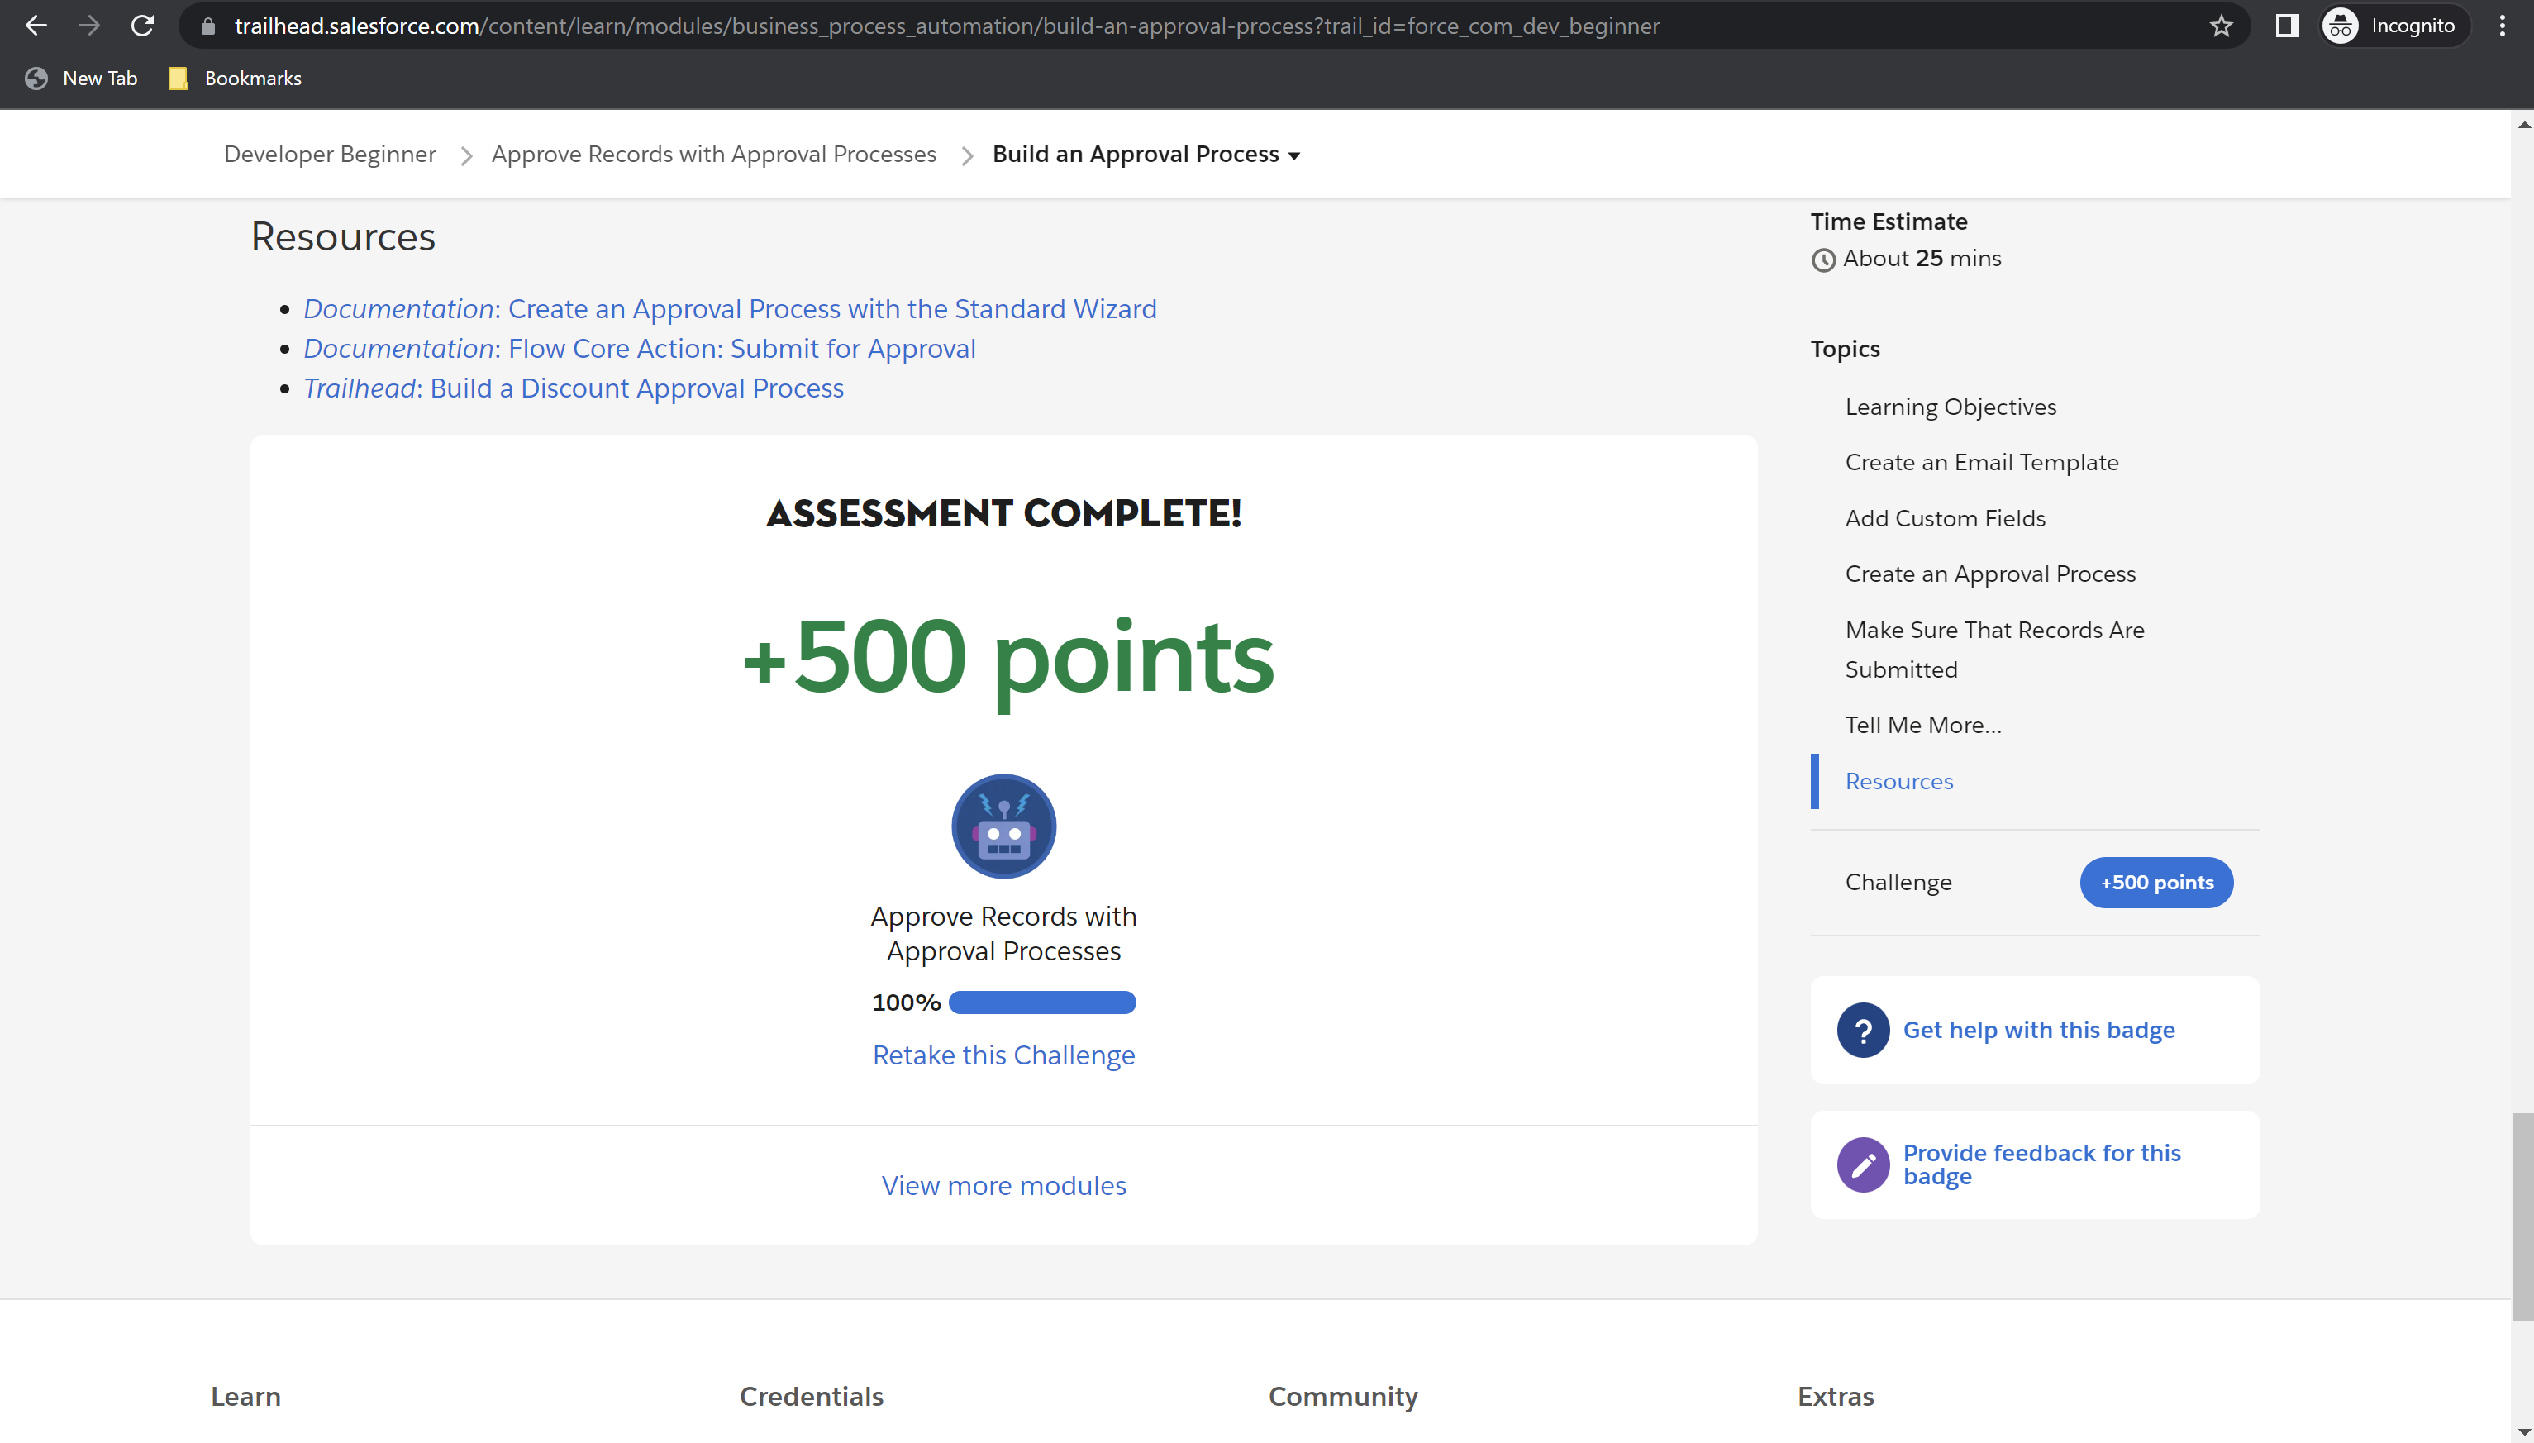

Module Badge earned

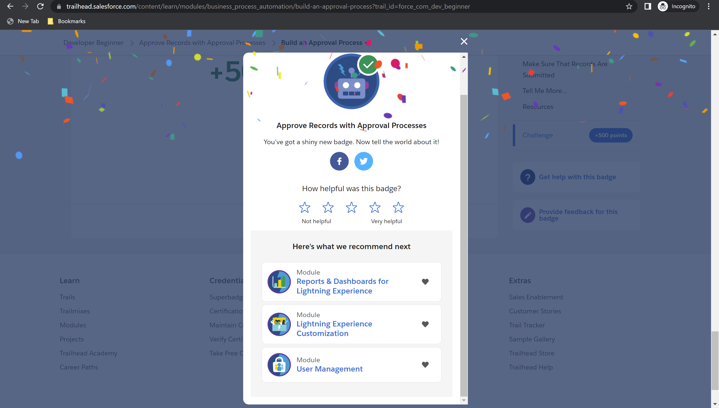

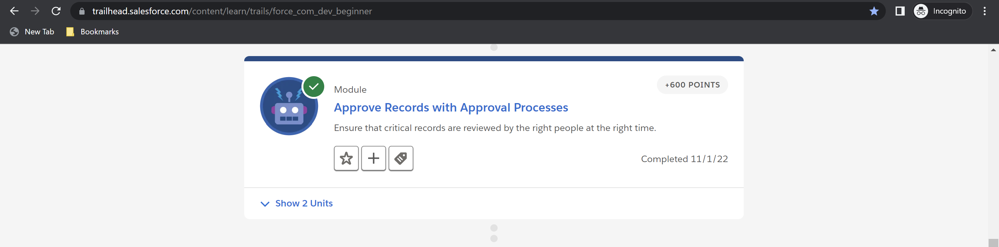

**Module 7: Salesforce Mobile App Customization – Total: 1700 points, Points Earned: 1700 points**

Challenge 1: 100 points earned

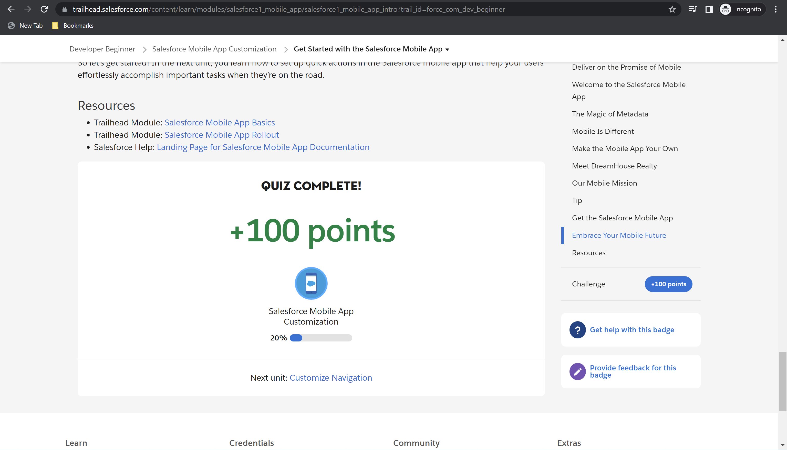

Challenge 2: 100 points earned

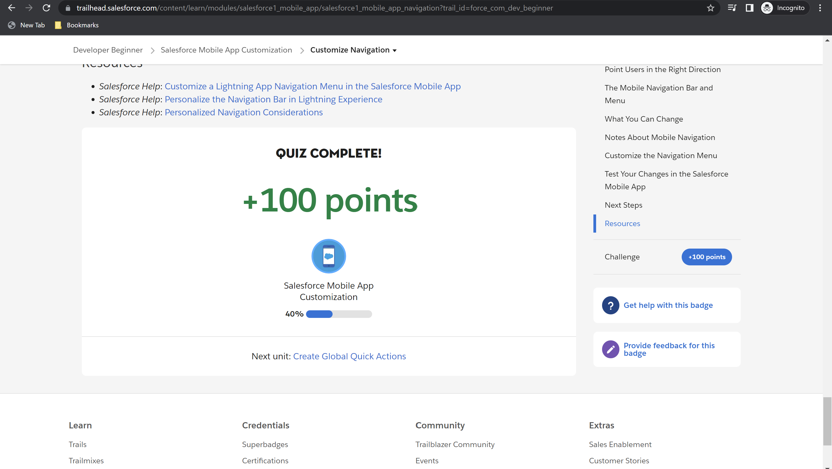

Challenge 3: 500 points earned

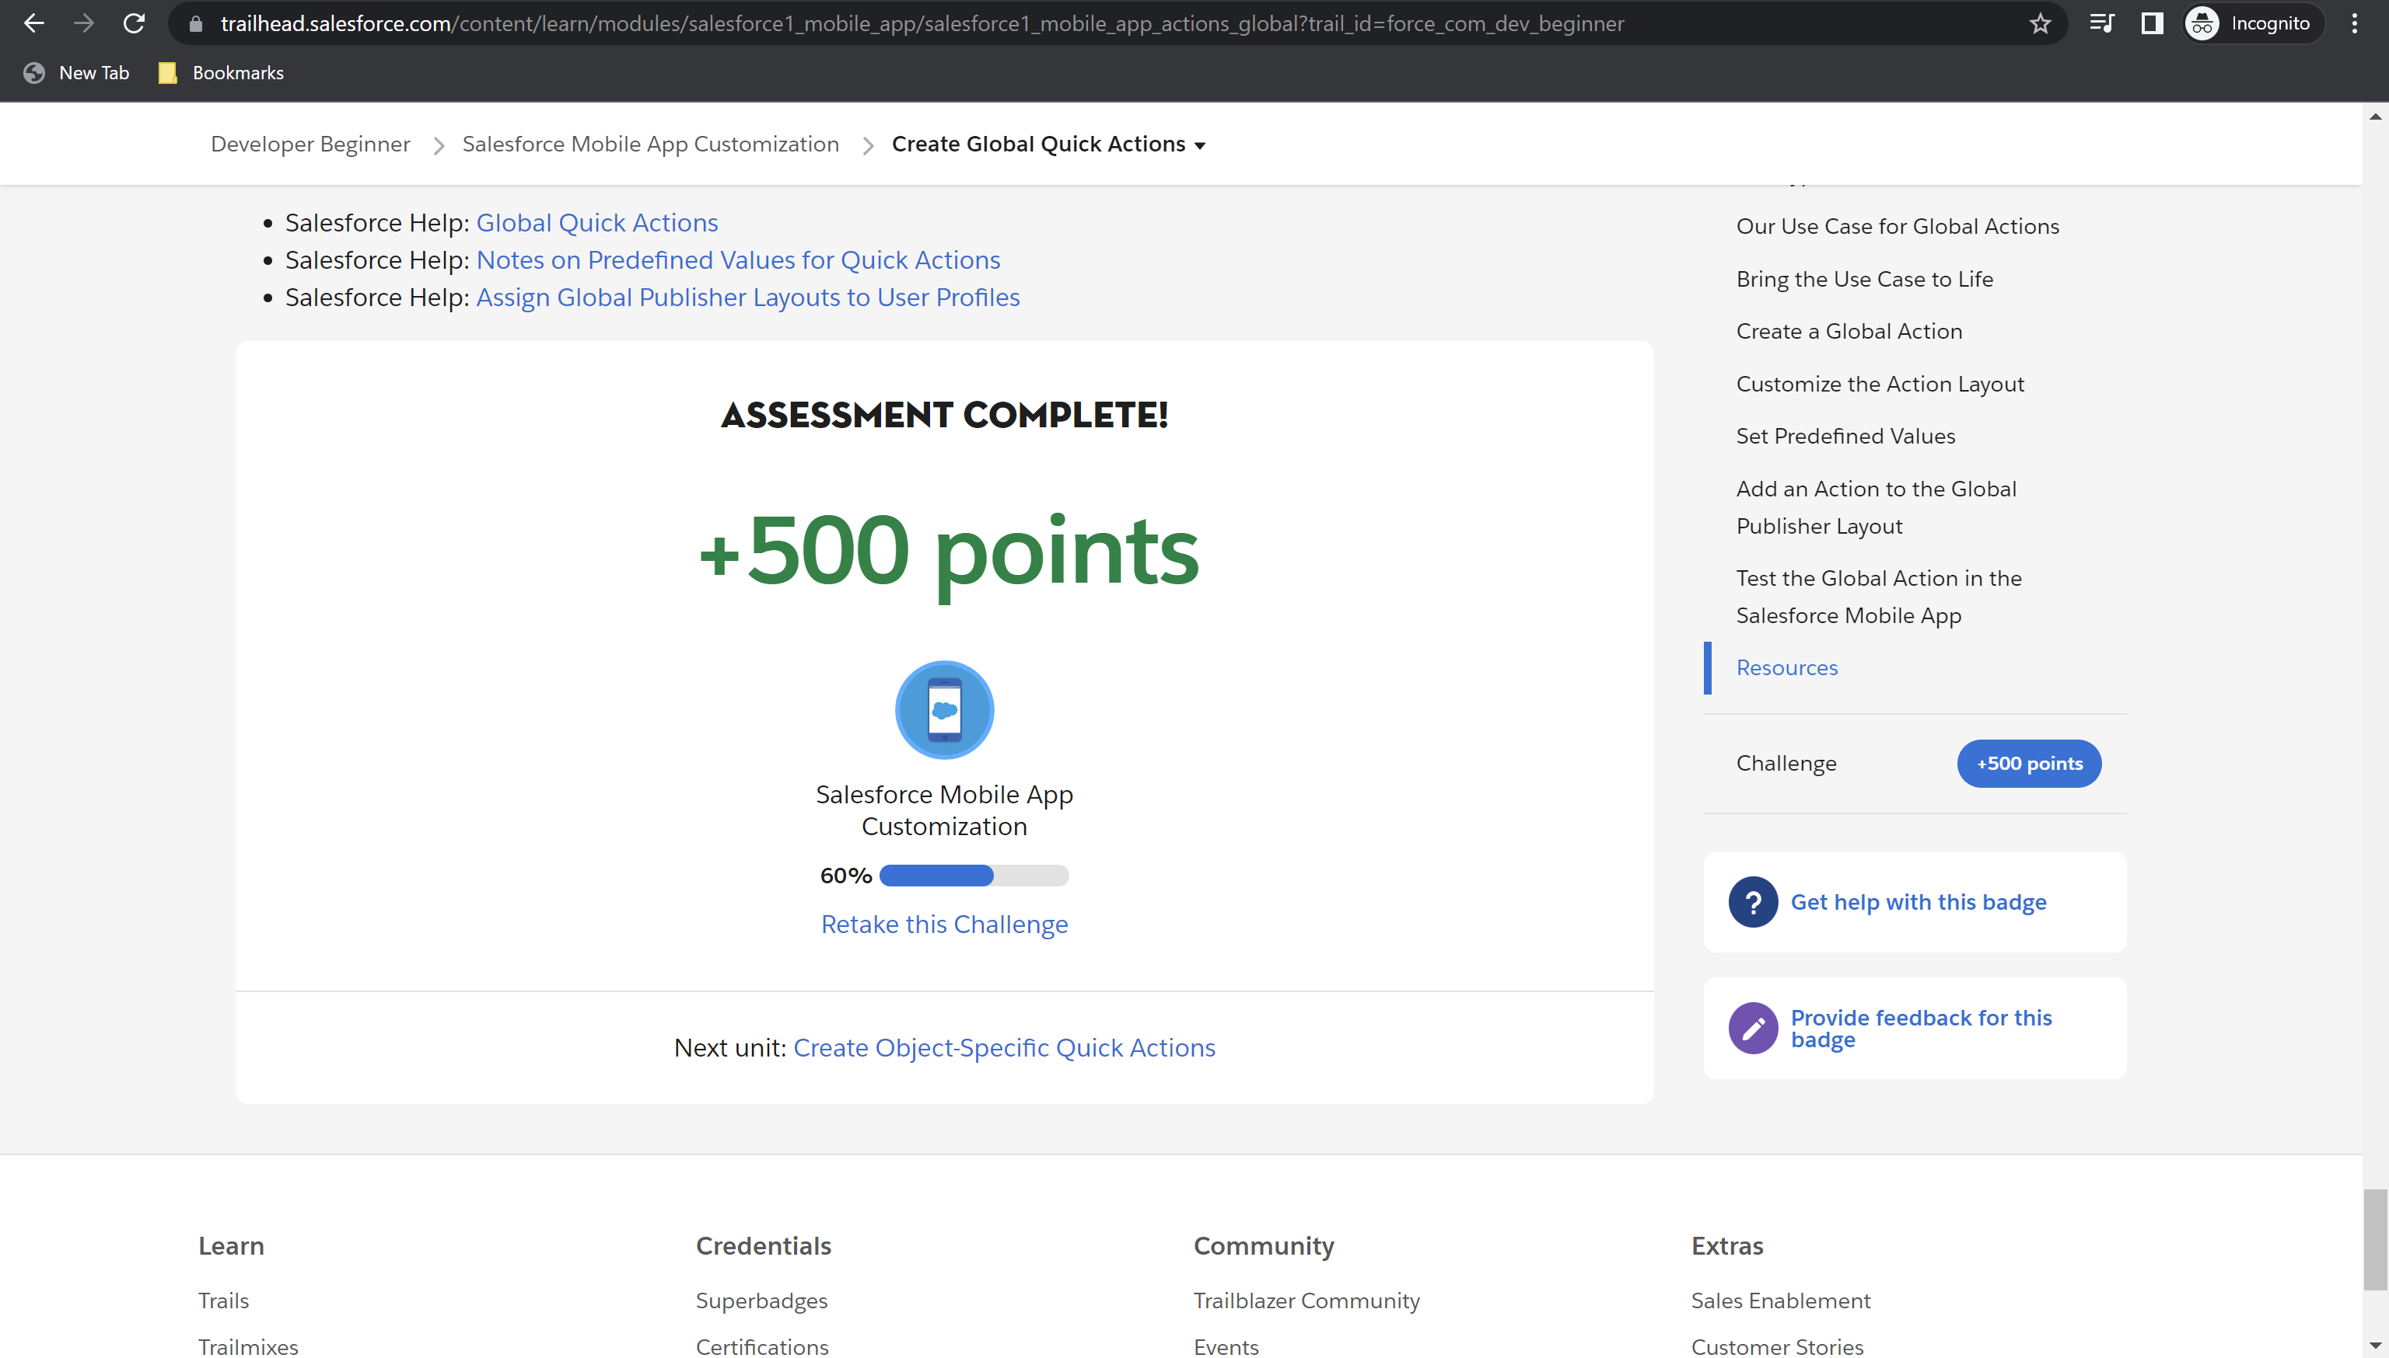

Challenge 4: 500 points earned

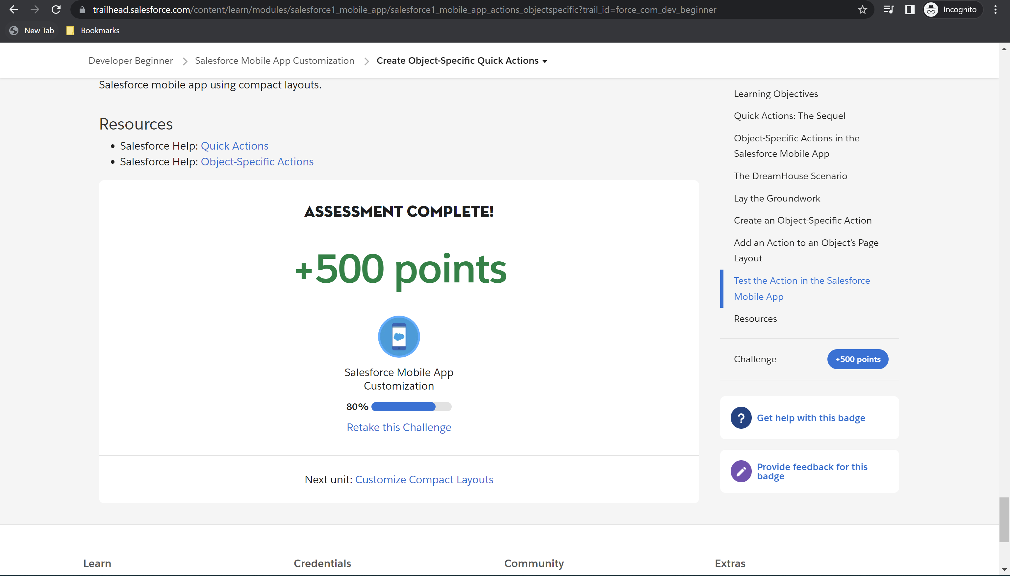

Challenge 5: 500 points earned

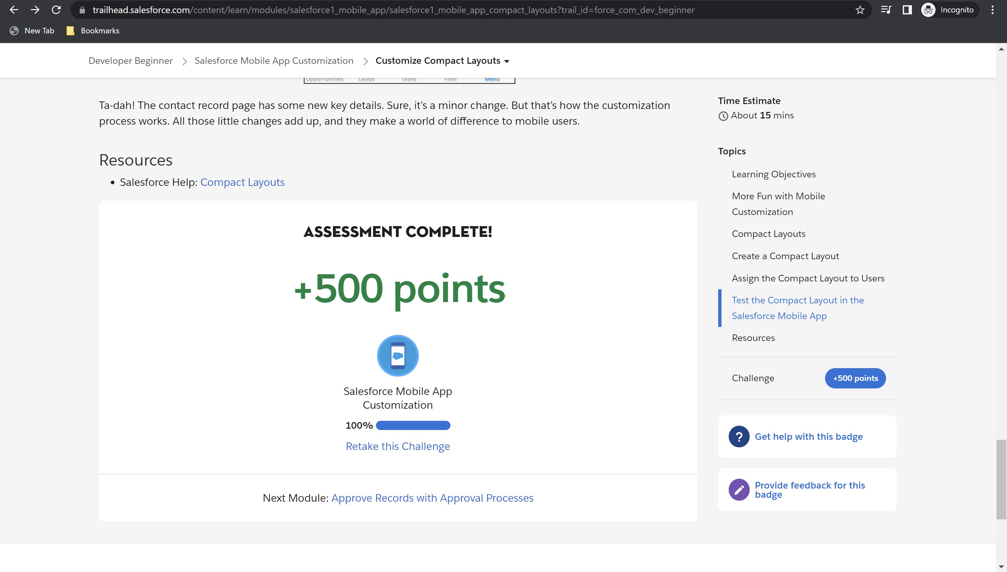

Module Badge earned

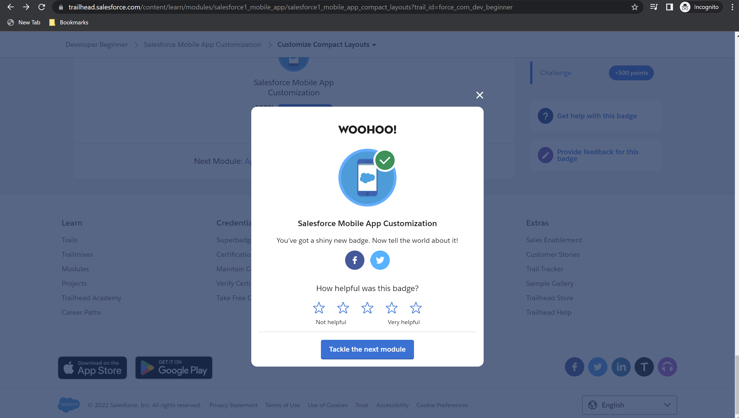

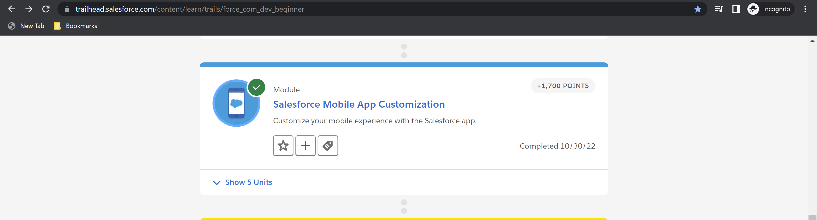

**Module 8: Apex Basics and Database – Total: 2100 points, Points Earned: 2100 points**

Challenge 1: 500 points earned

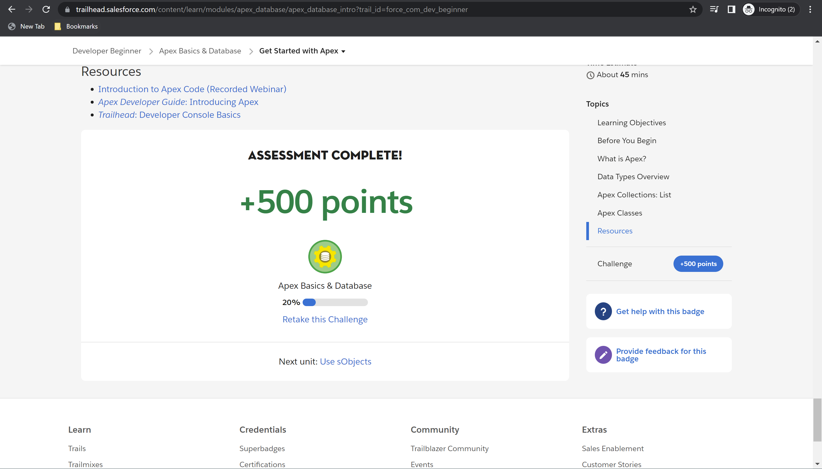

Challenge 2: 100 points

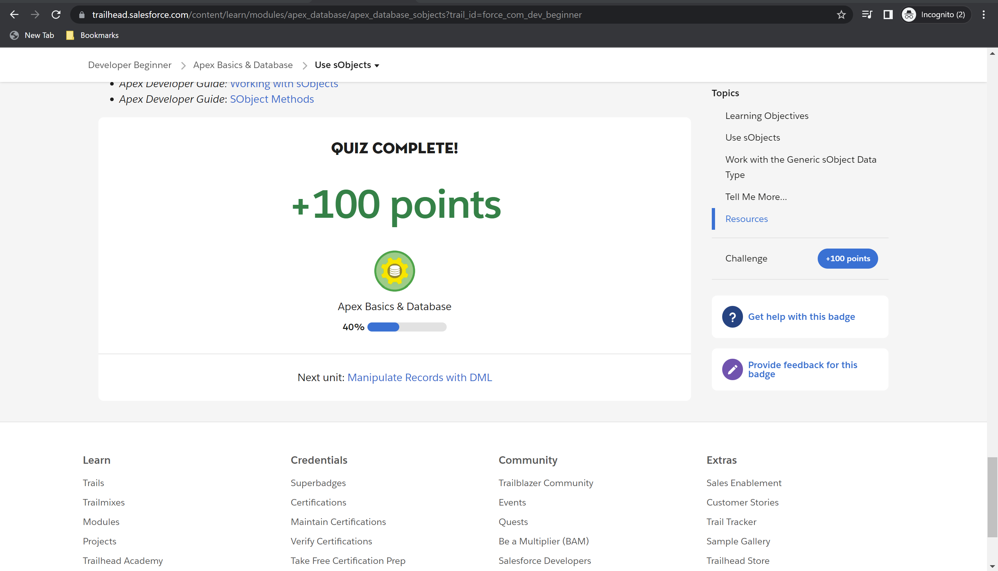

Challenge 3: 500 points earned

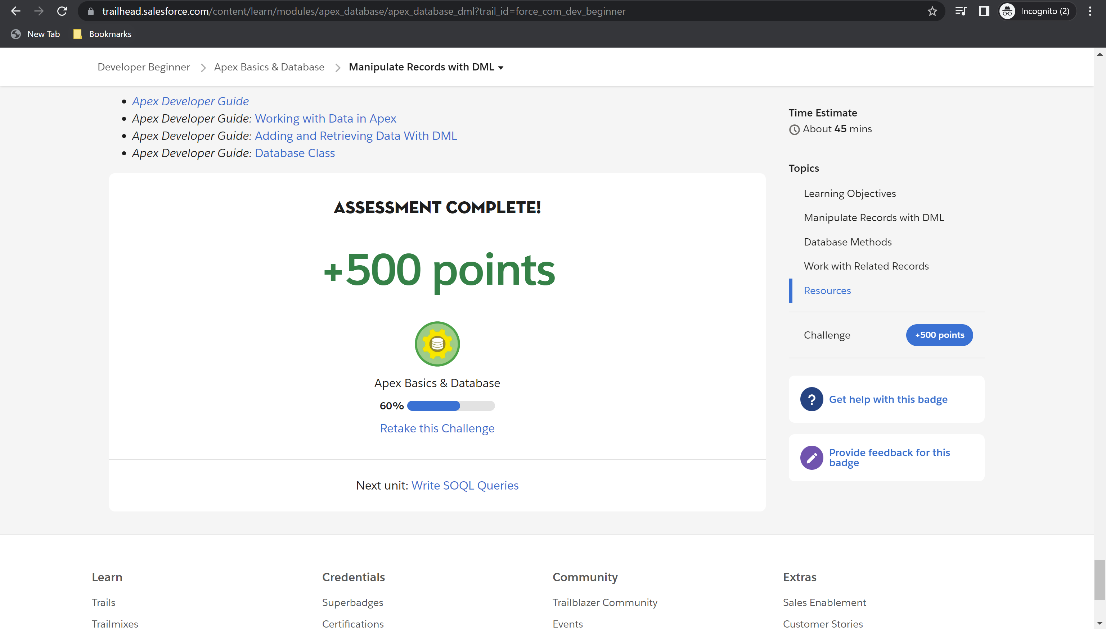

Challenge 4: 500 points earned

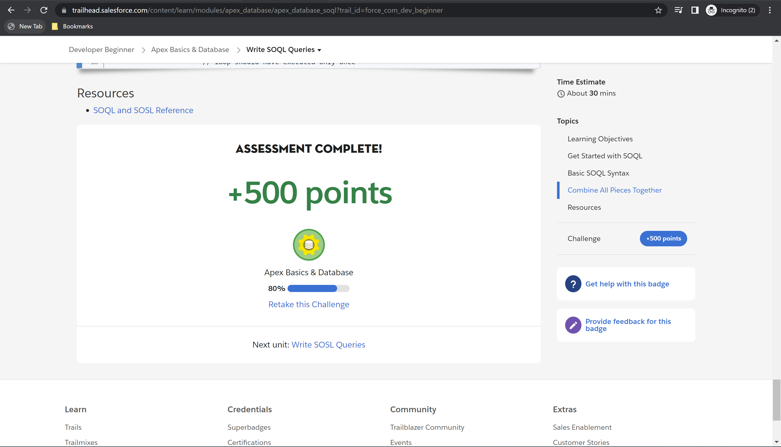

Challenge 5: 500 points earned

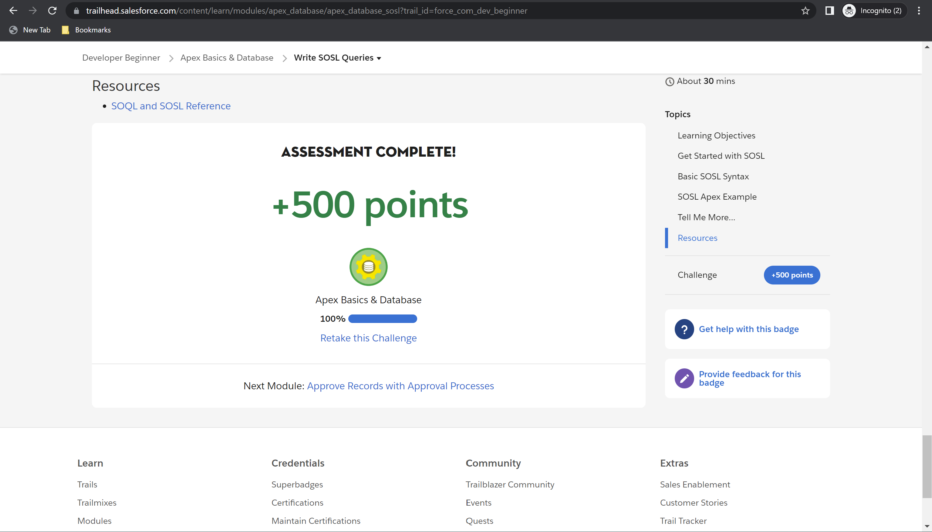

Module Badge earned

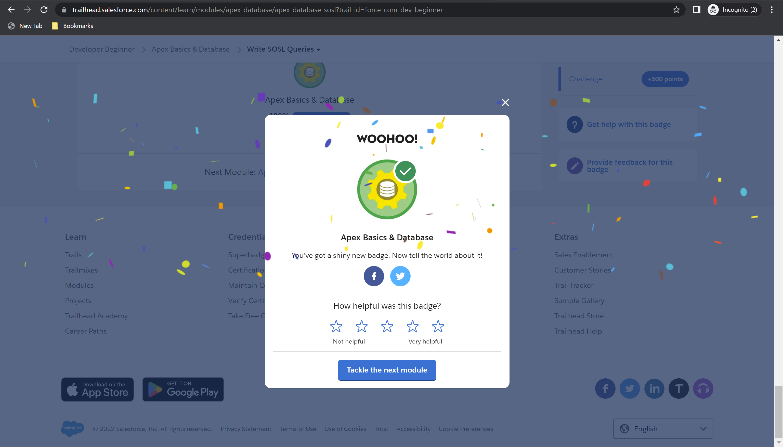

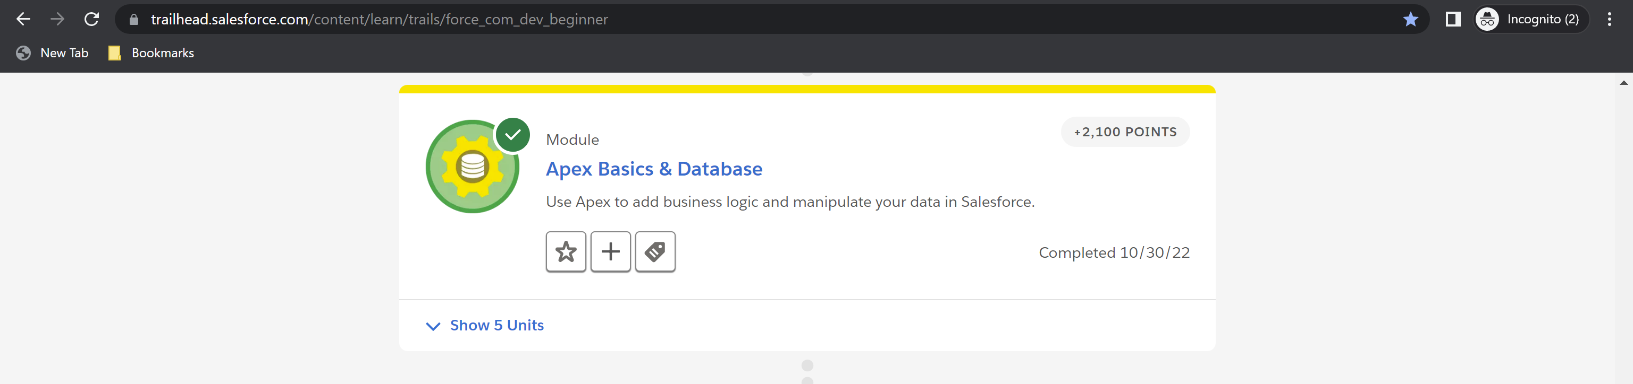

**Module 9: Apex Triggers – Total: 1000 points, Points Earned: 1000 points**

Challenge 1: 500 points earned

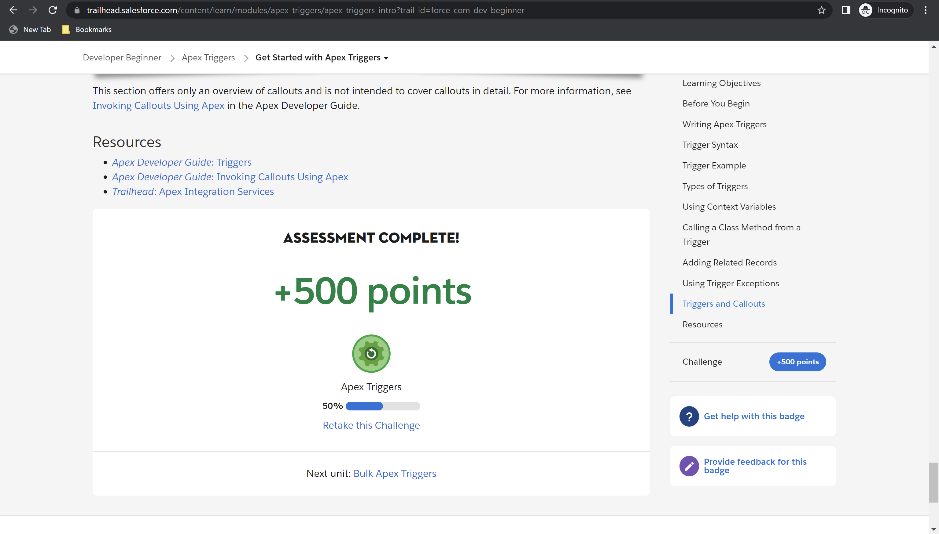

Challenge 2: 500 points earned

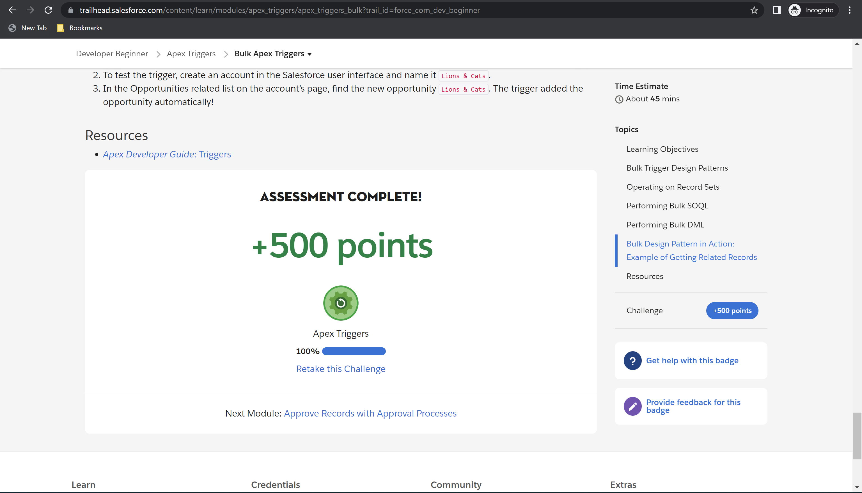

Module Badge earned

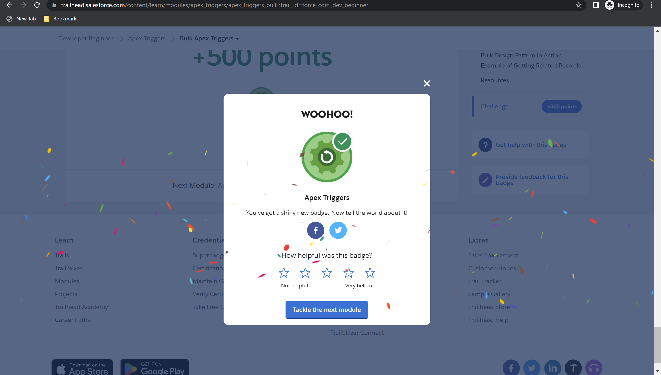

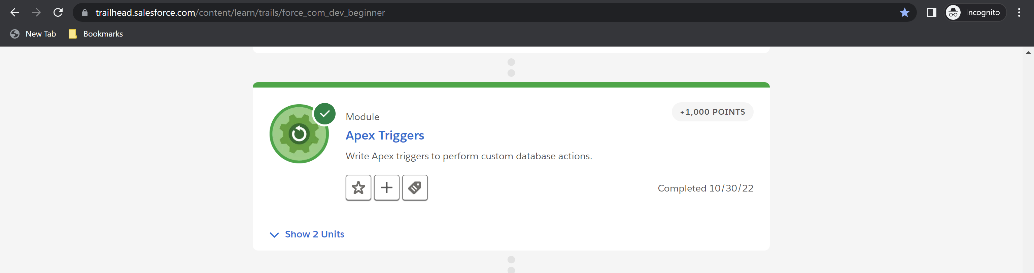

**Module 10: Apex Testing – Total: 1500 points, Points Earned: 1500 points**

Challenge 1: 500 points earned

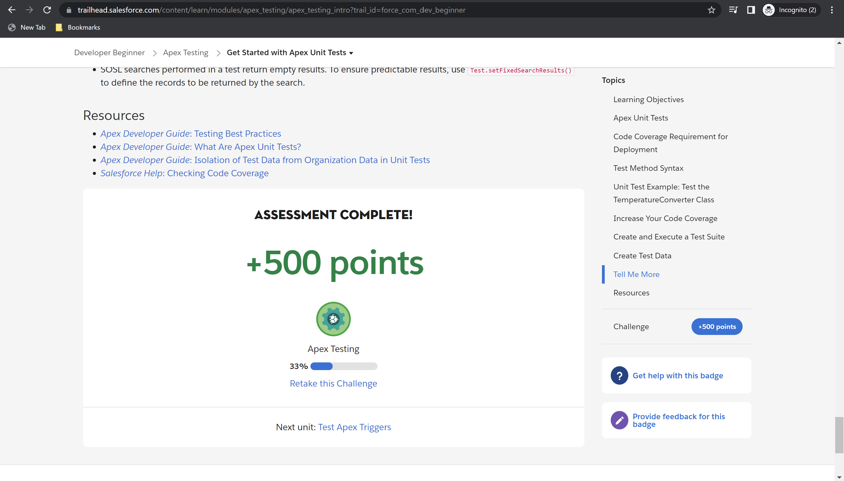

Challenge 2: 500 points earned

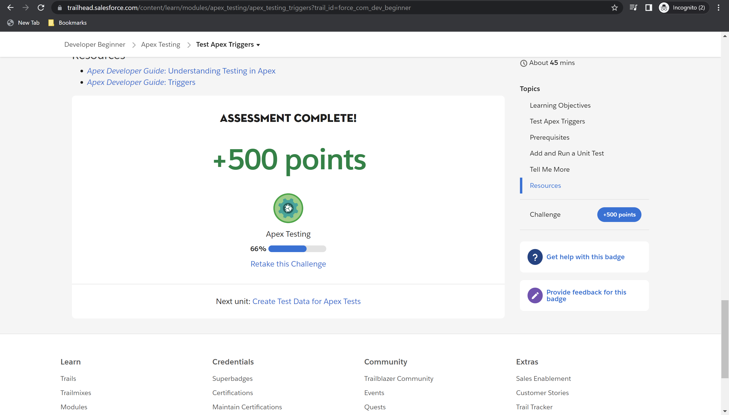

Challenge 3: 500 points earned

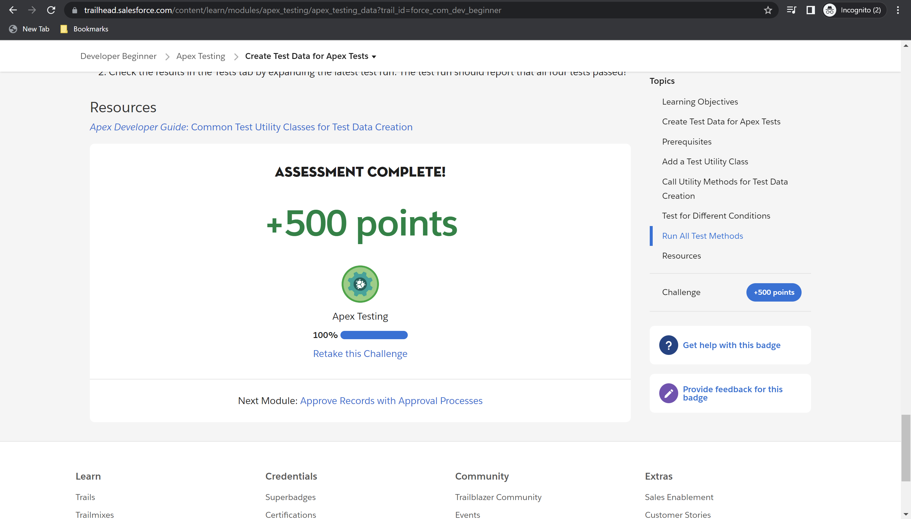

Module Badge earned

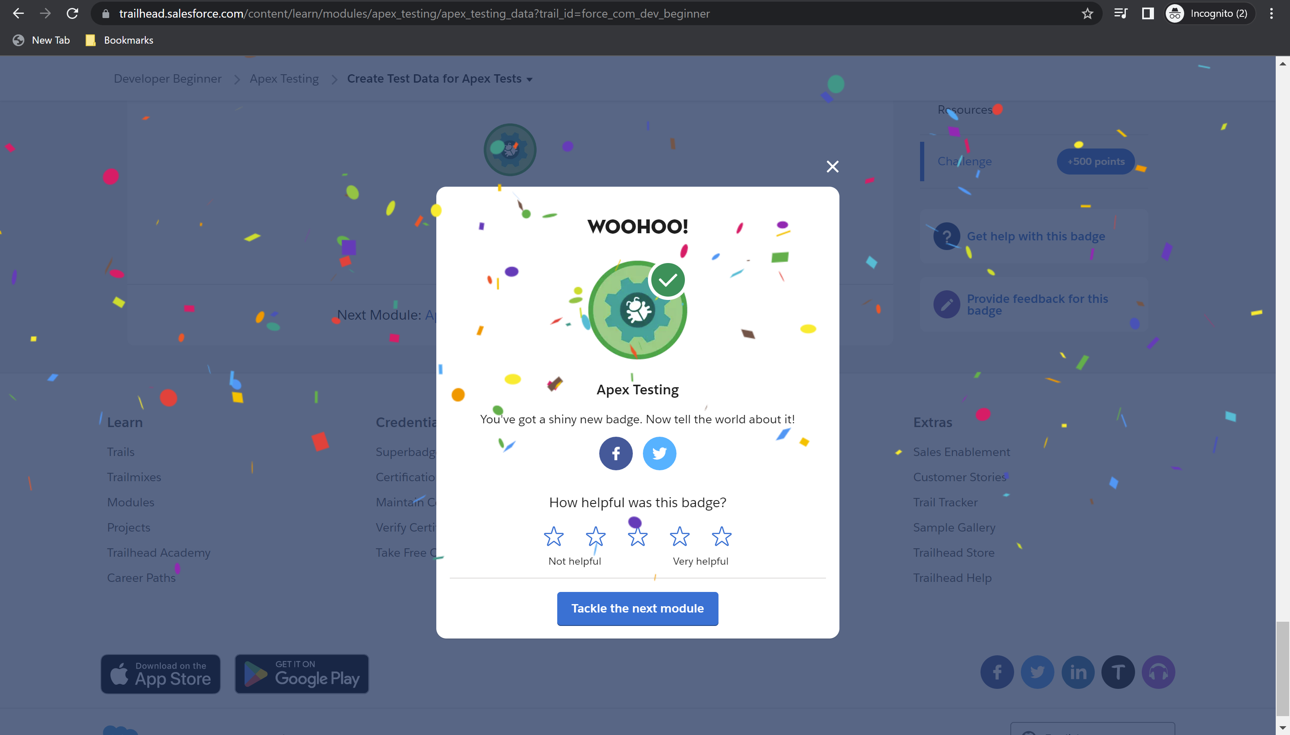

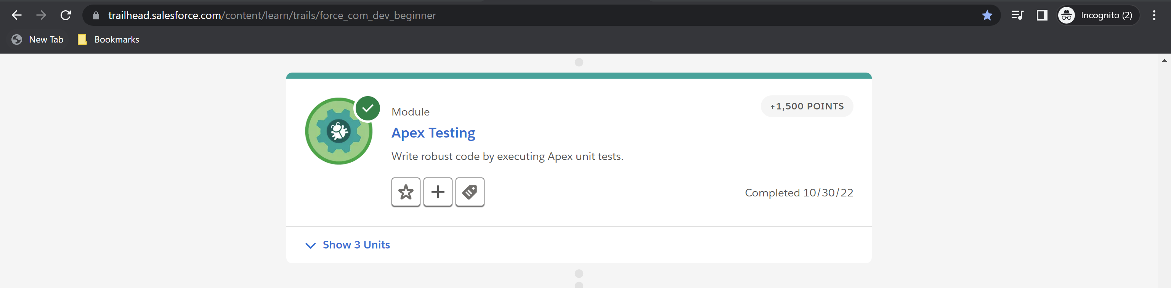

**Module 11: Visualforce Basics – Total: 4100 points, Points Earned: 4100 points**

Challenge 1: 100 points earned

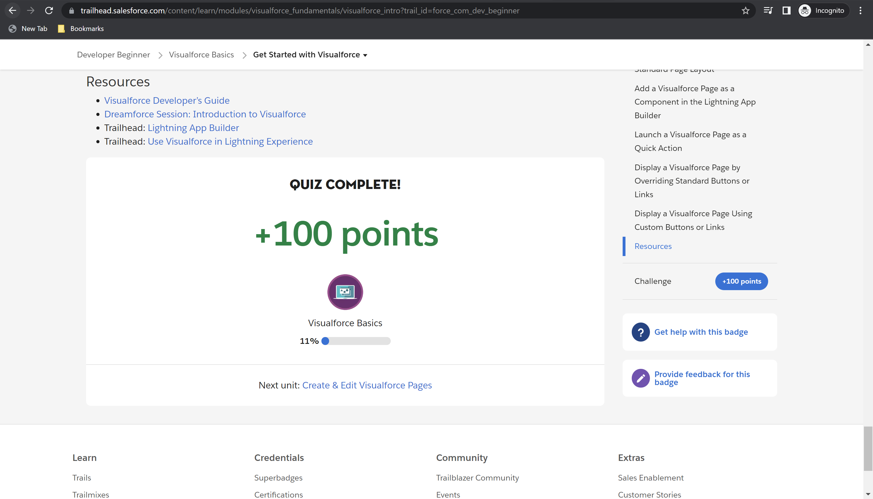

Challenge 2: 500 points earned

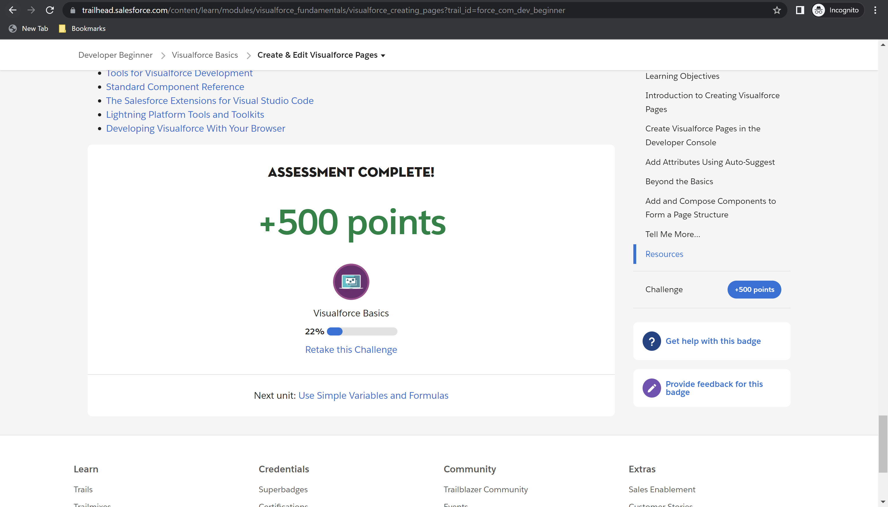

Challenge 3: 500 points earned

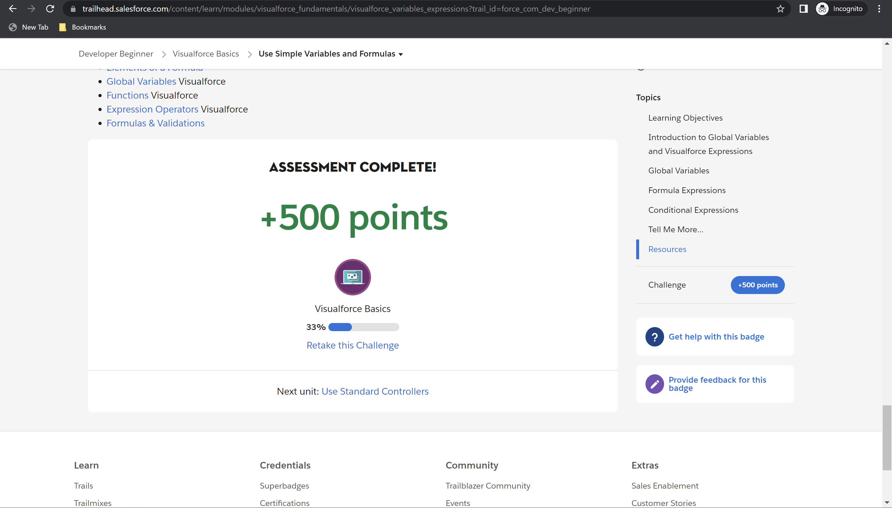

Challenge 4: 500 points earned

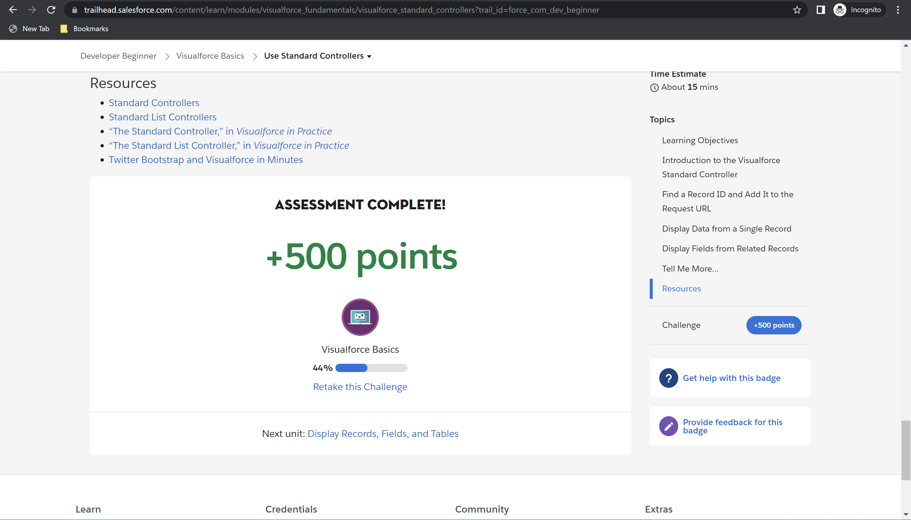

Challenge 5: 500 points earned

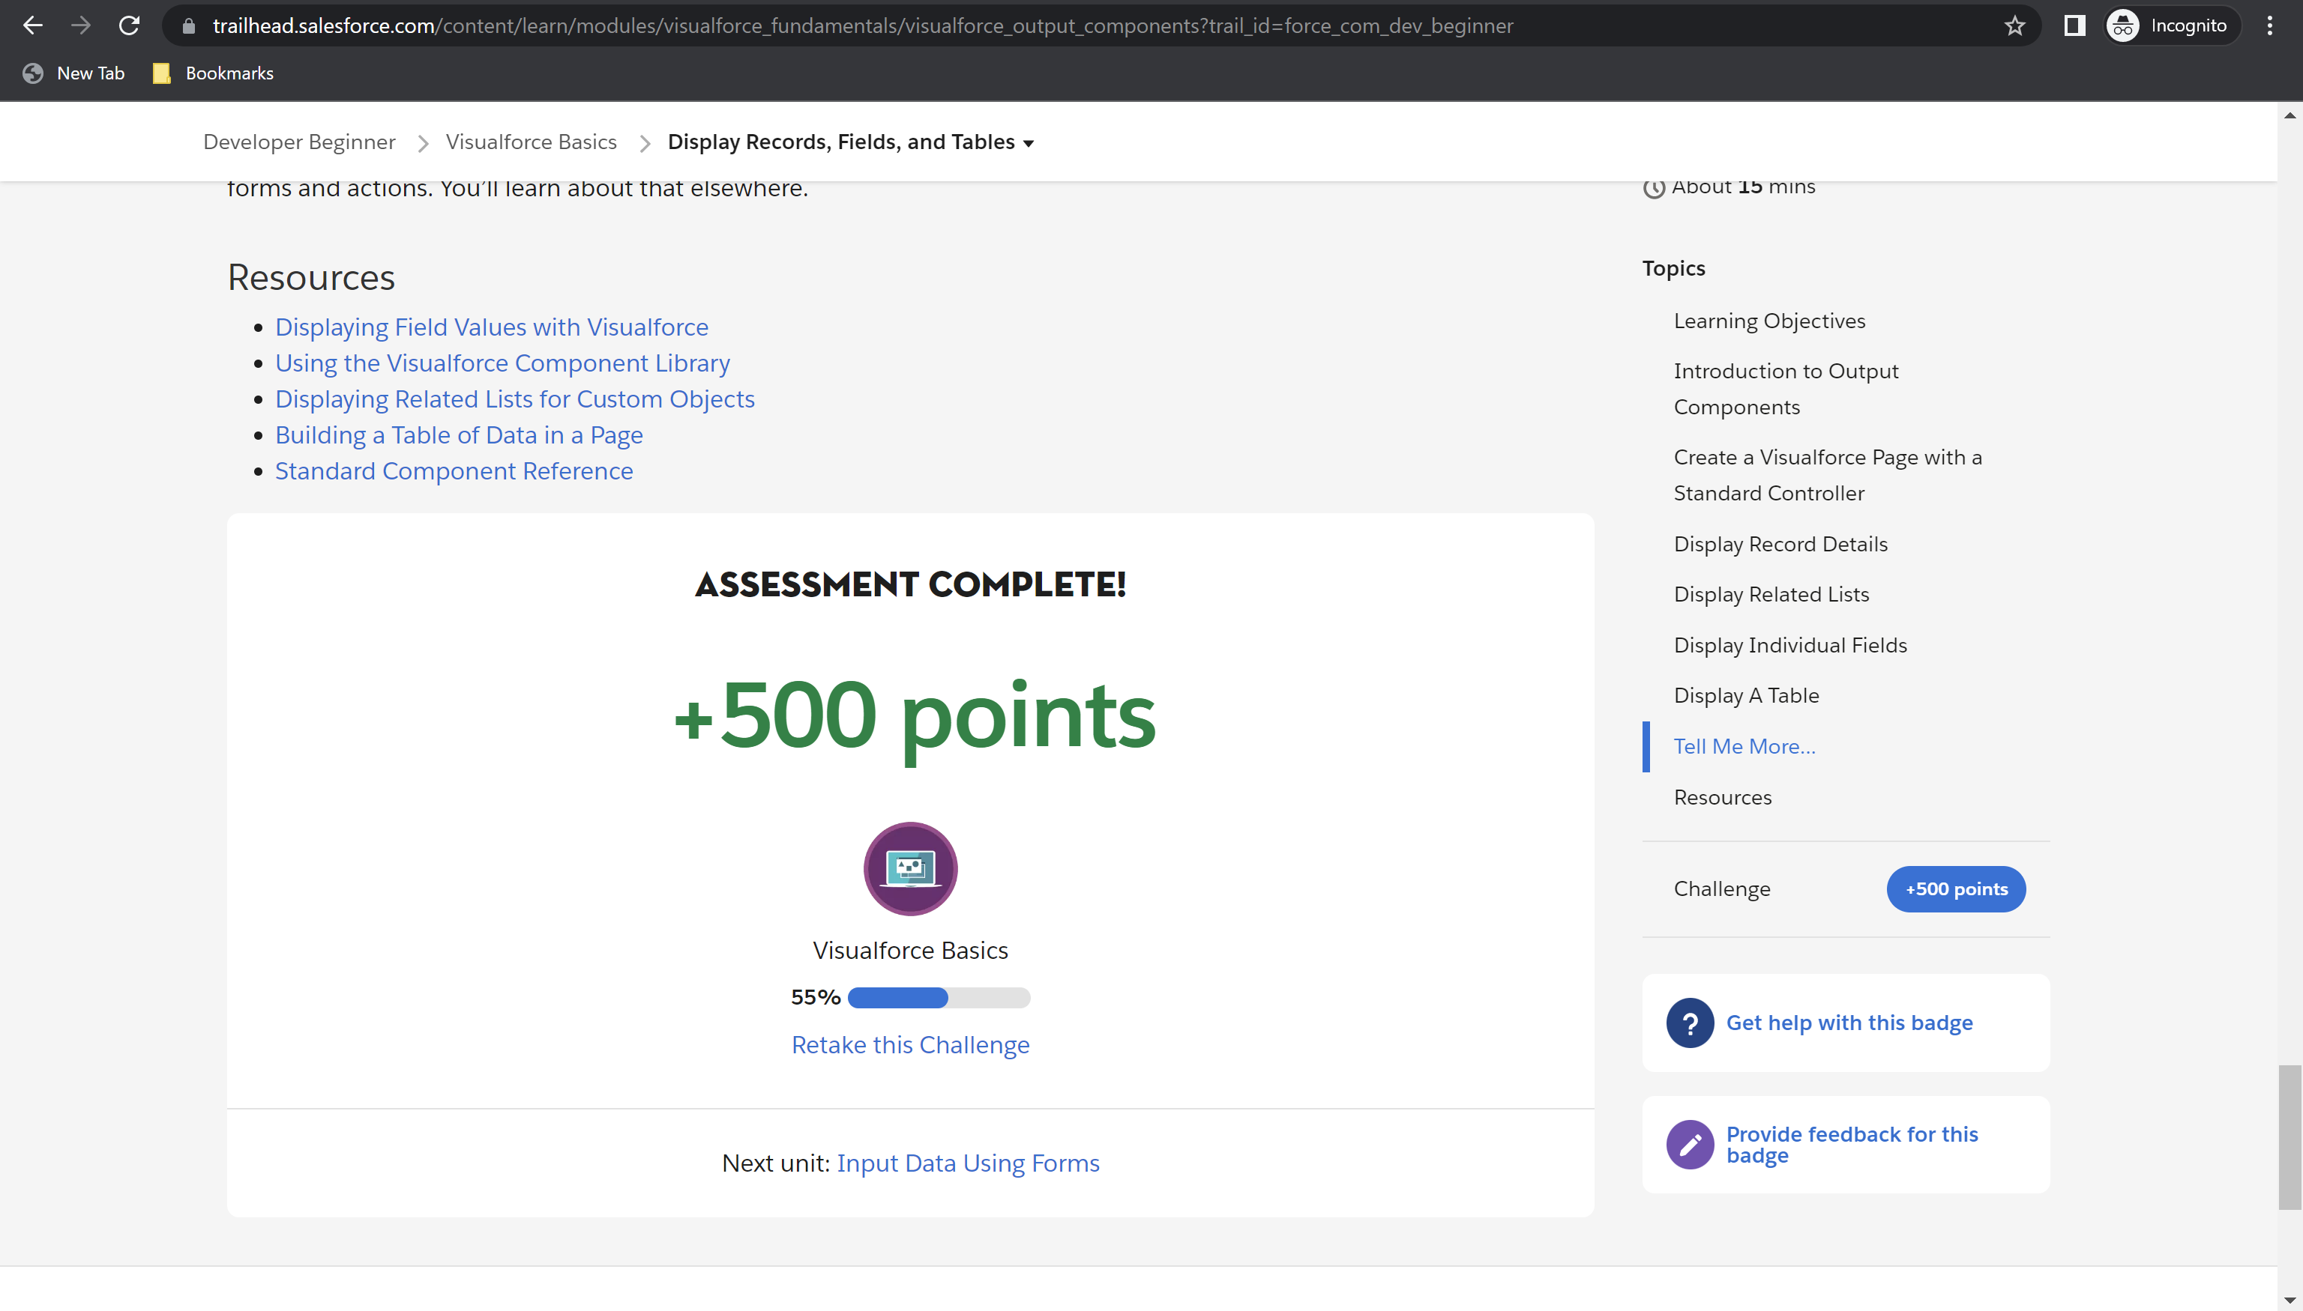

Challenge 6: 500 points earned

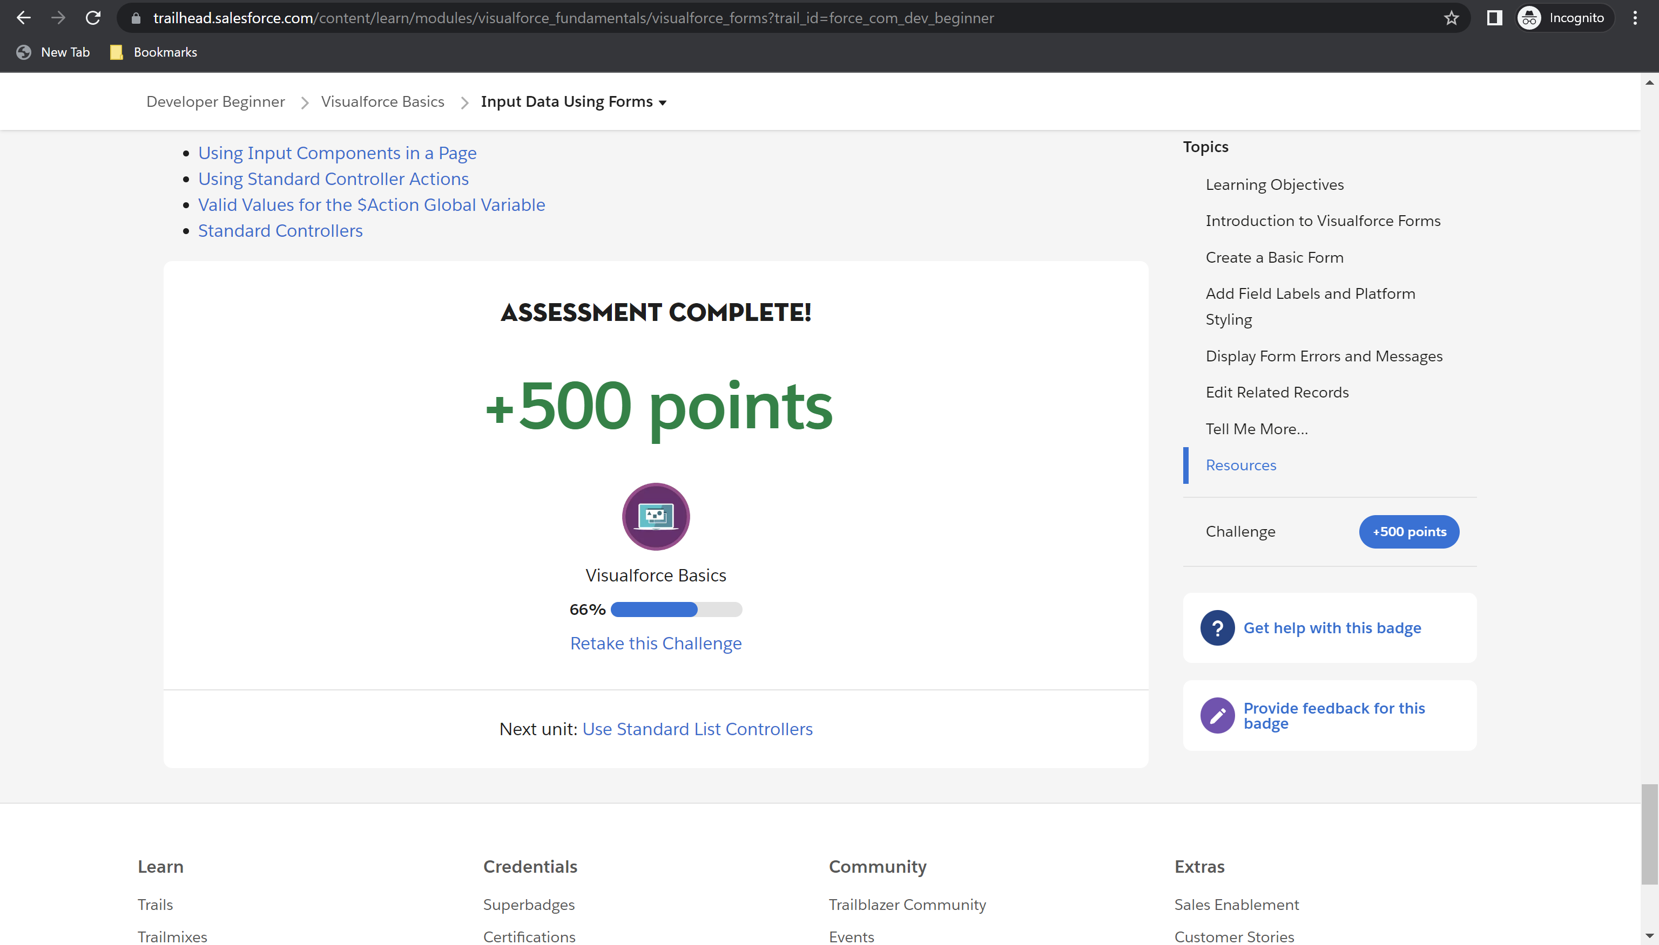

Challenge 7: 500 points earned

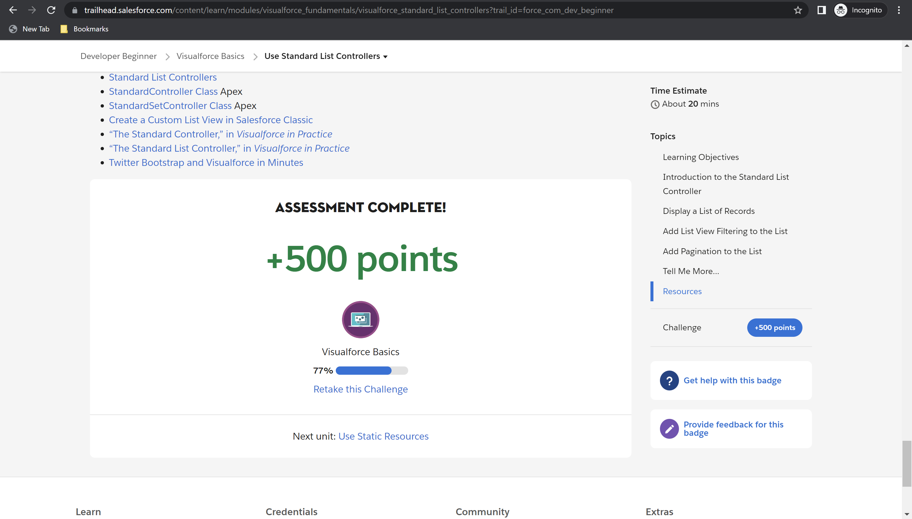

Challenge 8: 500 points earned

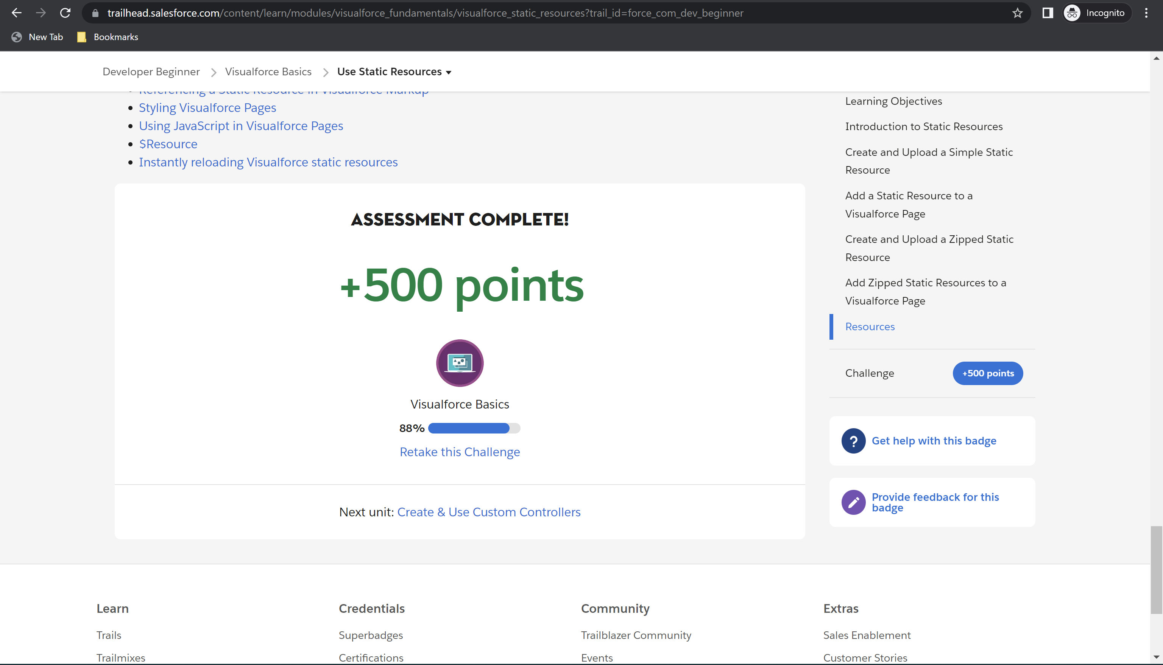

Challenge 9: 500 points earned

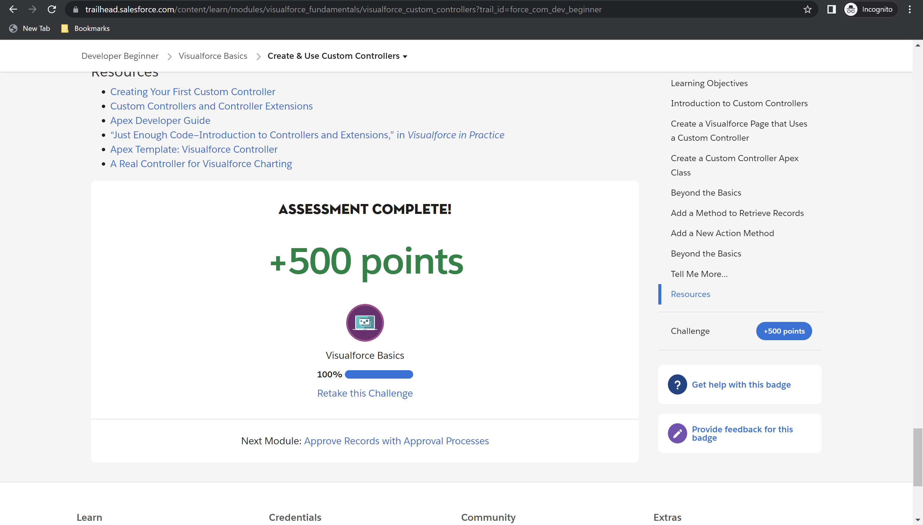

Module Badge earned

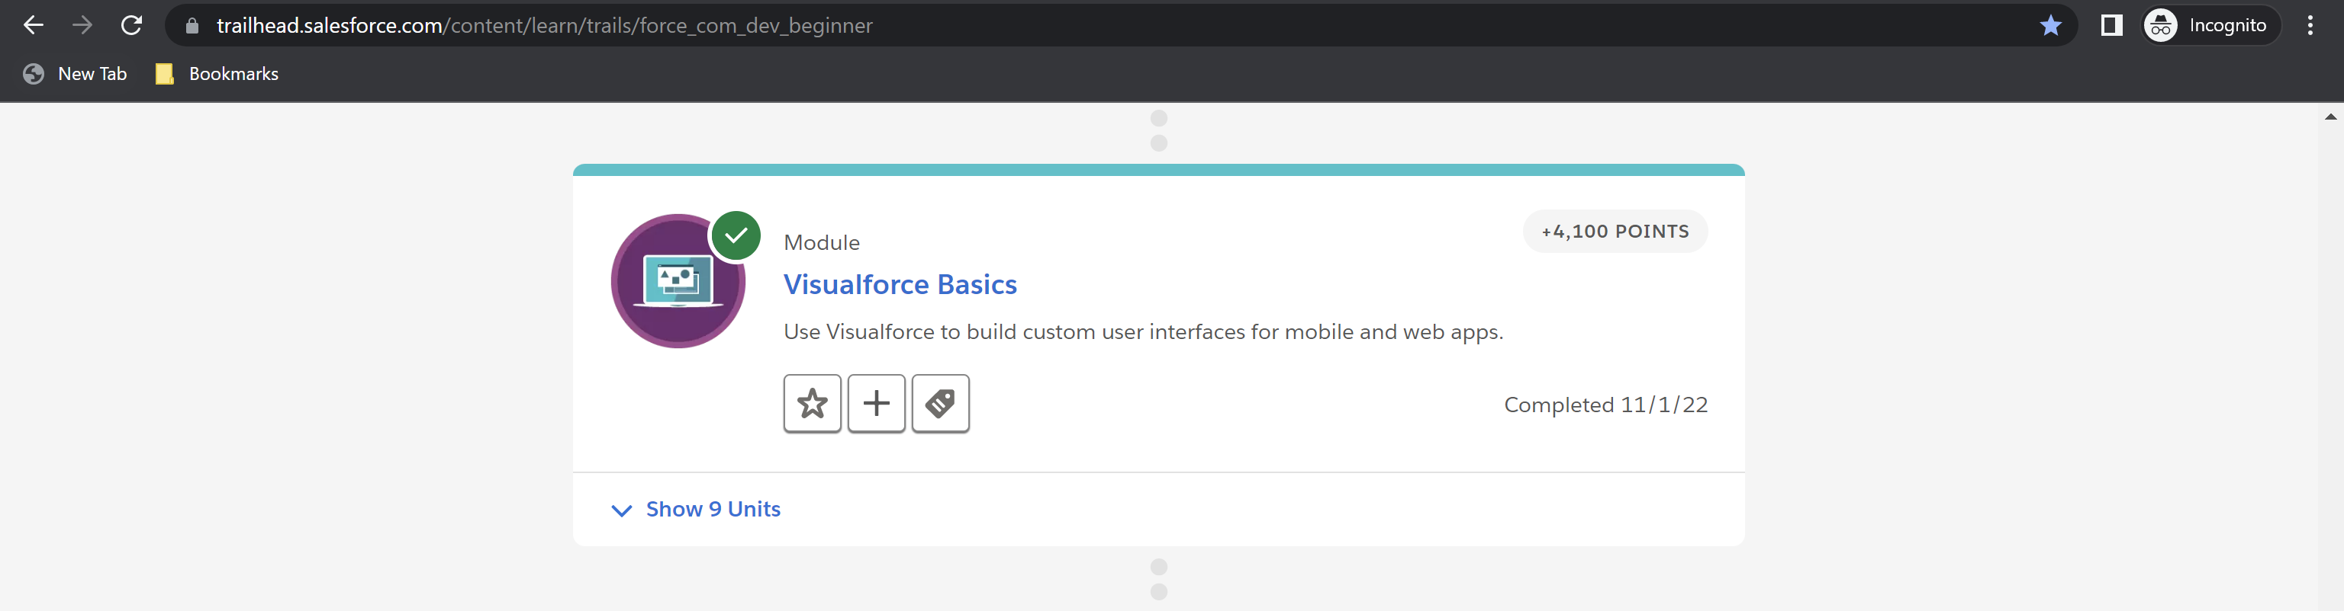

**Module 12: Developer Console Basics – Total: 2100 points, Points Earned: 2100 points**

Challenge 1: 100 points earned

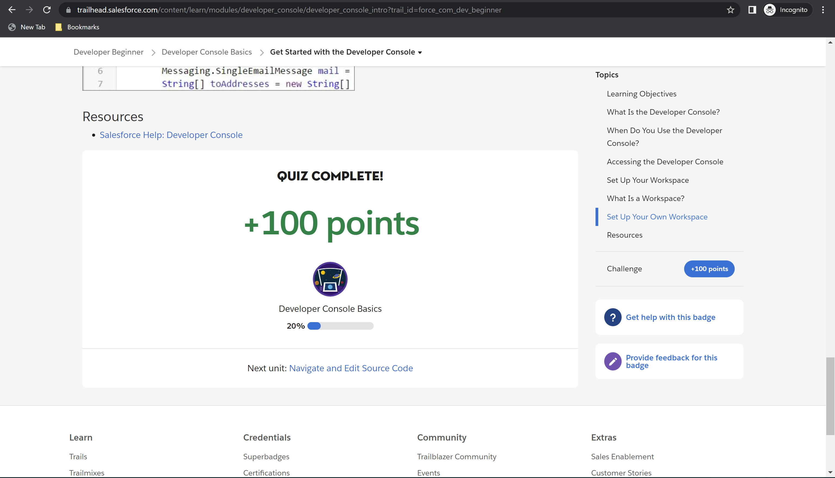

Challenge 2: 500 points earned

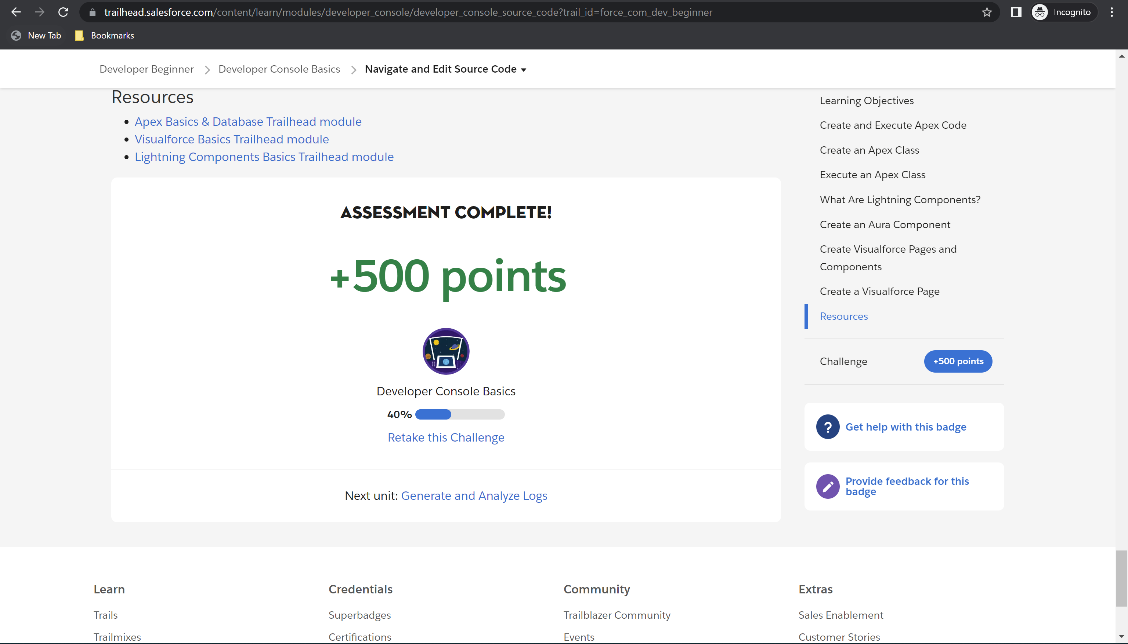

Challenge 3: 500 points earned

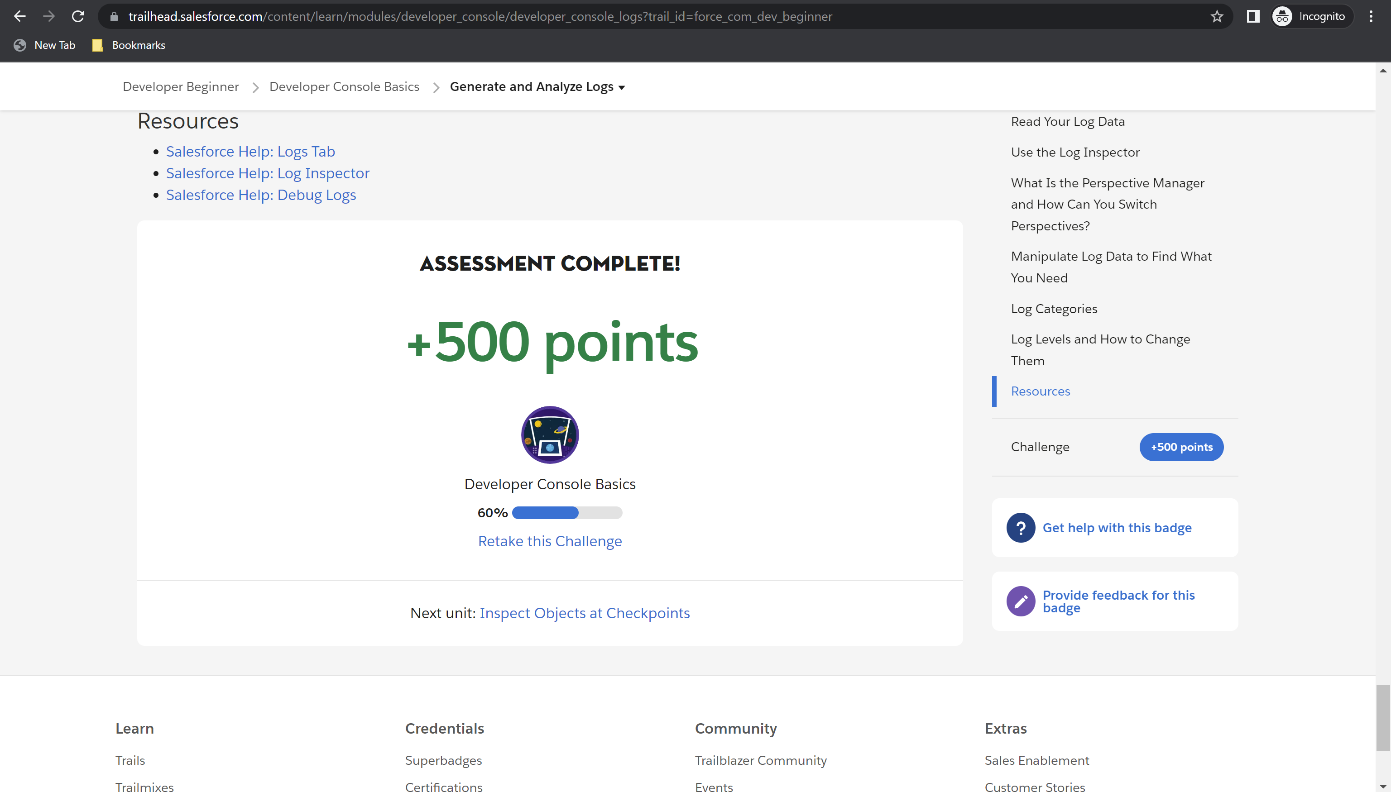

Challenge 4: 500 points earned

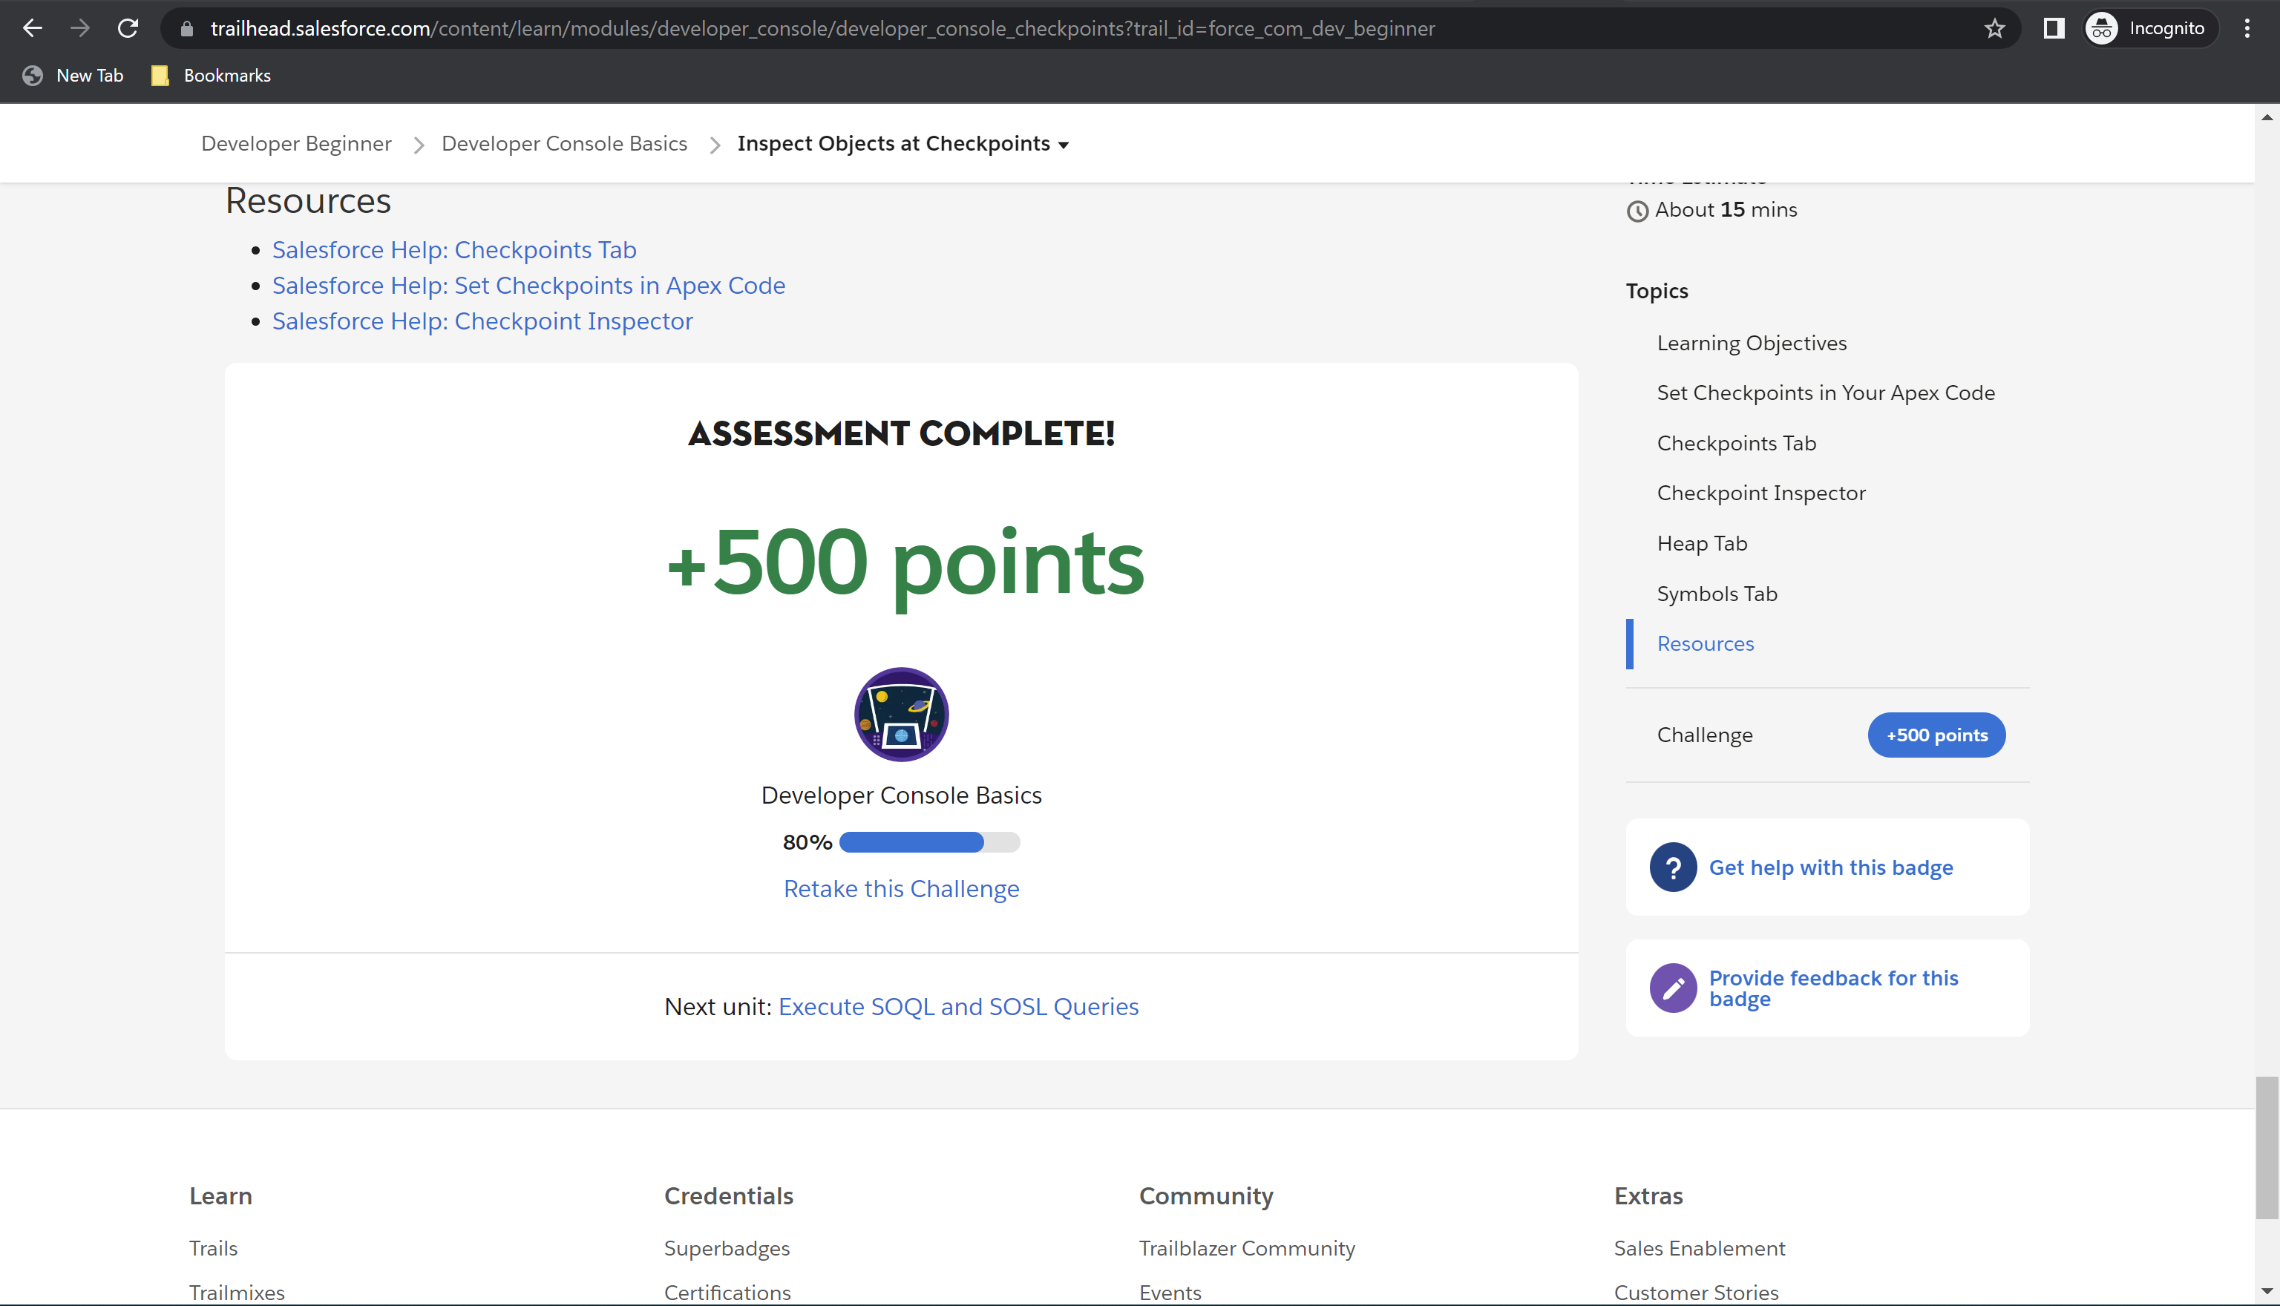

Challenge 5: 500 points earned

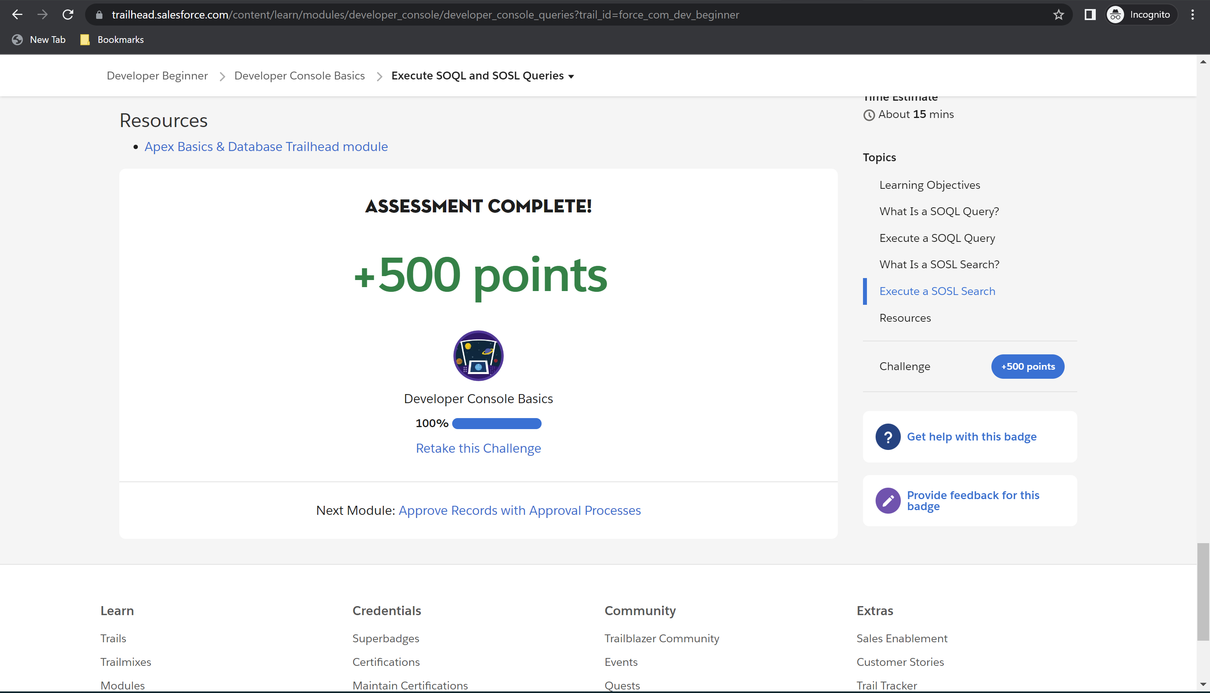

Module Badge earned

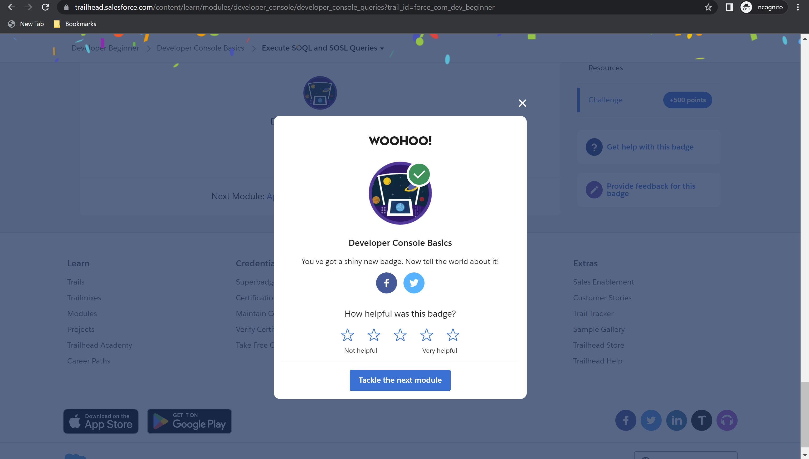

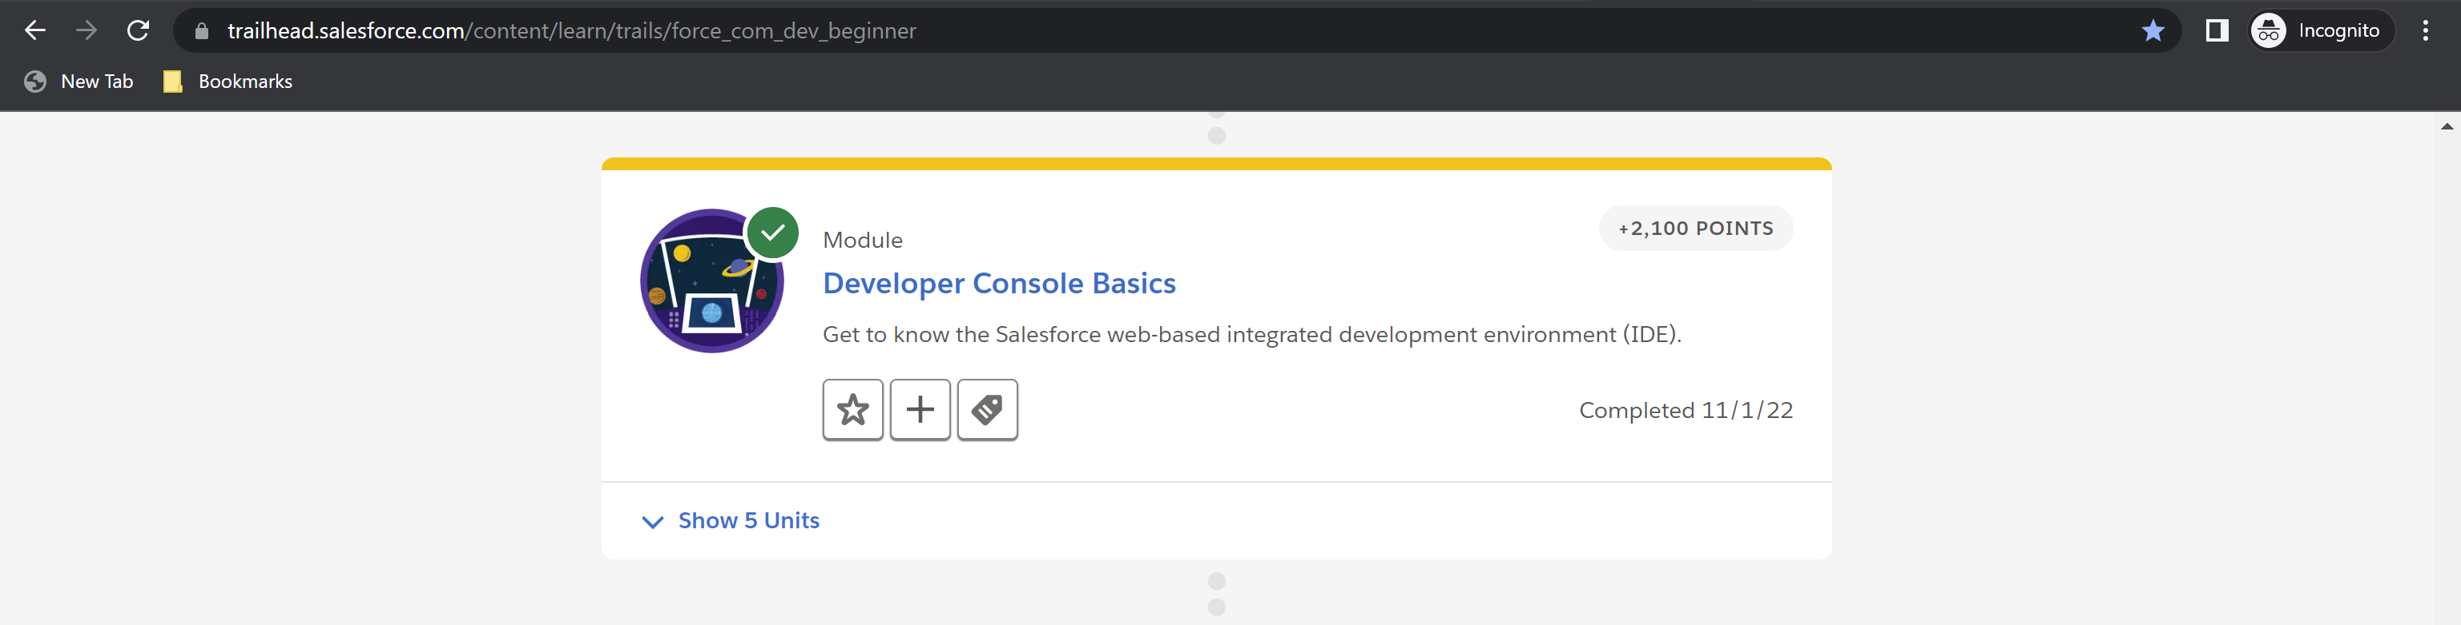

**Module 13: Quick Start: Visual Studio Code for Salesforce Development – Total: 300 points, Points Earned: 300 points**

Challenge 1: 100 points earned

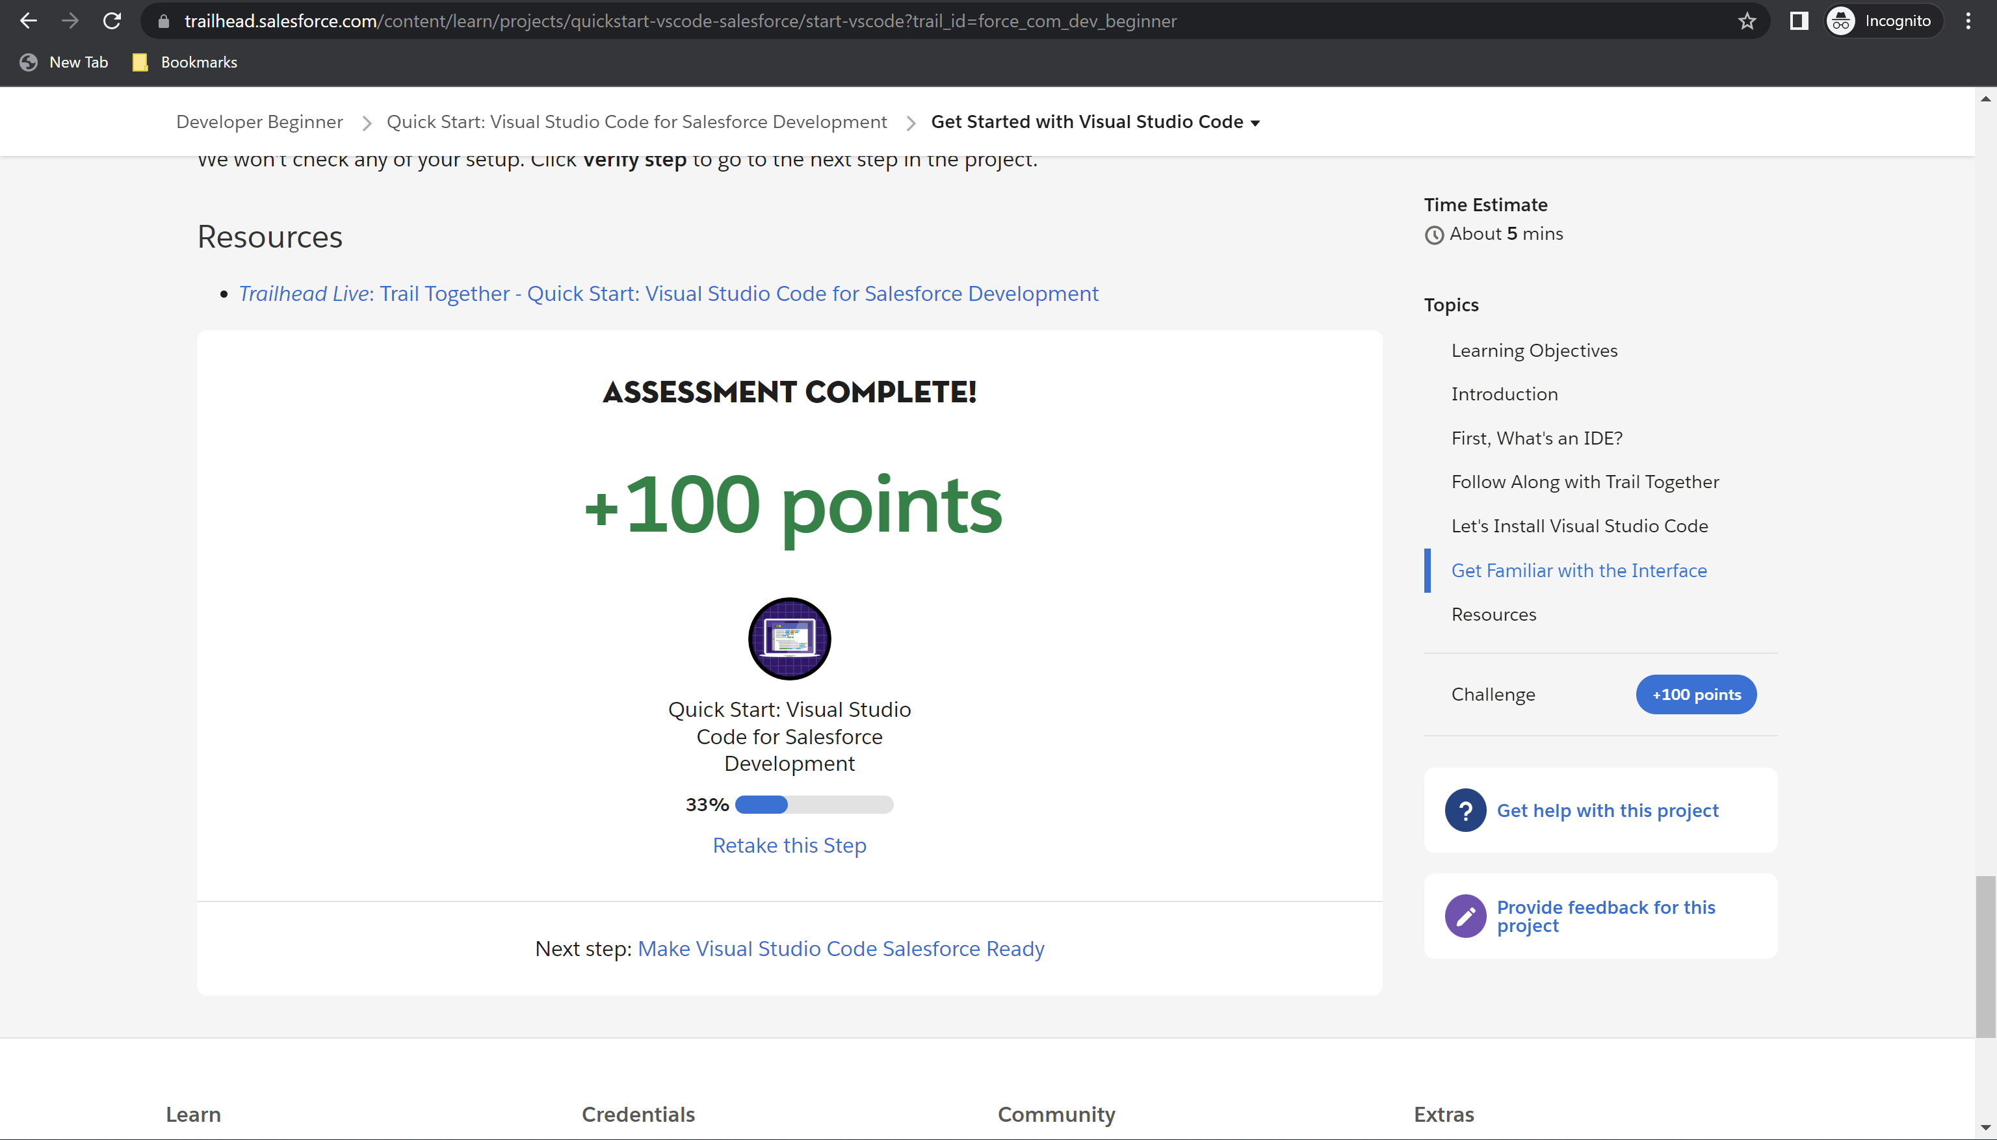

Challenge 2: 100 points earned

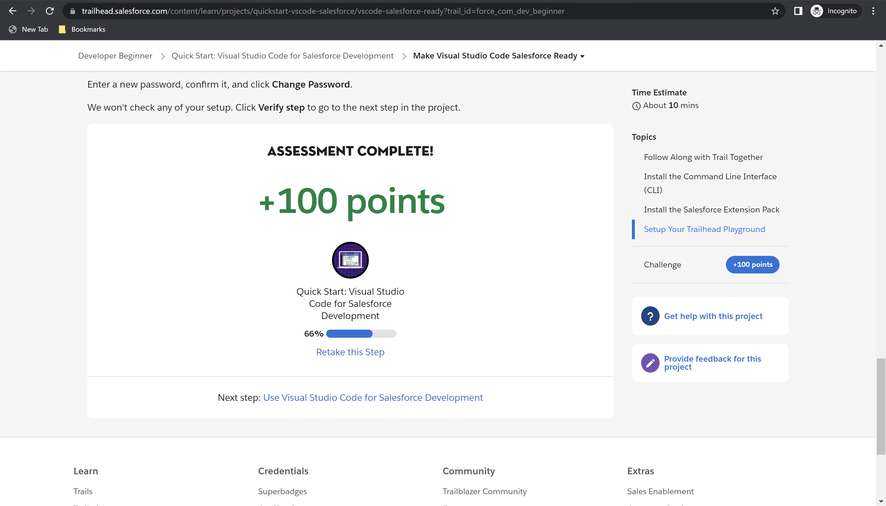

Challenge 3: 100 points

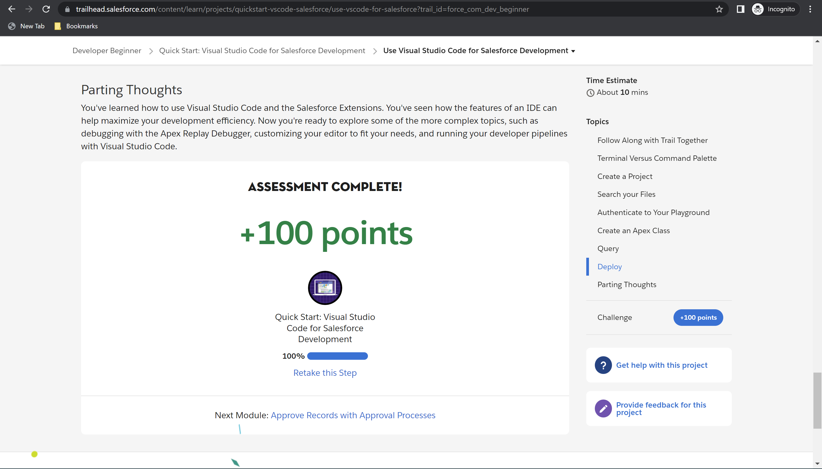

Module Badge earned

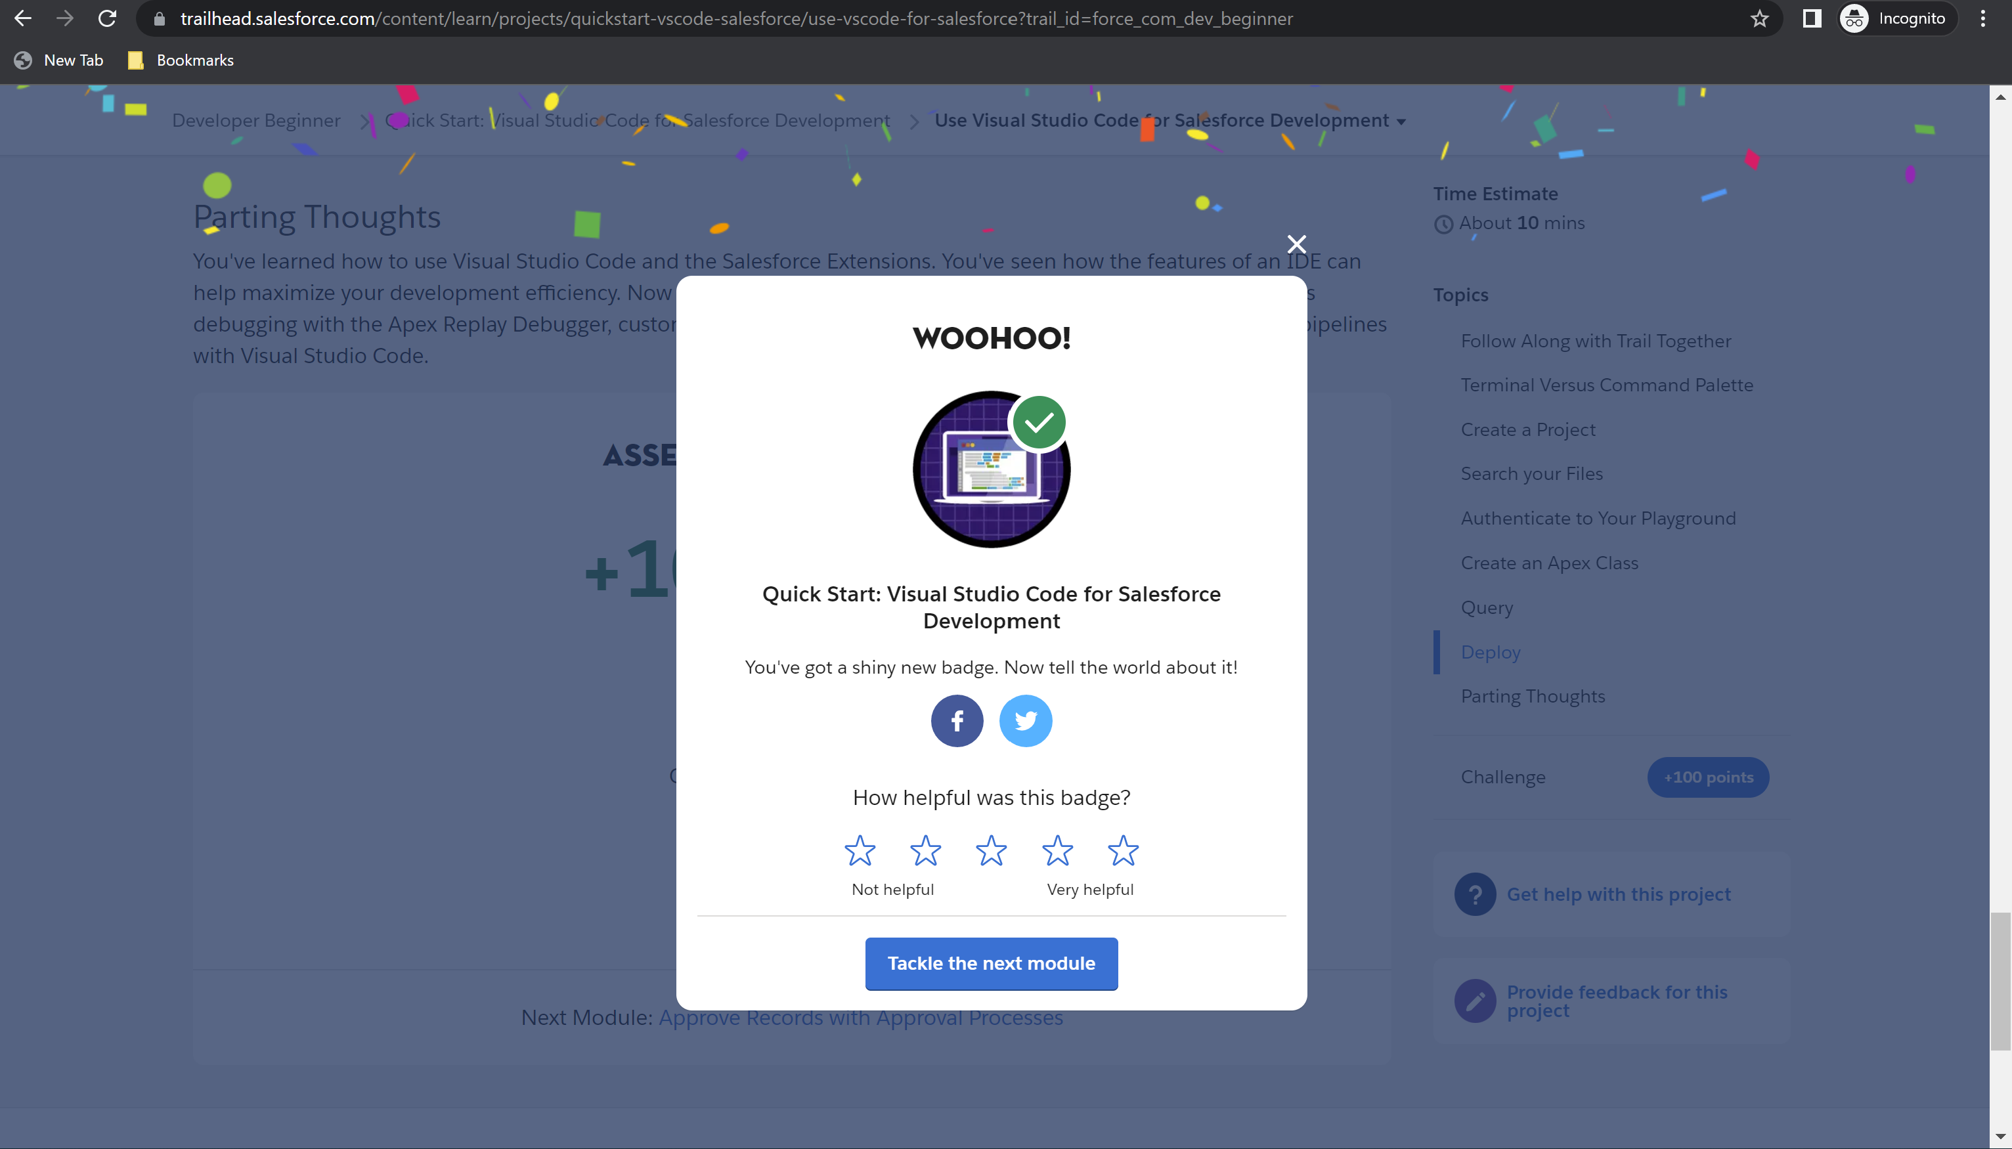

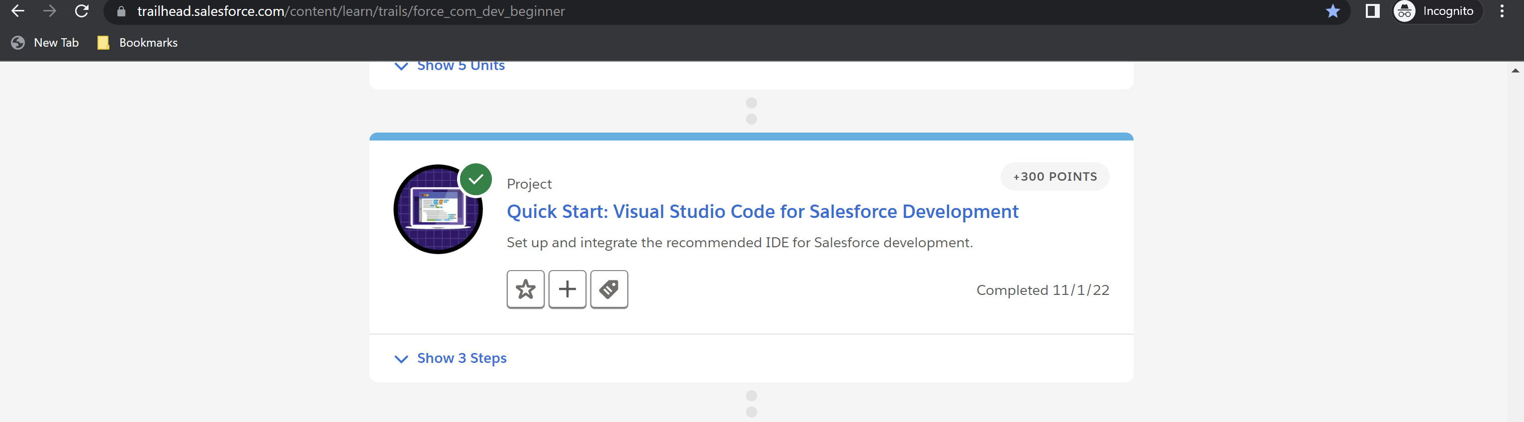

**Module 14: Quick Start: Search Solution Basics – Total: 300 points, Points Earned: 300 points**

Challenge 1: 100 points earned

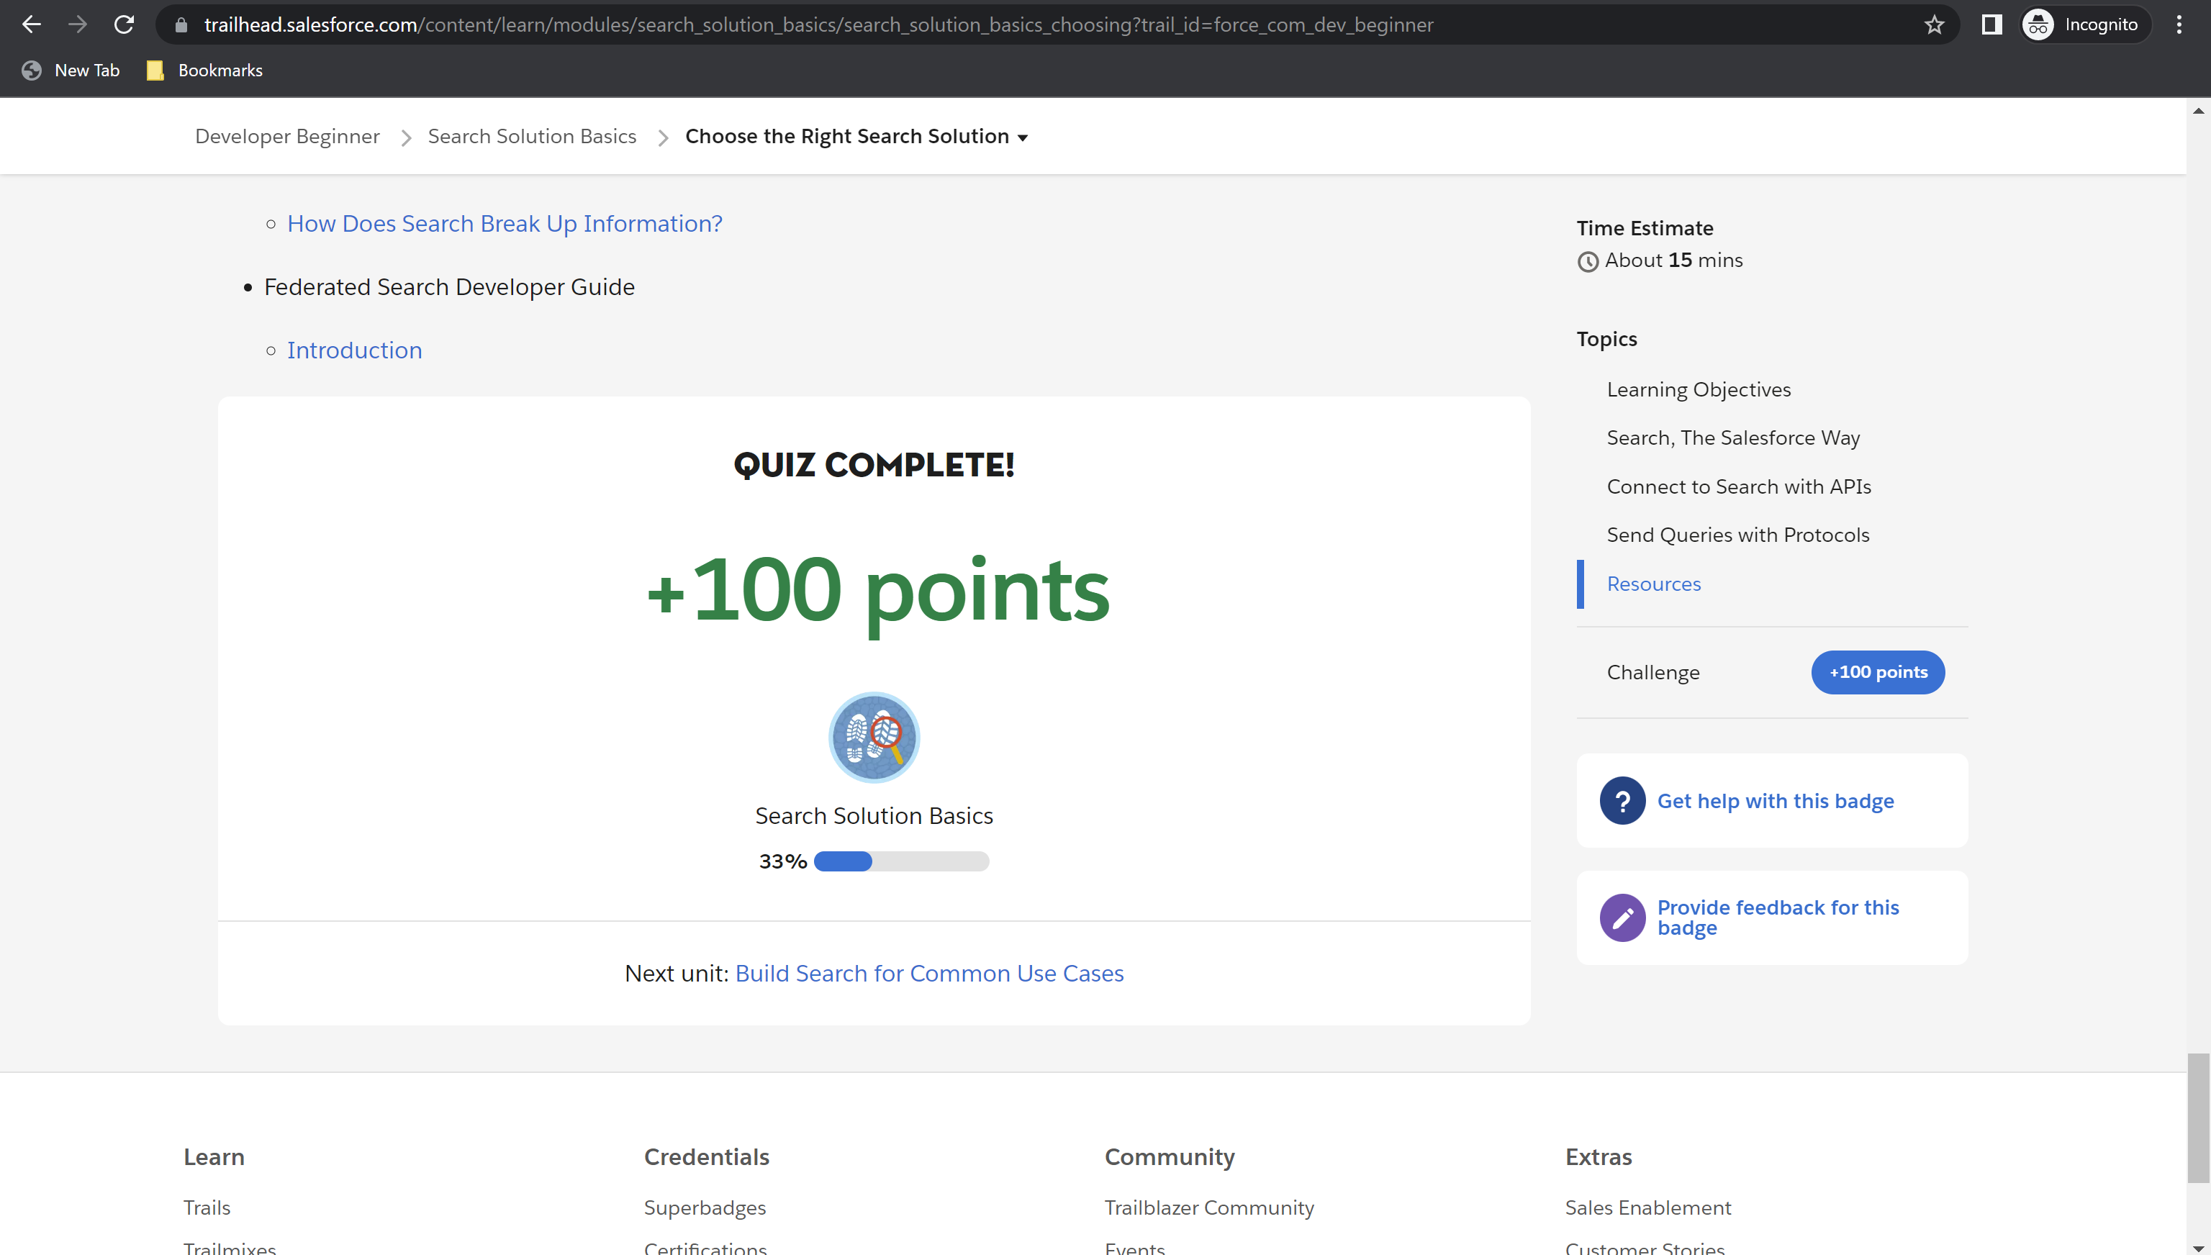

Challenge 2: 100 points earned

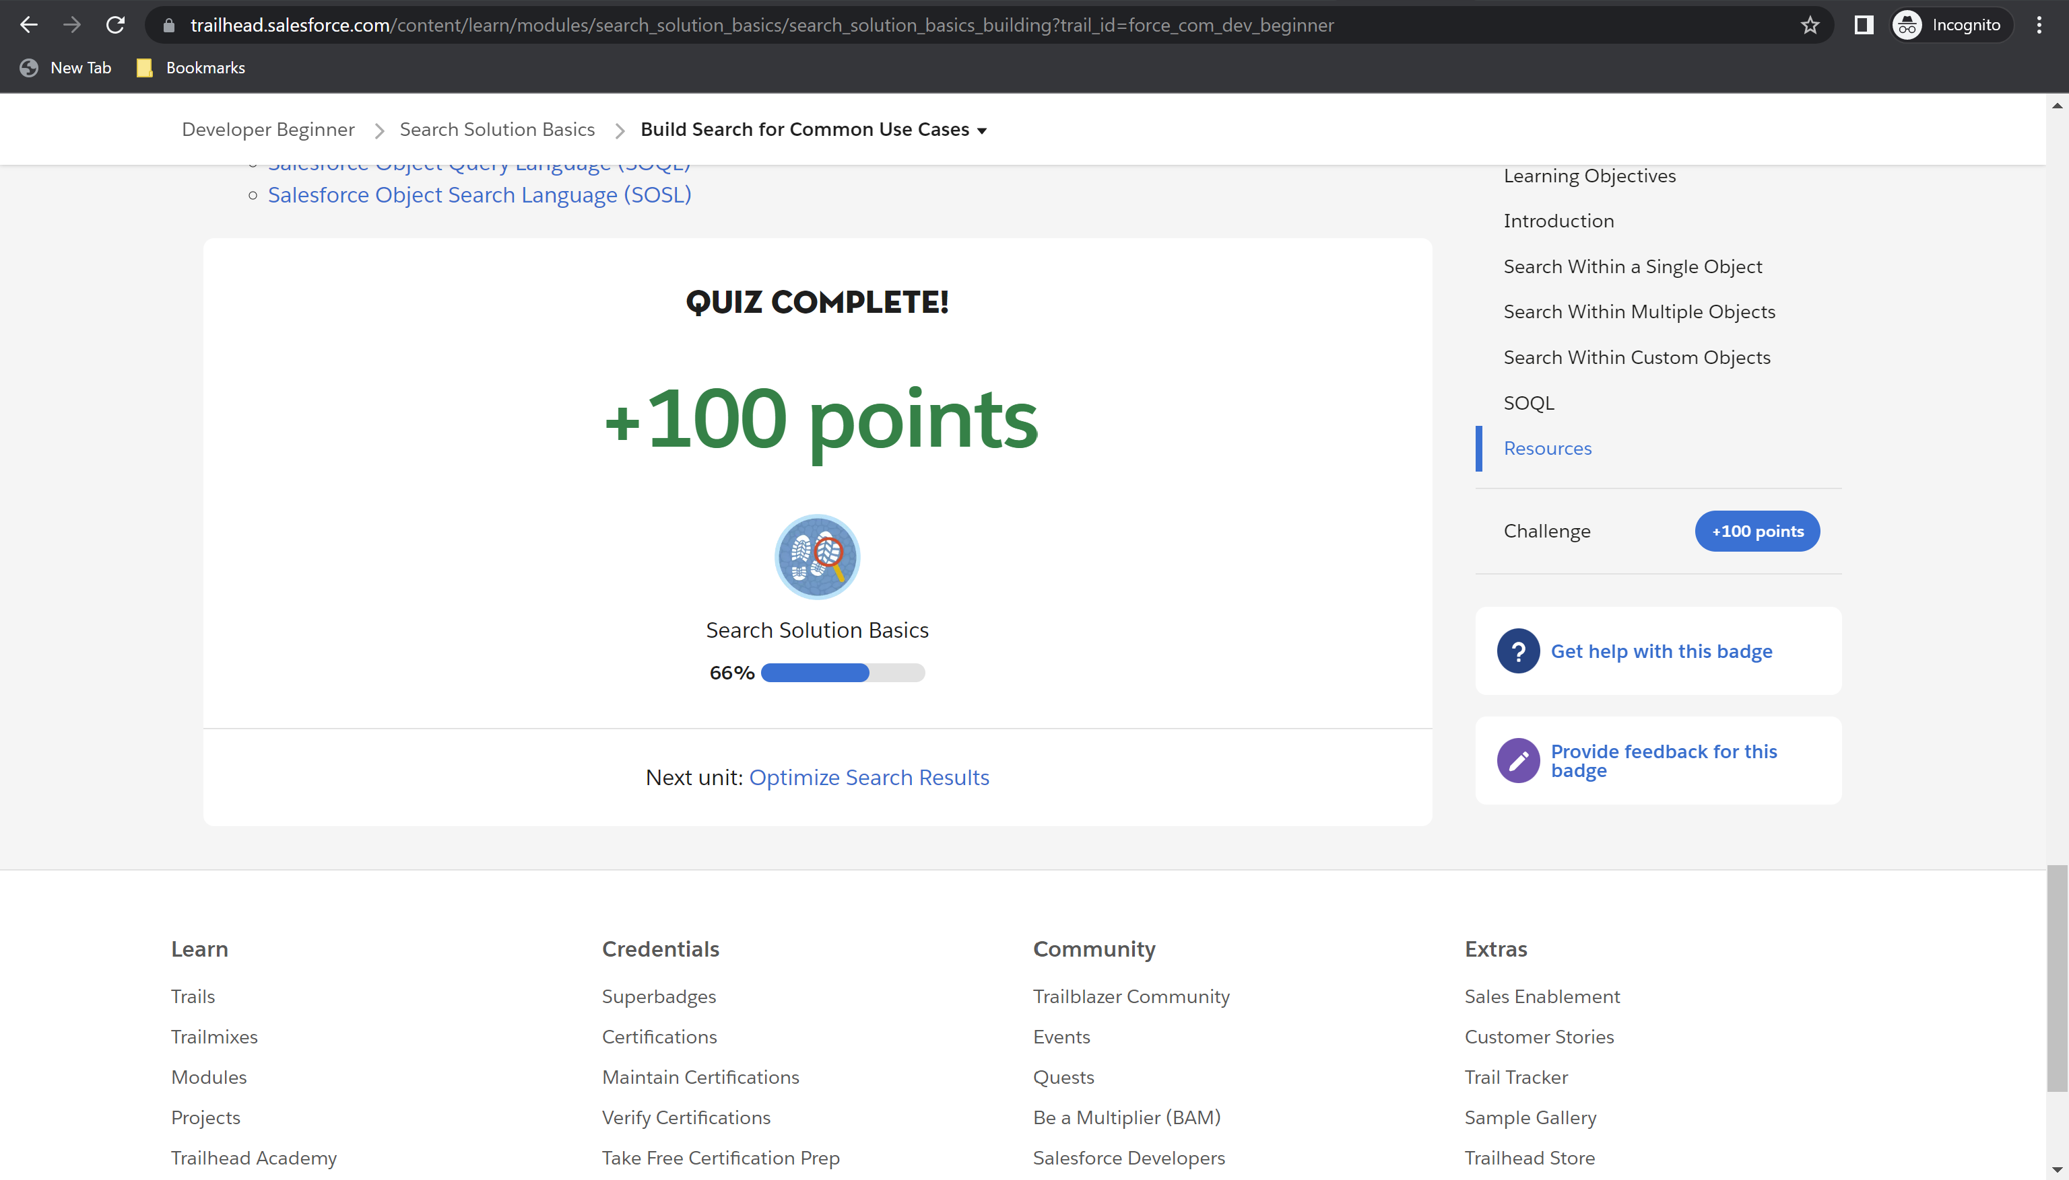

Challenge 3: 100 points

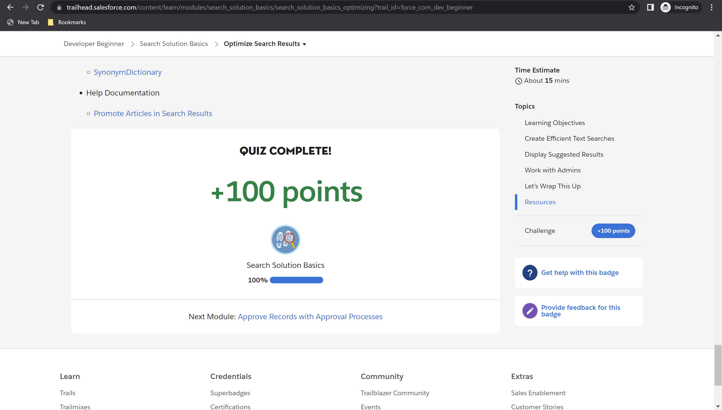

Module Badge earned

